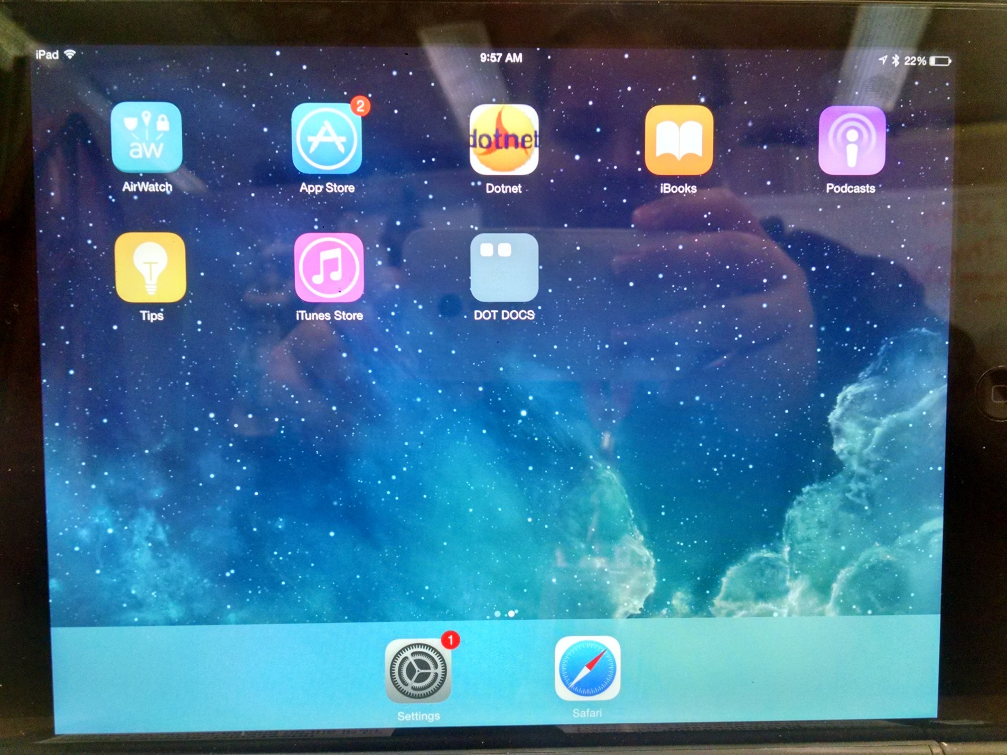

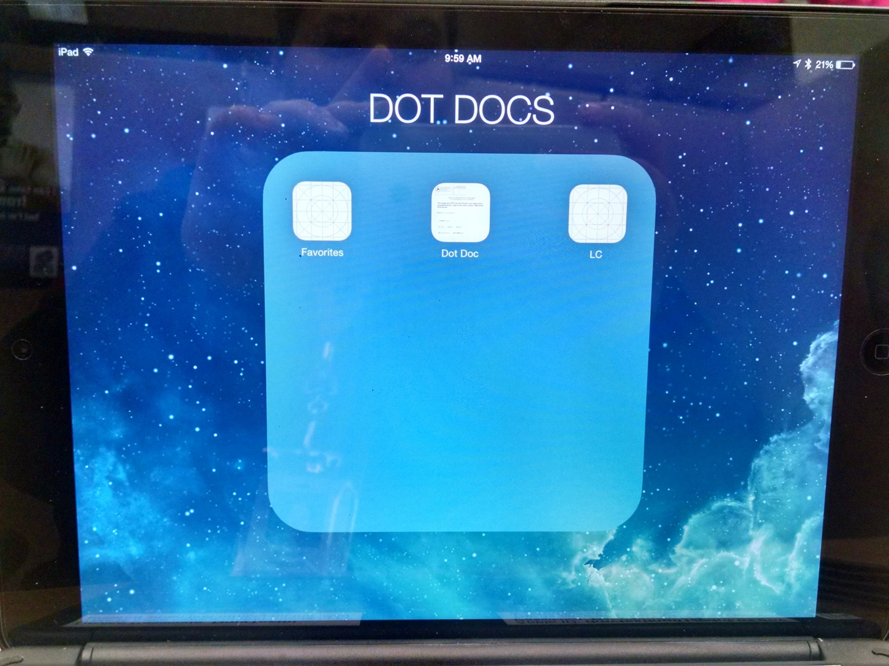

Credentials saved as one, in order of importance on tablet.

Credentials saved individually on tablet.