**Public Involvement Meeting Handout**

**(Highway)**

**(Termini)**

**(County)**

**Project ID: (XXXX-XX-XX)**



**(Date)**

**(Time)**

**(Location)**

**Purpose of the meeting**

(Explain the purpose and need for the project. Also outline our objective of explaining the information and obtaining public input into the proposed improvements. Much of the information in the project messages document can be used or expanded upon.)

(List any coordination meetings with local community officials.)

(Explain the format of the meeting.)

**Project information**

WisDOT is proposing to improve (# Miles) miles of (Roadway Name). Proposed improvements include: (Describe improvements in clear, understandable terms).

(List any, parking improvements, safety and overall benefits, reasons for improving the existing roadway and why WisDOT chose these alternatives and brief specifics that meeting attendees may find useful or of importance).

(Identify the status of the environmental study, historical or archaeological surveys, etc.)

**(Project Name) location/detour map**

**EXAMPLE**

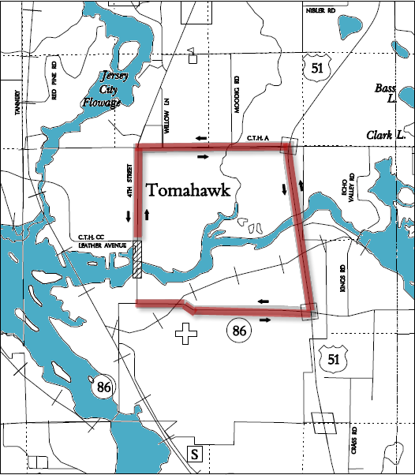

**Proposed traffic impacts**

Construction is scheduled to begin on (Date).

During construction, (Note specific road, interchange, and intersection closings. Specify dates and locations of closings when possible. **Example**: During construction, WIS 21 – between Pelican Lake Road and Price County X – will be reduced to one lane of traffic in each direction beginning Monday, February 17, 2010 and ending Friday, February 22, 2010.) Motorists can expect to encounter (Describe any temporary traffic signals, lane closures and flagging operations).

(Note any general impacts to businesses and residences. **Example**: Temporary driveway closures will be necessary during parts of the construction process. WisDOT will contact homeowners and businesses in advance before closing a driveway.)

Construction is currently scheduled for completion on (Date).

**Real estate**

Additional right of way will be required for this project. (Describe acquisition anticipations for specific locations and the need for acquisition). Preliminary right of way impacts are shown on the exhibits. WisDOT expects to begin real estate acquisition in (Month, Year).

(If no real estate will be required, please state that.)

**Project update/next steps**

List any previous public meetings and the date, meetings with local officials and the date.

Give a brief update of the current schedule in place including information on the completion of studies and approvals. Provide a timeline for the completion of the environmental process.

**Public input/comments**

We encourage you to talk to the project representatives and ask them questions. Attached to this handout is a sheet for your written comments and input regarding the proposed project. Please mail any written comments about the project before (Date) or leave them in the comment box tonight. You can also e-mail your comments to the contacts listed below.

Your comments assist us in developing a project that will serve the needs of the traveling public as well as the needs of the local community. Your input is welcome and appreciated throughout the design process.

For more information, please contact:

(Name)

Wisconsin Department of Transportation or Consultant Company Name

(Address)

(City, State, Zip Code)

(Phone)

(E-mail Address)

**Public Involvement Meeting Comment Form**

Project ID (xxxx-xx-xx)

(Project Name or Roadway)

(Project Termini or Construction Location)

(Name of County) County

(Date of Public Involvement Meeting)

Please place this form in the comment box or mail by (Date) to the address on the back of this sheet. Comments can also be e-mailed to (E-mail Address). Your comments assist us in developing a project that will serve the needs of the traveling public as well as the needs of the local community. Your input is welcome and appreciated throughout the design process.

Name: _____________________________________________________________

Address: ___________________________________________________________

Daytime Phone Number (optional): *______________________________________*

Email Address (optional): *______________________________________*

Please Print Comments (attach additional sheets if necessary)

|  |
| --- |
|  |
|  |
|  |
|  |
|  |
|  |
|  |
|  |
|  |
|  |
|  |
|  |
|  |
|  |
|  |

*The information in this document including names, addresses, phone numbers, e-mail addresses, and signatures is not confidential, and may be subject to disclosure upon request, pursuant to the requirements of the Wisconsin open records law, sections 19.31 - 19.39 of the Wisconsin Statutes.*

Fold here

[*Stamp or Pre-paid Postage*]

Wisconsin Department of Transportation

(*Address*)

Attn: (*Name*)

____________________________________________________

Fold here to mail