**Appendix A**

**TEST Methods & Sampling for HMA Pavement PWL QMP.**

The following procedures are included to the HMA Pavement Percent Within Limits (PWL) Quality Management Program (QMP) special provision:

* WisDOT Procedure for Nuclear Gauge/Core Correlation – Test Strip
* WisDOT Test Method for HMA PWL QMP Density Measurements for Main Production
* Sampling for WisDOT HMA PWL QMP

**WisDOT Procedure for Nuclear Gauge/Core Correlation – Test Strip**

Density Testing Zone of Approximately 200 lane ft

Outermost locations to be kept approx. 1.5 ft from edge of lane to the center of gauge





Middle locations @ approx. Center of Lane (i.e., 6 feet to center of gauge for 12-ft lane)





Intermediate locations to be at approx. 3.5 & 9.5 feet from edge of lane to center of gauge

Paving Direction



~ 50ft

~ 50 ft

~ 50 ft

~ 50 ft

Centered @

Random Locations 1 & 2

(identified by the Engineer)

**Figure 1: Nuclear/Core Correlation Location Layout**

The zones are supposed to be undisclosed to the contractor/roller operators. The engineer will not lay out density/core test sites until rolling is completed and the cold/finish roller is beyond the entirety of the zone. Sites are staggered across the 12-foot travel lane, and do not include shoulders. The outermost locations should be 1.5-feet from the center of the gauge to the edge of lane. [NOTE: This staggered layout is only applicable to the test strip. All mainline density locations after test strip should have a longitudinal- as well as transverse-random number to determine location as detailed in the *WisDOT Test Method for HMA PWL QMP Density Measurements for Main Production* section of this document.]



Individual locations are represented by the symbol as seen in Figure 1 above. The symbol is two-part, comprised of the nuclear test locations and the location for coring the pavement, as distinguished here:

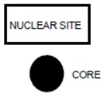

The nuclear site is the same for QC and QV readings for the test strip, i.e., the QC and QV teams are to take nuclear density gauge readings in the same footprint. Each of the QC and QV teams are to take a minimum of two one-minute readings per nuclear site, with the gauge rotated 180 degrees between readings, as seen here:

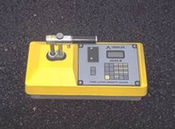 

1. (b)

**Figure 2: Nuclear gauge orientation for (a) 1st one-minute reading and (b) 2nd one-minute reading**

Photos should be taken of each of the 10 core/gauge locations of the test strip. This should include gauge readings (pcf) and a labelled core within the gauge footprint. If a third reading is needed, all three readings should be recorded and documented. Only raw readings in pcf should be written on the pavement during the test strip, with a corresponding gauge ID/SN (generalized as QC-1 through QV-2 in the following Figure) in the following format:

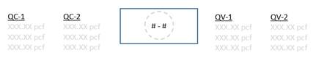

**Figure 3: Layout of raw gauge readings as recorded on pavement**

Each core will then be taken from the center of the gauge footprint, and will be used to correlate each gauge with laboratory-measured bulk specific gravities of the pavement cores. One core in good condition must be obtained from each of the 10 locations. If a core is damaged at the time of extracting from the pavement, a replacement core should be taken immediately adjacent to the damaged core, i.e., from the same footprint. If a core is damaged during transport, it should be recorded as damaged and excluded from the correlation. Coring after traffic is on the pavement should be avoided. The contractor is responsible for coring of the pavement. Coring and filling of core holes must be approved by the engineer. The QV team is responsible for the labeling and safe transport of the cores from the field to the QC laboratory. Core density testing will be conducted by the contractor and witnessed by department personnel. The contractor is responsible for drying the cores following testing. The department will take possession of cores following initial testing and is responsible for any verification testing.

Each core 150 mm (6 inches) in diameter will be taken at locations as identified in Figure 1. Each random core will be full thickness of the layer being placed. The contractor is responsible for thoroughly drying cores obtained from the mat in accordance with ASTM D 7227 prior to using specimens for in-place density determination in accordance with AASHTO T 166.

Cores must be taken before the pavement is open to traffic. Cores are cut under Department/project staff observation. Relabel each core immediately after extruding, or ensure that labels applied to pavement prior to cutting remain legible. The layer interface should also be marked immediately following extrusion. Cores should be cut at this interface, using a wet saw, to allow for density measurement of only the most recently placed layer. Cores should be protected from excessive temperatures such as direct sunlight. Also, there should be department custody (both in transport and storage) for the cores until they are tested, whether that be immediately after the test strip or subsequent day if agreed upon between Department and Contractor. Use of concrete cylinder molds works well to transport cores. Cores should be placed upside down (flat surface to bottom of cylinder mold) in the molds, one core per mold, cylinder molds stored upright, and ideally transported in a cooler. Avoid any stacking of pavement cores.

**WisDOT Test Method for HMA PWL QMP Density Measurements for Main Production**

For nuclear density testing of the pavement beyond the test strip, QC tests will be completed at three locations per sublot, with a sublot defined as 1500 lane feet. The three locations will represent the outside, middle, and inside of the paving lane (i.e., the lane width will be divided into thirds as shown by the dashed longitudinal lines in Figure 3 and random numbers will be used to identify the specific transverse location within each third in accordance with CMM 8-15). Longitudinal locations within each sublot shall be determined with 3 independent random numbers. The PWL Density measurements do not include the shoulder and other appurtenances. Such areas are tested by the department and are not eligible for density incentive. Each location will be measured with two one-minute gauge readings oriented 180 degrees from one another, in the same footprint as detailed in Figure 2 above. Each location requires a minimum of two readings per gauge. QV nuclear testing will consist of one randomly selected location per sublot. The QV is also comprised of two one-minute readings. This is depicted as follows, with QC test locations shown as solid lines and QV as dashed.

1 lot (7500 lane ft)

12 driving lane (typical)

Division of lane width into approximate thirds for distribution of transverse random numbers

Paving Direction

Note: 12 driving lane (typical), excludes shoulders even when paved integrally

Sublot 5

(1500 ln ft)

Sublot 4

(1500 ln ft)

Sublot 2

(1500 ln ft)

Sublot 3

(1500 ln ft)

Sublot 1

(1500 ln ft)

**Figure 5: Locations of main lane HMA density testing (QC=solid lines, QV=dashed)**

QC and QV nuclear density gauge readings will be statistically analyzed in accordance with the following section of this Appendix. (Note: For density data, if F- and t-tests compare, QC data will be used for the subsequent calculations of PWL value and pay determination. However, if an F- or t-test does not compare, the QV data will be used in subsequent calculations.)

**Sampling for WisDOT HMA PWL QMP**

*Delete CMM 8-36.4 Sampling Hot Mix Asphalt and replace with the following to update sublot tonnages:*

Sampling Hot Mix Asphalt

At the beginning of the project, the contractor determines the anticipated tonnage to be produced. The frequency of sampling is 1 per 750 tons (sublot) for QC and 1 per 3750 tons (lot or 5 sublots) for QV as defined by the PWL QMP SPV. A test sample is obtained randomly from each sublot. The contractor must submit the random numbers for all mix sampling to the department before production begins.

*Example 1*

Expected project production is 12,400 tons. The number of required samples is determined based on this expected production (per PWL QMP SPV) and is determined by the random sample calculation.

Sample 1 – from 50 to 750 tons

Sample 2 – from 751 to 1500 tons

Sample 3 – from 1501 to 2250 tons

Sample 4 – from 2251 to 3000 tons

Sample X – ………………………

Sample 16 – from 11,251 to 12,000 tons

Sample 17 – from 12,001 to 12,400 tons

The approximate location of each sample within the prescribed sublots is determined by selecting random numbers using ASTM Method D-3665 or by using a calculator or computerized spreadsheet that has a random number generator. The random numbers selected are used in determining when a sample is to be taken and will be multiplied by the sublot tonnage. This number will then be added to the final tonnage of the previous sublot to yield the approximate cumulative tonnage of when each sample is to be taken.

To allow for plant start-up variability, the procedure calls for the first random sample to be taken at 50 tons or greater per production day (not intended to be taken in the first two truckloads). Random samples calculated for 0-50 ton should be taken in the next truck (51-75 ton).

This procedure is to be used for any number of samples per project.

If the production is less than the final randomly generated sample tonnage, then the random sample is to be collected from the remaining portion of that sublot of production. If the randomly generated sample is calculated to be within the first 0-50 tons of the subsequent day of production, it should be taken in the next truck. Add a random sample for any fraction of 750 tons at the end of the project. Lot size will consist of 3750 tons with sublots of 750 tons. Partial lots with less than three sublot tests will be included into the previous lot, by the engineer.

It’s intended that the plant operator not be advised ahead of time when samples are to be taken. If the plant operator is involved in recording a Pb (%AC) to match up with the mix sample tonnage, then notification need not be earlier than 60 minutes before the mix sample being taken.

If belt samples are used during troubleshooting, the blended aggregate will be obtained when the mixture production tonnage reaches approximately the sample tonnage. For plants with storage silos, this could be up to 60 minutes in advance of the mixture sample that’s taken when the required tonnage is shipped from the plant.

*Delete CMM 8-36.4.2.1 through 8-36.4.2.3 and replace with the following PWL Split Sample Sizes*

*PWL Split Sample Sizes*

- Minimum sample sizes are referenced below and are guidance for meeting requirements for test completion.

|  |  |
| --- | --- |
| **Mixture NMAS** | **Minimum Individual Sample Size** |
| < 12.5mm (1/2") | 35 lb (4 x 35 = 140 lb) |
| 19.0mm - 25.0mm (3/4" – 1") | 50 lb (4 x 50 = 200 lb) |
| > 37.5mm ( 1-1/2") | 80 lb (4 x 80 = 320 lb) |

- The total sample for larger NMAS (nominal maximum aggregate size) mixtures will be enough to provide the required minimum testing sample size as defined in Figure 6.

*Delete 8-36.5.1.1 Step 1 and replace with the following Initial Splitting of Sample*

***Initial Splitting of Sample***

For QC sample reduction the HMA sample in the containers is mixed and quartered. The quartering process should then proceed as follows:

i. Collect the minimum sample size given in the *PWL Split Sample Size* section above. Split the sample into “Test” and “Retained” samples. Place entire sample on table, quickly re-mix and split to minimize temperature loss. Split the Test & Retained samples as shown on Figure 6. For 1/2" mixes start with at least a total of 105 lb of HMA.

Figure 6 Superpave Sample for 105 lb for three-way split for QC, QV, and retained samples

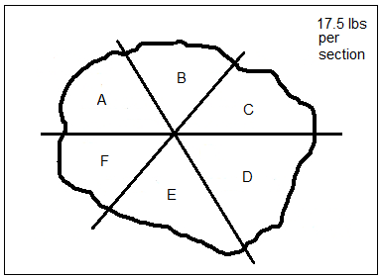

|  |  |
| --- | --- |
| (a) | (b) |

ii. For a three-way split shown in Figure 3, *diagonal sections*, as indicated on the sketch, must be combined to form the QV sample (A+D), retained sample (B+E) and the QC test sample (C+F). The retained sample must be bagged, labeled, and stored in a safe dry place. The retained samples may be tested using the “rule of retained” (see “Definitions” section).

iii. The QC & QV test samples are then further split for the specified tests. Continue the splitting process in *Further Reduction of Samples to Test Sizes* for the test materials until individual samples are in the oven.

*Delete CMM 8-36.5.2 Use of Alternative Sampling / Quartering Devices (ex: Quartermaster) and replace with the following:*

*Use of Alternative Sampling / Quartering Devices (ex: Quartermaster)*

Use of other devices to assist in the sampling and splitting procedures may be used with approval of the department. The Quartermaster is one such device. A picture of a Quartermaster device is shown in Figure 7.

Figure 7 Quartermaster Quartering Device

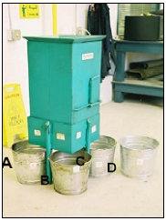

*Example 3*

If a quartermaster is used to reduce a PWL split sample into the proper quanitites, it is required to collect four times the minimum sample size shown in *PWL Split Sample Sizes* (e.g. 4 x 35 is approximately 140 lb), use the selected device to split, and discard the extra quadrant of material. The quartermaster is used to blend the asphalt mixture to minimize any segregation during the splitting process. The following steps helps to ensure uniform splits for each party/quadrant and should be followed for each PWL sample collected.

Figure 8 PWL Sample Splitting with Quartermaster

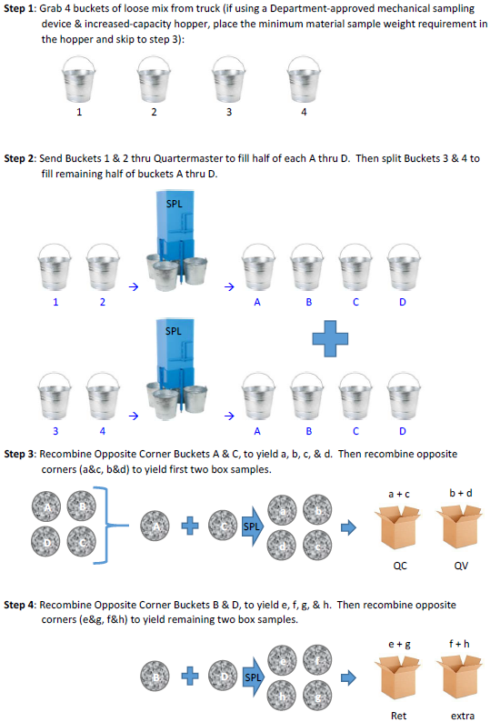

Appendix A-TEST Methods & Sampling for PWL QMP HMA Pavements (20171002)