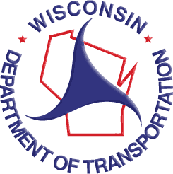

FTA Section 5310 Lease Agreement Instructions

Requirement

WisDOT must review and approve the Grantee-Lessee Lease Agreement document before signatures are obtained. Failure to comply with this requirement may negatively impact future funding.
Background
Grantees awarded federal transit grant funds through WisDOT may acquire and lease vehicles (assets) to other entities such as local public bodies or agencies, private nonprofit organizations, or private for-profit transportation operators.
Grantees are responsible for ensuring their Lessee(s) operate the vehicles on its behalf as outlined in the grant application awarded by WisDOT.
Action Steps
 | Grantee Action Steps | Guidance
1. | Draft Lease Agreement document | A Lease Agreement Template is available as a sample. Additional language may be attached to adhere to local requirements.
2. | Submit draft Lease Agreement and the signed Lease Agreement Request for Approval Form to WisDOT | Ensure the draft incorporates the minimum required elements outlined in the Lease Agreement Template.
3. | Obtain Approval from WisDOT | WisDOT will notify the Grantee of approval by signing and returning the Lease Agreement Request for Approval Form to the Grantee.
4. | Obtain Signatures on Lease Agreement | Grantee should obtain signatures on the Lease Agreement after WisDOT approval
5. | Post signed Leased Agreement on the  BlackCat® Online Grant Management System on the Resource Tab. | Post the signed lease agreement and the WisDOT approval letter for each Lessee on BlackCat.

Note: If terms and conditions change at any time during the Lease Agreement, the Grantee should follow steps 1-5.

