Wisconsin Department Transportation
www.wisconsindot.gov
Real Estate - Land & Property for Sale

Asking price is $33,700.
0.29 ACRES, Located at the Northwest Corner of County Highway KR & Lakeshore Drive, Village of Mt. Pleasant, Racine County. For more information, email: scott.dellenbach@dot.wi.gov or phone (414) 327-2607.
The sale is subject to Governor’s approval per Wisconsin Statute 84.09(5). The district will recommend the purchaser whose offer is accepted be approved by the Governor.

Property is offered for sale in “AS IS” condition. It is the responsibility of the purchaser to secure firsthand information about the local real estate tax rate, utility services, allowable access, zoning ordinances and building codes, to determine the utility of the land.

AERIAL OF SUBJECT SITE

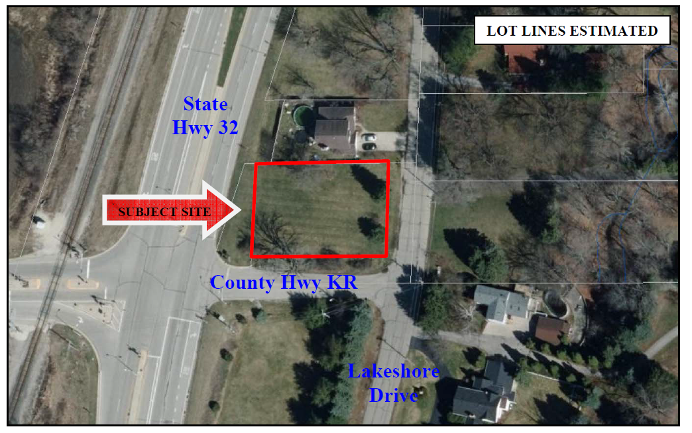

SITE DESCRIPTIVE SUMMARY
The subject site is located in the southeastern portion of the Village of Mount Pleasant. Specifically, it is
located at the northwest corner of County Highway KR and Lakeshore Drive. It includes a common street
address of 5330 S. Lakeshore Drive. As shown in the aerial above, the site is rectangular in configuration.
It is 90.71 feet wide and includes a depth of 136.97 feet. It contains a land area of 12,425 square feet or
approximately 0.29 acre. The parcel can be further identified as Racine County tax key number 151-03-23-32-075-000.

General information about surplus land and property for sale or lease and more listings at: http://wisconsindot.gov/Pages/doing-bus/real-estate/landsales/default.aspx

