Wisconsin Department Transportation
www.wisconsindot.gov
Real Estate - Land & Property for Sale

Project ID: T01-1(9) Aux.5.1, Parcel 2B

Asking price is $26,600.
+/- 0.19 ACRES, Located at the 9500 block of 11th Avenue, Village of Pleasant Prairie, Kenosha County. For more information, email: scott.dellenbach@dot.wi.gov or phone (414) 327-2607.
The sale is subject to Governor’s approval per Wisconsin Statute 84.09(5). The district will recommend the purchaser whose offer is accepted be approved by the Governor.

Property is offered for sale in “AS IS” condition. It is the responsibility of the purchaser to secure firsthand information about the local real estate tax rate, utility services, allowable access, zoning ordinances and building codes, to determine the utility of the land.

AERIAL OF SUBJECT SITE

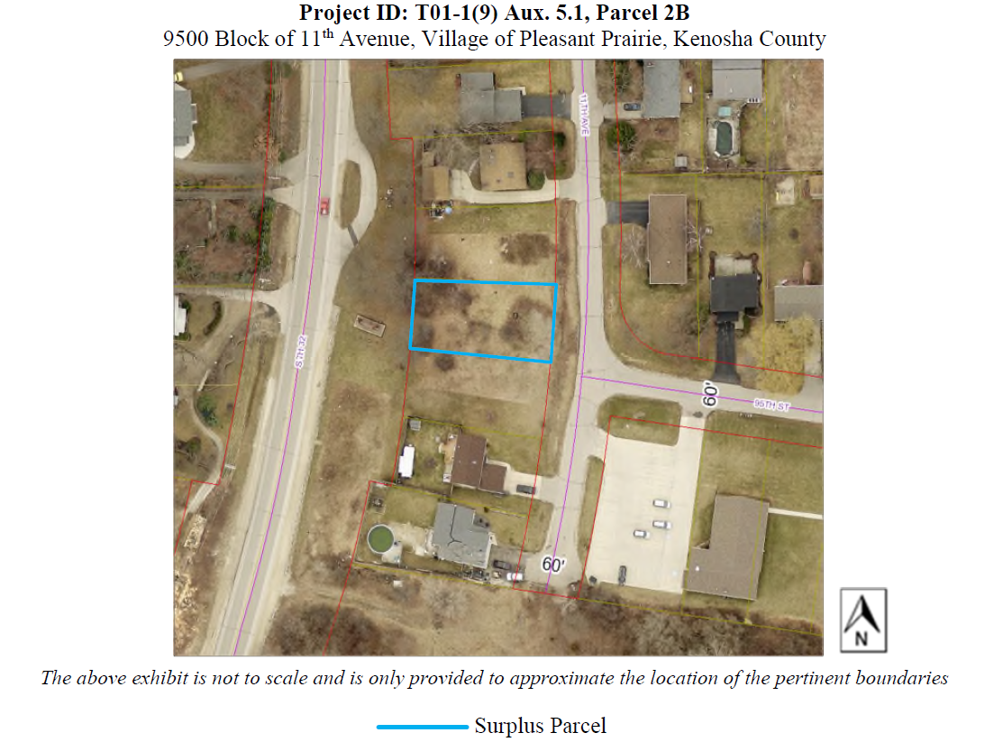

General information about surplus land and property for sale or lease and more listings at: http://wisconsindot.gov/Pages/doing-bus/real-estate/landsales/default.aspx

