Wisconsin Department Transportation
www.wisconsindot.gov
Real Estate - Land & Property for Sale

SALE OF STATE-OWNED SURPLUS LANDS

The location of the parcel is 4104 State Highway 83, Town of Wheatland, Kenosha County. The parcel is a trapezoid-shaped unimproved vacant land parcel located along STH 83 just south of 340th Avenue on the west side of STH 83. Access will be a single access point along STH 83.

The parcel measures approximately 2.96 acres. The property is currently zoned A-2; General Agricultural District, according to the Town of Wheatland zoning ordinance. The Purchaser will be responsible for any necessary rezoning.

Asking $77,000

To request “Bid Packet” for specific location, conditions and general terms, email: scott.dellenbach@dot.wi.gov or phone 414-870-8820.

Further information below.
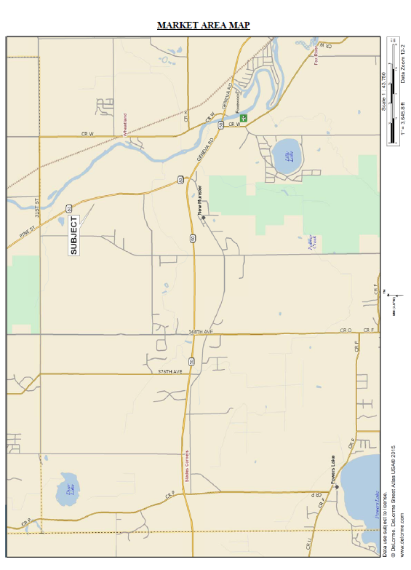
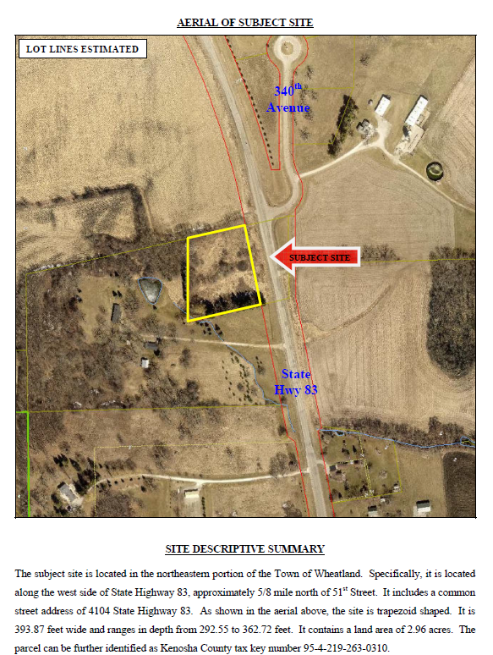

General information about surplus land and property for sale or lease and more listings at: http://wisconsindot.gov/Pages/doing-bus/real-estate/landsales/default.aspx

