Wisconsin Department of Transportation
Division of Transportation System Development (DTSD) - Joe Nestler, Admn
Statewide Bureaus - Steve Krebs, Deputy Admn
Bureau of Technical Services (BTS) - Scott Lawry, Dir

WisDOT Real Estate (RE) Information
Norman Pawelczyk, RE Mgr – Acquisition & Services Section; Utility & Access Unit
Greg Gasper, RE Mgr – Appraisal/Relocation/Property Management Section
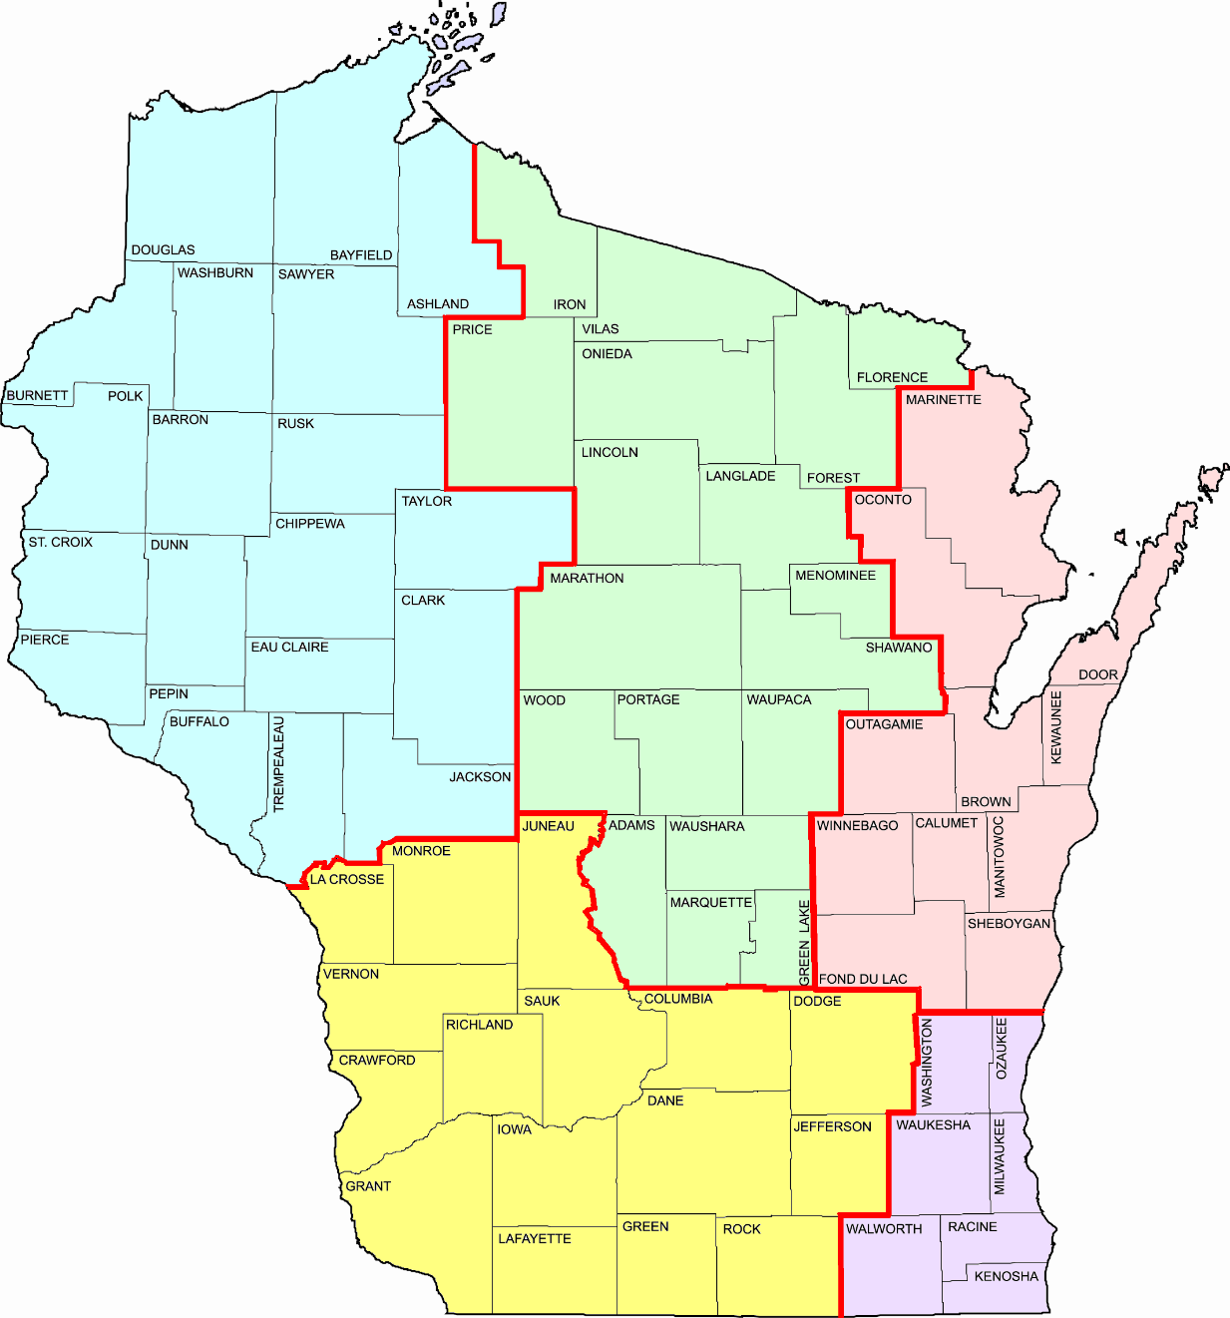
Fond du Lac was D2, now NE
Menominee & Shawano were D3, now NC
WisDOT Real Estate Region Offices

KEY: For FIIPS, EAPS and/or READS.

Eau Claire (EAU) – NW/D6
Green Bay (GRE) – NE/D3
La Crosse (LAX) – SW/D5
Madison (MAD) – SW/D1
Rhinelander (RHI) – NC/D7
Superior (SUP) – NW/D8
Waukesha (WKE) – SE/D2
Wis Rapids (WIS) – NC/D4
Buffalo, Trempealeau & Jackson were D5, now NW
Juneau was D4, now SW
Northeast Region (D3 GRE)
Bruce Enke, TSS Chief
Curt Van Erem, RE Supv
North Central Region (D4 WIS & D7 RHI)
Craig Smits, TSS Chief
Brent Stella, RE Supv
Southeast Region (D2 WKE)
James Robinette, TSS Chief
Bob Duffeck, ES Trans Supv
Craig Andersen, RE Supv

Northwest Region (D6 EAU & D8 SUP)
Paul Conlin, TSS Chief
Debra Stensland, RE Supv (SUP)
Heather Dresel, RE Supv (EAU)

Southwest Region (D1 MAD & D5 LAX)
Jennifer Queram, TSS Chief
Cory Schlagel, RE Supv (LAX)

