Wisconsin Department of Transportation
Rebecca Burkel, Division Administrator
Steve Krebs, Deputy Administrator, Statewide Bureaus
Scot Becker, Deputy Administrator, Regions
Scott Lawry, Bureau of Technical Services Manager

WisDOT Real Estate (RE) Information
Norman Pawelczyk, RE Manager – Acquisition & Services Section; Utility & Access Unit
Greg Gasper, RE Manager – Appraisal/Relocation/Property Management Section
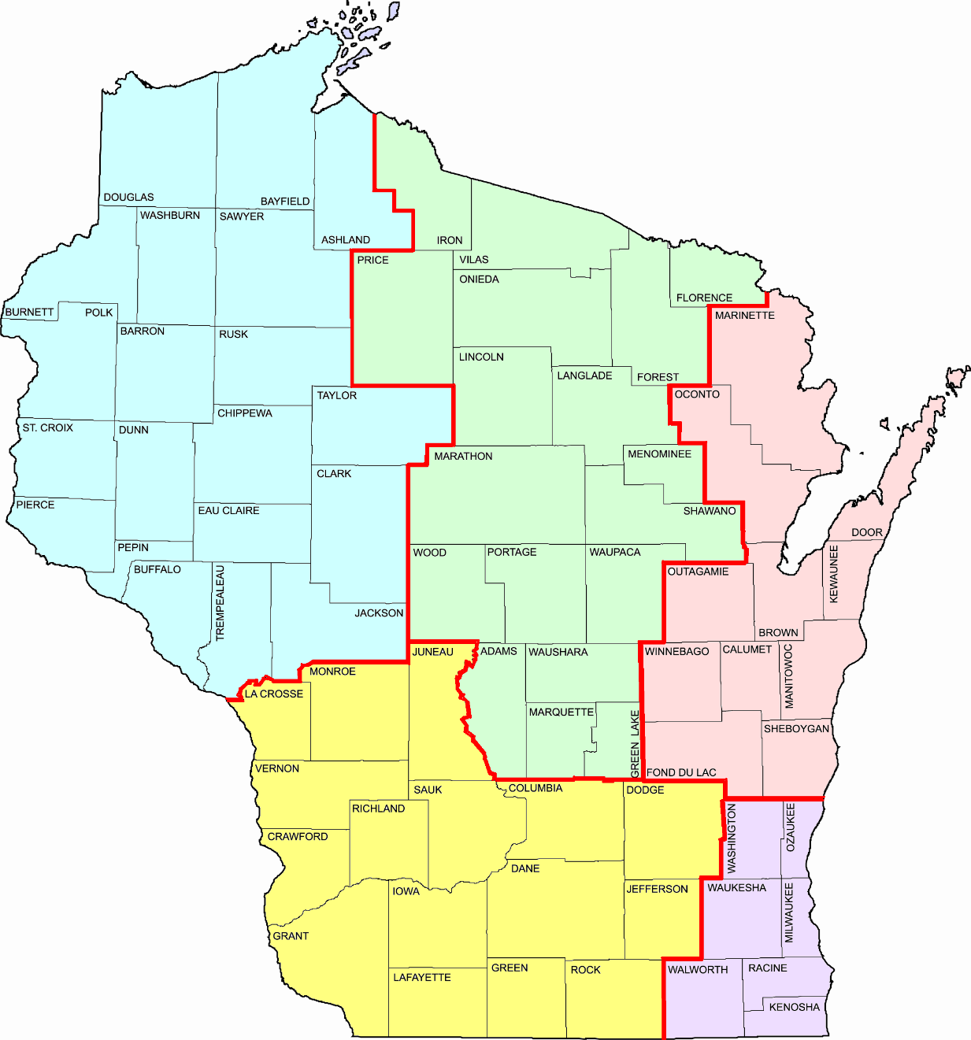
Fond du Lac was D2, now NE
Menominee & Shawano were D3, now NC
Buffalo, Trempealeau & Jackson were D5, now NW
Juneau was D4, now SW
Northeast Region (D3 GRE)
Alan Rommel, TSS Chief
Curt Van Erem, RE Supv.
North Central Region (D4 WIS & D7 RHI)
Craig Smits, TSS Chief
Brent Stella, RE Supv.
Southeast Region (D2 WKE)
James Robinette, TSS Chief
Nicole Mauch, RE Supv.
Bob Duffeck, ES Trans Supv

Northwest Region (D6 EAU & D8 SUP)
Brent Pickard, TSS Chief
Debra Stensland, RE Supv.
Heather Dresel, Trans. Spec. Supv.

WisDOT Real Estate Region Offices

KEY: For FIIPS, EAPS and/or READS.

Eau Claire (EAU) – NW/D6
Green Bay (GRE) – NE/D3
La Crosse (LAX) – SW/D5
Madison (MAD) – SW/D1
Rhinelander (RHI) – NC/D7
Superior (SUP) – NW/D8
Waukesha (WKE) – SE/D2
Wis Rapids (WIS) – NC/D4
Southwest Region (D1 MAD & D5 LAX)
Jennifer Queram, TSS Chief
Cory Schlagel, RE Supv. (LAX) & (MAD)

