MOVING COST AGREEMENT
FOR THE RELOCATION OF
OUTDOOR ADVERTISING SIGNS

(a.k.a., Outdoor Advertising Relocation Agreement)

ORIGINALLY EFFECTIVE SEPTEMBER 26, 1996 -
DATE OF JOINT FINANCE COMMITTEE APPROVAL

Revised October 2023

RE1033

Table of Contents

Page
Part 1 - General 3
1.1 Parties to, Purpose and Term of Agreement 3
1.2 Communication Between Parties 3
1.3 Scope of Agreement 3
1.4 Criteria for Users of Policy 4
1.5 Takedown and Removal of Signs;
How and When Payment is to be Made 4
1.6 History of Agreement 4
1.7 Dispute Resolution 5

Part 2 - Relocation Cost Schedule 5
2.1 General 5
2.2 Scope Of and Adjustments to Scheduled Costs 5
2.3 What is Not Included in Scheduled Costs 6
2.4 Procedures for Using Schedule 6
2.5 Payment Schedule Summary Worksheet 6
2.6 Relocation Cost Schedule 6-7

Part 3 - Itemized Cost Reimbursement Contract 8
3.1 General 8

Part 4 - Adjustments to Schedule and Part 3 Costs 8
4.1 General 8
4.2 Height Above Ground Level (HAGL) 8
4.3 Structural Variations 9
4.4 Electrical 9
4.5 Utility Costs 9
4.6 Platforms and Aprons 9
4.7 Copy Credit 9
4.8 Other Reimbursable Relocation Expenses 9
4.9 Salvage 10
4.10 Reimbursement of Advertising Revenue;
Temporary Removal of Sign 10
4.11 Depreciation 11
4.12 Extenuating Circumstances 12
4.13 Betterment 12
4.14 Holdover and Rent Calculation 12

APPENDIX: Working Documents/Forms 13-17
- Outdoor Advertising Survey, RE1676 (04/15)
- Payment Schedule Summary Worksheet, RE1677 (04/15)
- Relocation Claim – Application and Release, RE1527 (08/18)
- Sign Removal Agreement, RE1678 (04/15)
- Sign Schedule Claims Checklist, unnumbered (01/15)

PART 1 - GENERAL

1.1 Parties to, Purpose and Terms of Agreement

This Agreement has been created by the Outdoor Advertising Association of Wisconsin (hereinafter referred to as "OAAW") and the Wisconsin Department of Transportation (hereinafter referred to as "WisDOT"). The purpose is to establish a simplified, consistent and justifiable means by which an outdoor advertising sign company owner (hereinafter referred to as "Owner") eligible to use the provisions of this Agreement can be appropriately reimbursed for an eligible off premise outdoor advertising sign structure (hereinafter referred to as "Sign") that must be removed and/or relocated as a result of a highway project. This Agreement shall not address illegal Signs, nor does it address any situation violating state or federal statute.

It is the intent of this Agreement to implement the provisions of Section 9155 (6y) of 1995 Act 113. This Agreement is subject to impairment by subsequently enacted or adopted state and federal laws, regulations and administrative rules.

This Agreement was originally effective as of September 26, 1996, the date of approval by the Joint Finance Committee, for a term of three years. In November 2008, the Outdoor Advertising Association of Wisconsin and the Wisconsin Department of Transportation agreed that this Moving Cost Agreement would be adjusted every two years. The numbers in the relocation cost schedule will be adjusted based on the percentage change in the Producer Price Index for steel for the prior two-year period.

1.2 Communication Between Parties

It is the intent of the OAAW and the WisDOT to foster better communications in the circumstances surrounding the necessary removal and relocation of an outdoor advertising Sign, so that problems can be identified early in the acquisition process. This will allow both parties to be aware of cost reimbursement issues, disclose the facts, allow for appropriate search time for the Owner and perhaps find resolution of part or all of the issues at hand well before the removal of the Sign is required.

The success of this Agreement is dependent upon both organizations generating responsible trust and understanding in the evaluation of each individual sign relocation situation. The WisDOT will make efforts on new sign issues to advise an Owner of appropriate meetings early in the preliminary planning stages (public involvement process) of a highway project to allow the affected Owner(s) and the WisDOT to mutually address concerns. It is the intent that both parties willingly and openly present all necessary data and information to support the situation at hand.

Subsequent to this early communication effort, the WisDOT is required by state and federal law to provide the Owner with the 90-day notice and 30-day reminder for the sign removal, and it is understood that the Owner will adhere to this removal date in the absence of a mutual written Agreement stating a different date has been negotiated.

1.3 Scope of Agreement

The Agreement contains two specific tools to aid in the relocation of signs:

- Part 2: A Schedule of costs for outdoor advertising signs that applies to signs which range from sixty (60) square feet to one thousand, five hundred (1,500) square feet in area. These costs are intended to be all-inclusive with adjustments as detailed in Part 2 of this Agreement. Provisions and procedures for filing a claim under Part 2 are detailed.
- Part 3: A required procedural format for filing a claim for more complex sign relocations. This procedure is to be used upon mutual agreement between the Owner and WisDOT when Sign contains Extenuating Circumstances (Part 4.12) that may substantially reduce or exceed scheduled costs.

                - It is not necessarily the intention of this Agreement to address resolution of just compensation in the event a Sign cannot be moved (e.g., non-conforming under Wis. Stats. s. 84.30). However, this Agreement may be used for this purpose upon mutual agreement between the WisDOT and the Owner. Also, there may be circumstances which render the cost of Sign relocation greater than the value of the Sign. In these circumstances, the WisDOT shall pay the lesser of the relocation cost or the value of the Sign (Part 4.12).

1.4 Criteria for Users of Policy

It is the intent of this Agreement that an eligible Owner be a licensed, professional sign company, with adequate insurance requirements and other requirements reasonably expected of such companies. A Sign under consideration for this Agreement must be owned by the eligible Owner that will be seeking reimbursement, either at the time the sign is identified as being impacted by a highway project, or who during the process acquires the Sign as part of a bona fide offer. (In the latter case, the Owner must ascertain from the seller that the sign is to be relocated, and must provide written notice to the WisDOT of ownership.) Said Owner in accepting payment from the WisDOT for relocating a Sign under either Part 2 or Part 3 of this Agreement assumes all responsibility for rebuilding the Sign at a new site and for meeting all local ordinances and safety considerations.

1.5 Takedown and Removal of Sign; How and When Payment is to be Made

Takedown and Removal: It will normally be the responsibility of the Owner to takedown and remove the Sign. However, there may be circumstances where the Sign has no value to the Owner and can be taken down more cost effectively by the WisDOT (see Part 4.9 Salvage). The WisDOT reserves the right in such situations to evaluate the costs and, if reasonably prudent to do so, have the Sign removed and deduct the scheduled takedown costs from the payment to the Owner.

Payment: Payment shall be made by WisDOT to the Owner when: 1) a claim is signed by the Owner, agreeing to be reimbursed under this program, and 2) after the sign is removed from the highway right of way. Removal must be by the date indicated on the notification by WisDOT to Owner, and notice shall be given by WisDOT to Owner at ninety (90) days prior to this date, as required under the Uniform Relocation Act, and at thirty (30) days prior to this date, as is WisDOT practice. However, a different removal date, arranged mutually between the WisDOT and Owner and acknowledged in writing will preempt the removal date indicated on the notification and will not waive the Owner's right to reimbursement under this Agreement (such an arrangement may contain other terms (i.e., rent to be paid by the Owner to the current landowner based upon the land lease in effect at the time). WisDOT will tender payment within thirty 30 days after WisDOT has received the sign relocation claim and other required documentation and the Owner has notified WisDOT that the sign is removed.

Payment shall be made to Owner under this Agreement only when the Owner's Sign is occupying the property with consent of the landowner (under lease or extension) for consideration, or owned by Owner, on the date the WisDOT acquires the parcel upon which the Sign is located.

Upon acceptance of payment under this Agreement, the Owner waives any right to future claims for damage or loss involving this Sign(s).

Provided that the WisDOT has given the 90 day notice and 30 day reminder to remove the Sign, in the event the signs are not removed by the removal date as specified in the notice or by mutual agreement, it is understood by the Owner that WisDOT shall remove the Sign and the amounts due the Owner under the terms of this Agreement shall be offset by the costs to WisDOT for removal of the sign and project delay, if applicable. The Owner will be entitled to the balance, if any, of relocation benefits. In the event the WisDOT does not provide the required 90 and 30 day notices, the removal date shall be extended by the notice period not given and the Owner shall not be responsible for project costs accrued by WisDOT throughout this period.

1.6 History of Agreement

The Original Agreement was prepared July 1, 1996 by: The Outdoor Advertising Association of Wisconsin and the Wisconsin Department of Transportation. Revisions were made in November 1997 to Parts 2.5, 3.2, 4.11, and the Outdoor Advertising Survey Sheet (Appendix). Revisions were subsequently made in June of 2002 to pages 8 & 11 (worksheets) marked obsolete; Appendix to contain most recent forms: RE1527, RE1676, RE1677, RE1678. On February 9, 2005, language and form updates were made. In November 2008, revisions were made to parts 1.1, 2.1, 2.2, 2.5 (Payment Schedule Summary Worksheet), 2.6 (Relocation Cost Schedule), 4.5, 4.8, 4.9, 4.11, and 4.12; a new section 1.6 History of Agreement was added, and parts 1.2, 1.3, 1.4 and 1.5 were renumbered. Updates to Relocation Cost Schedule were made February 2011 and again January 2013. In January 2013, current versions of each form were made a part of this updated agreement. Also in January 2013, total number of pages were reduced due to changes in font style and sizes, and removed duplicate identical draft of Payment Schedule Summary Worksheet, which is now only displayed in Appendix along with the other forms, and page numbers referenced for each part in Table of Contents were updated. Also corrected part 4.6 referencing where platform amounts are found. Final changes were to update all references of the DOT, to read the WisDOT, and to correct the term lineal, to read linear.

The original, 1996 agreement contained the following procedure for revising the agreement: “On or around the anniversary date of this Agreement, or at any time mutually agreeable to both parties, the OAAW and the WisDOT may make modifications upon mutual consent on non-cost related terms of the Agreement to expedite relocation issues as the Schedule is implemented. Cost-related terms, most importantly the scheduled costs in the Schedule shall not be modified during the term. However, in the event this agreement is extended at the end of the term, costs will be adjusted based upon annual statewide cost modifiers for similar structures from the most current Boeckh Cost Service Manual available at that time.” This provision is no longer valid as of November 1, 2008. See page 3, sec. 1.1 for November 2008 revisions to this procedure.

1.7 Dispute Resolution

During the term of this Agreement, a team of four (4) individuals, two (2) from the OAAW and two (2) from the WisDOT, will act as a review committee to help implement the Agreement, to answer questions arising from its use, to aid in a final decision on a complex or confusing Sign issue, or to mediate a Sign issue between the WisDOT and an Owner.

PART 2 - RELOCATION COST SCHEDULE

2.1 General

The Relocation Cost Schedule (Schedule) is for the relocation of Signs that range from 60 - 1500 square feet in area. Additional costs to be added for two-sided, side-by-side and certain V-type signs are addressed in the Schedule; typically all double deck and some V-type signs may be submitted under Part 3 of this Agreement. The Schedule (page 10) is intended to include poster panel and bulletin, as well as wood and steel structures. The Schedule is intended to include the vast majority of Sign relocations, and it is understood by the OAAW and the WisDOT that slight variations in actual costs higher or lower than the scheduled amount will balance out in all sign transactions over time.

2.2 Scope of and Adjustments to Scheduled Costs

Scope of Scheduled Costs: The costs in the Schedule are derived from estimated costs itemized by the OAAW and provided to the WisDOT for typical sign relocations. The costs reflect takedown of an existing structure, the relocation of the structure, and the cost of rebuilding a sign new adjusted for the salvageable portions of the existing sign (See Part 4.9, Salvage). Additionally, depreciation shall be considered on signs, which are being relocated on the same site or a comparable site (See Part 4.11, Depreciation). For the original 1996 agreement, the OAAW derived the scheduled costs from standards developed by the Outdoor Advertising Association of America, applicable engineering codes for a 30lb. wind load requirement (the national engineering code and COMM code for structures), and a reasonable average itemized breakdown of labor, equipment and other costs for relocation obtained through general experience. In 2008, costs were based on actual quotes and invoices, which were affected by the 2006 International Building Code (IBC) Standards.

Costs in this Schedule are intended to be all - inclusive of reasonable costs required for: assessing the sites; removing the existing structure (Owner removing the posts, and WisDOT removing underground footings); and re-erecting the sign with all new materials, less adjustments for salvageable components and other factors. The height above ground level (HAGL) used for Scheduled costs is fifteen feet (15').

Adjustments to Scheduled Costs: The Schedule contains adjustments for:

- Variations in HAGL greater or less than fifteen feet (15') (Part 4.2 and Schedule);
- A back-to-back (two-sided), side-by-side, or V-type sign (Part 4.3);
- Electrical costs for illumination fixtures, installation and wiring based upon the size of the Sign (Part 4.4 and Schedule, Part 2.6);
- Utility charges which must be documented by separate invoice (Part 4.5);
- Platforms and aprons (Part 4.6);
- Credit for copy if Sign is not under a live or ongoing contract (Part 4.7).

The costs being claimed under the Schedule may be further adjusted as appropriate for:
- Other reimbursable relocation expenses, which include costs for variances, permitting and legal fees in finding and negotiating/ re-negotiating a lease for the new site (Part 4.8);
- Salvage (Part 4.9);
- Advertising revenue, temporary removal of sign (must see Part 4.10);
- Depreciation on same or comparable site (Part 4.11).

2.3 What is Not Included in Scheduled Costs

Extenuating Circumstances (Part 4.12) may exist that cause a given Sign relocation to substantially exceed or fall below the Scheduled amounts. Such Circumstances may require the use of the Itemized Cost Reimbursement Contract (Part 3) upon mutual agreement between the Owner and WisDOT. In any situation where costs exceed the Schedule (Part 2.6), they must be documented and itemized as indicated in Part 3 of this Agreement.

2.4 Procedures for Using Schedule

The intent of this Schedule is to simplify and improve the Sign relocation reimbursement process for both the WisDOT and the OAAW. The procedures below outline required steps for reimbursement and are developed to enhance communications, so that appropriate information is exchanged and the reimbursement made under this Agreement is justifiable.

- Communication shall be initiated by the WisDOT during the preliminary planning/scoping phase of a project in which an Owner's Sign will be impacted.
- The impacted Owner will be contacted during the preliminary planning stage of the project and invited to the public information meeting(s) prior to the sign being surveyed in the field by both WisDOT and the Owner.
- An Outdoor Advertising Survey (RE1676) (see: Appendix) must be filled out in full to capture all necessary information on the Sign. The Survey should be jointly filled out by the WisDOT and the Owner, and copies provided for both parties.
- The Payment Schedule Summary Worksheet (RE1677) (see: Appendix) must be filled out, indicating the appropriate cost on the Schedule, with adjustments as indicated.
- The Survey Sheet and the Summary Worksheet must be submitted along with the WisDOT Real Estate Reimbursement Claim - Application and Release (RE1527) (see: Appendix) for reimbursement to occur.
- Payment will be made as indicated in Part 1.3 of this Agreement, and upon receipt of payment by Owner; future claims of any kind relative to this Sign are waived.
- In the event there are Extenuating Circumstances (Part 4.12) relative to this Sign that may indicate costs will exceed the Scheduled amounts, Owner has the option of filing an estimated Itemized Cost Reimbursement Contract (Part 3) to capture these costs.

2.5 Payment Schedule Summary Worksheet

See Payment Schedule Summary Worksheet (RE1677) in Appendix.

2.6 Relocation Cost Schedule

See current Relocation Cost Schedule (next page).

Relocation Cost Schedule

NOTE: This schedule is intended to cover most sign situations.
Schedule is based upon a 15' HAGL.
Adjustments must be made based on Part 4 of this Agreement.

Sign Size | Wood | Steel  (Adjust. +60%) | HAGL Adj. (Part 4.2)  (2022 Adjust. +60%)  $/Per linear foot | Electrical  (Part 4.4)
60 - 85 | Takedown $ 1,216  Build new $ 4,921  Total $ 6,137 | Takedown $ 2,154  Build new $ 9,317  Total $11,471 | $120 | $1,435
86 - 115 | Takedown $ 1,216  Build new $ 5,261  Total $ 6,477 | Takedown $ 2,154  Build new $ 11,009  Total $ 13,162 | $207 | $1,435
116 - 145 | Takedown $ 1,470  Build new $ 6,394  Total $ 7,864 | Takedown $ 2,603  Build new $12,008  Total $14,611 | $223 | $1,435
145 - 180 | Takedown $ 1,645  Build new $ 7,531  Total $ 9,176 | Takedown $ 2,913  Build new $13,800  Total $16,713 | $259 | $1,435
181 - 220 | Takedown $ 1,859  Build new $ 8,570  Total $10,429 | Takedown $ 3,292  Build new $16,763  Total $20,055 | $345 | $1,435
221 - 270 | Takedown $ 2,034  Build new $ 9,753  Total $11,787 | Takedown $ 3,602  Build new $18,690  Total $22,292 | $379 | $1,435
271 - 350 | Takedown $ 2,988  Build new $11,692  Total $14,680 | Takedown $ 5,292  Build new $23,739  Total $29,031 | $483 | $2,570
351 - 475 | Takedown $ 3,696  Build new $16,138  Total $19,834 | Takedown $ 6,546  Build new $29,555  Total $36,095 | $622 | $2,570
476 - 600 | Takedown $ 4,170  Build new $20,533  Total $24,730 | Takedown $ 7,385  Build new $38,309  Total $45,694 | $776 | $2,570
601 - 800 | Takedown $ 4,643  Build new $27,149  Total $31,792 | Takedown $ 8,223  Build new $50,924  Total $59,147 | $1,036 | $4,840  (assumes 4 lights)
801 - 1000 | Takedown $ 5,045  Build new $34,719  Total $39,764 | Takedown $ 8,935  Build new $63,381  Total $72,316 | $1,381 | $4,840  (assumes 4 lights)
1001 - 1300 | Takedown $ 5,446  Build new $42,287  Total $47,733 | Takedown $ 9,645  Build new $75,841  Total $85,486 | $1,727 | $7,110  (assumes 6 lights)
1300 - 1500 | Takedown $ 5,850  Build new $49,858  Total $55,708 | Takedown $ 10,360  Build new $ 88,298  Total $ 98,658 | $1,985 | $7,110  (assumes 6 lights)
PART 3 - ITEMIZED COST REIMBURSEMENT CONTRACT

3.1 General

It is intended that the fixed costs in Part 2 be used for every applicable sign situation. However, circumstances infrequently may significantly increase or decrease the cost of sign relocation to a degree that scheduled costs are not appropriate. Part 3 of this Agreement, Payment Schedule Summary Worksheet is to be used when the WisDOT and the Owner mutually agree that complexities in relocating a Sign create extenuating circumstances (Part 4.12) that generate costs substantially greater, or less than, the Part 2 Schedule, or the Sign size exceeds the maximum size of those identified in Part 2.

When used, this Worksheet is auditable at any time by the WisDOT or a state agency. The Owner using this Worksheet must upon reasonable notice permit the WisDOT or agency to access company documentation and information to support the costs for Signs itemized in the Payment Schedule Summary Worksheet.

Full explanation and documentation must be provided for any cost exceeding the amounts in the Part 2 Schedule. The Owner may use the Schedule as a base, but shall provide detail on the extenuating circumstances that have exceeded scheduled amounts.

The cost of relocation or the value of the Sign (value to be determined in the future), whichever is less, will be the basis of payment in those circumstances where complex and potentially excessive relocation costs are indicated (Part 4.12).

It is assumed that the Sign structure at the new site will be reconstructed with equivalent materials or components, and comply with current standards and codes. Costs shall be adjusted for salvage (Part 4.9) as applicable. Relocation costs to be submitted on this contract are subject to other adjustments similar to those in the Part 2 Schedule, in addition to betterment (Part 4.13). The Payment Schedule Summary Worksheet is the format under which an Owner shall file a claim under Part 3 of this Agreement.

In order to be reimbursed under Part 3 of this Agreement, an Outdoor Advertising Survey, this Payment Schedule Summary Worksheet with all necessary documentation, and the Relocation Claim-Application and Release must be submitted to WisDOT (see: Appendix).

PART 4 - ADJUSTMENTS TO SCHEDULE AND PART 3 COSTS

4.1 General

This section outlines the adjustments that should be made to the Schedule, and, in the event Part 3 is being used, provides explanation and cost information for the Itemized Cost Reimbursement Contract (Part 3). Some of these adjustments must be considered and applied in all situations. Some apply only in specific circumstances.

4.2 Height Above Ground Level (HAGL)

The Height Above Ground Level (HAGL) is the height of the Sign from ground level to the bottom of the Sign face. For Signs that have HAGL below or exceeding 15 feet, make adjustments as indicated in the Schedule on the Worksheet (Part 2.5) or the Contract (Part 3).

HAGL to HARG: HAGL shall be based upon maintaining a comparable Height Above Road Grade (HARG) for the relocated Sign as compared to the existing Sign.

When HAGL in Schedule May Not Apply. The costs for HAGL cover heights to thirty feet (30'). If HAGL exceeds 30', or the Sign does not fall within the scheduled size range, Part 3 of this Agreement should be considered.

4.3 Structural Variations

Make adjustments below for varying Sign structures. These adjustments apply only when the Part 2 Schedule is being used as a base for cost submittal. (If the Part 3 Contract is being used for signs that are not in the size ranges provided, full documentation must be submitted.)

- Back-to-back (two-sided): 1.3 times the total cost as indicated in the Schedule, if both sides are equivalent in size. If the sides are of different sizes, adjustment must be calculated at thirty percent (30%) of the build new cost for that smaller single face size in the Schedule, added to the cost from the Schedule of the larger single face.
- Side-by-side: If signs are not joined, take the sum of the costs in size ranges of the two individual signs. If signs are joined, take the cost in the appropriate size range that represents the total square footage.
- V-type: If the cost of the V-type sign can reasonably be estimated by using the Schedule (similar to the side-by-side calculations), use the Schedule. Or, if the Owner and WisDOT mutually agree, Part 3 may be used providing full documentation.
- Double deck: Same as V-type above.

4.4 Electrical

Electrical costs (includes service panel, meter socket, service head, ground rods, fixtures, wire conduit, pipe, misc. hardware and labor) will be reimbursed only when the existing Sign is illuminated. The Schedule displays adjustments for relocation of illuminated signs based upon the given size ranges. Use these scheduled costs for all types of fixtures (i.e., metal halide, florescent, quartz). On a back-to-back Sign, use 1.8 times the total cost indicated in the Schedule. Electrical components as listed above are subject to salvage credits (Part 4.9).

4.5 Utility Costs

This represents the costs invoiced from a utility supplier (example: WE Energies) to bring power from the nearest right of way or nearest electrical source to the sign site. These replacement costs must be actual, reasonable and necessary and provide the same level of power or service as the sign being removed and may include new utility poles, trenching, underground directional drilling, transformers etc. It does not include items listed under Part 4.4 Electrical. All utility costs must be fully documented with price quotations/invoices.

4.6 Platforms and Aprons

Reimbursement for platforms and aprons will be as follows.

Platforms (planking/decking with supports; a plank or walk rail is not considered a platform for this purpose): These are included in Item 2 Adjustments of Payment Schedule Summary Worksheet, 24" width - add $25 per linear foot; 36" width - add $42 per linear foot; and, 48" width - add $55 per linear foot.

Aprons: All widths - add $12 per linear foot.

4.7 Copy Credit

If the Sign is unsold, or face is blank on the date WisDOT acquires the parcel on which the Sign sits, a credit must be applied for the costs to repaint the existing copy, transfer vinyl, or apply a new poster panel. Deduct $2.00 per square foot in this event.

4.8 Other Reimbursable Relocation Expenses

These expenses are those reasonable costs, including permitting fees, negotiation of land leases, and legal fees if necessary to establish a new site. The current federal allowance of $2,500 per structure shall be paid for these other expenses (back-to-back, any side-by-side, any V-type, or decked Sign are considered a single structure for purposes of this provision). This amount should be inserted into the Payment Schedule Summary Worksheet.

4.9 Salvage

Salvage Credit: A salvage credit shall adjust costs when structural components in a takedown may be used to rebuild the structure, or may be returned to stock for future use or in the case of steel components that are sold for scrap or salvage by the company. Salvaged components shall be determined at the time the WisDOT and the Sign Owner complete the Outdoor Advertising Survey or at the time the sign is removed or retained by the sign company. If a reasonable and prudent businessman would reuse the component in the normal course of business or sell that component for scrap, that component should be salvaged and salvage credit given. Many signs will have few or no salvageable components due to the fact that national standards which are embodied in Wisconsin building codes have become more stringent in recent years and the older sign components no longer meet those standards.

No Salvage Value: If a component has no salvage value, it shall be disposed of. In this event, or in the event of minimal salvage, the WisDOT reserves the right to require that the Owner takedown and remove the Sign and be provided takedown costs, or have it removed by WisDOT contractors and deduct takedown costs from the reimbursement to the Owner, whichever is more cost effective (see Part 1.5).

Calculation of Salvage: The value assigned to salvageable components shall be calculated at ten percent (10%) of the present cost of like parts. This salvage credit percentage was determined with consideration for the nature of salvageable parts in the sign industry - often, no immediate market exists, nor can the components be used for the Sign be relocated. The Owner shall use the current Formetco Guide to price sign supplies, and the OAAA supplier's manual for fabricated steel, in establishing the value on which salvage will be taken. Salvage shall be computed on the portion of the component, which is useable after removal. For example, if a 30' I-beam is cut off above ground, leaving a 20' useable section, the calculation shall be made upon the 20' useable section.

Categories of salvage that shall be considered: The calculation of salvage shall be considered according to the four component categories below, and the Owner must follow the guidelines indicated.

- Salvage of pipes, poles and beams. Generally, components under twenty feet (20') will not be salvageable, unless they are set up with anchor bolt designs. All structures with anchor bolt design should be considered salvageable if not deteriorated beyond reasonable use.
- Salvage of head and platforms. These components are present on most larger structures and are typically constructed of steel bolted to the pipes or beams, but may also be of wood construction. Heads and platforms shall be considered salvageable unless the steel components are deteriorated beyond reasonable repair, or unless wood platforms are old or in a condition too poor to reuse.
- Salvage of electrical fixtures and meter boxes. These shall be considered salvageable unless the components are corroded or otherwise deteriorated, or obsolete as consistent with contemporary construction standards or code.
- Salvage of face or face sections. Condition of the face or its method of attachment shall determine if salvage value may be realized. For example: if a facing is attached in such a way that it may be damaged during removal, if a high degree of rust exists on metal faces, or there are numerous coats of paint to make re-attachment difficult, salvage is unlikely.

Procedure: The total calculation for salvageable components must be inserted into the Payment Schedule Summary Worksheet if claiming under the Relocation Cost Schedule, or the itemized invoices if the Owner will be documenting significant extenuating circumstances.

4.10 Reimbursement of Advertising Revenue, Temporary Removal of Sign

When Eligible: In the event that an outdoor advertising Sign is temporarily removed during a construction project, and will be replaced at the same location at the end of the project, the Owner shall be eligible for reimbursement of revenue lost during such time, providing that the Owner continues paying rent to the landowner and maintains responsibility for all other ownership costs during this period. This provision shall not apply in normal relocations or when revenue is lost due to temporary road closures or diversion of traffic (detours) during construction. This provision also applies only to legally established Signs and, in the case of a legal non-conforming Sign, the Owner must provide proof of permission to re-establish such Sign from the appropriate zoning body having jurisdiction over the site. WisDOT will provide the Owner with a letter documenting the need for temporary removal that may be submitted to the zoning body for this purpose.

Costs to be Reimbursed for Removal, Re-erection and Revenue Loss: The costs for removal and re-erection of the Sign shall also be paid in accordance with this Agreement and all applicable adjustments. Reimbursement will be subject to depreciation (Part 4.11), as the re-erection will be on the same site. Other reimbursable relocation expenses (Part 4.8) shall not apply. For revenue loss, it is the Owner's responsibility to provide documentation for reimbursement, which may include but not be limited to: proof of contract revenue, or the inability to provide coverage at another rental location.

Calculation of Reimbursement Amount: The reimbursement shall be based upon the total revenue generated by the structure for a three year period (whether or not vacant during part of this period) immediately preceding the date of displacement, then divided by 36, and multiplied by the number of months the structure is estimated to be out of service.

WisDOT Right to Pay Lesser of Costs: In the event that the total calculated revenue loss, takedown and re-erection costs are significant enough that they may appear to approach or exceed the value of the Sign (value to be determined, see Part 4.12), the WisDOT shall have the right to evaluate the costs and pay the lesser of the two.

4.11 Depreciation

When Depreciation Applies: Since the sign schedule is used mainly for signs that can be relocated, depreciation should be considered and entered on the sign schedule for each sign at the time the sign schedule is completed. Only under certain circumstances, such as utilization of the sign schedule to develop for the purpose of WisDOT acquiring a non-relocatable sign, should depreciation not be entered. A comparable site is one that would offer visibility or market exposure similar to that enjoyed if the Sign was able to remain on the existing site. Both the Owner and the WisDOT shall mutually agree that a site meets the criteria for comparability.

How Depreciation Applies: Depreciation shall be applied to the total, build new cost value of the sign under Part 2 of the Payment Schedule Summary Worksheet. It is to be a practical application of depreciation, with both parties reasonably evaluating the condition of the sign. For the purposes of this Schedule, and in order to simplify the calculation, guidelines set forth below provide the Owner and the WisDOT with a mechanism for estimating the discount, which should be taken.

Calculation of Depreciation: The amount of the payment to the Owner for the build new cost shall be discounted according to the guidelines below, and this discounted amount will be credited on the Payment Schedule Summary Worksheet (referenced in 2.5; shown in Appendix) as appropriate.

Guidelines for Calculation: During the initial meetings between the Owner and the WisDOT to evaluate the Sign in question, the Outdoor Advertising Survey will be filled out, indicating approximate age and condition of the Sign. Both the Owner and the WisDOT should discuss the age and Sign condition and use reasonable judgment as to how the Sign depreciation applies to the guidelines below. Though there may or may not be a correlation between the age of a Sign and its remaining life, age should be one factor to consider.

Again, the following descriptions should be used as guides. Because of the subjective nature of such estimates, their application will require discussion between the parties to reach a mutually agreeable rate of depreciation. The Owner and WisDOT need not to be limited to the percentage listed, and extrapolation or negotiation may be appropriate (i.e., “good-excellent” or “poor-fair” may justify mid-range percentages). In any event, the rationale for the decision as to the amount of depreciation should be documented on the Outdoor Advertising Survey.

“Functional obsolescence” for the purposes of this section is defined as those factors, which may limit the use or effectiveness of a Sign. It may be in its design, orientation or location, or surrounding development or vegetation, which inhibits its visibility, and over which the Owner may be unable to exert control.

- Excellent - NO DEPRECIATION. A Sign in this category will have an unlimited remaining life. It will be in new or like-new condition, showing virtually no weathering, wear and tear. There will be no indication of functional obsolescence.
- Good - 20% DEPRECIATION. A Sign in this category will have many years of remaining life. The structure and face, though physically sound, will show signs of weathering, wear and tear, curable through normal maintenance. There will be no indication of functional obsolescence.
- Fair - 40% DEPRECIATION. A Sign in this category will be approaching the mid-point in its life. The structure and face, though generally physically sound, will show advanced signs of weathering, wear and tear and will require replacement or repair of some components as a result of deferred maintenance. There may also be indications of functional obsolescence.
- Poor - 60% DEPRECIATION. A Sign in this category will have a limited remaining life without needed repairs. Substantial deferred maintenance is evident, requiring considerable repair or replacement of key components. Its replacement in the foreseeable future may be indicated, due to physical and/or functional obsolescence.
- Very Poor - 80% DEPRECIATION. A Sign in this category will be obviously near the end of its remaining life. It will be in nearly unsound condition. Severe deterioration will be evident. Its imminent need for replacement will be indicated, due to physical and/or functional obsolescence.

4.12 Extenuating Circumstances

Extenuating Circumstances are situations arising in a relocation that the Owner and the WisDOT mutually agree may substantially increase or decrease the costs of moving a Sign and render the Part A Schedule amounts inappropriate. These situations are anticipated to be relatively infrequent. Increases may be, but are not limited to: a case where the WisDOT requests the Owner to remove substantial in ground footings; environmental issues; substantial re-engineering of the Sign structure necessitated by the highway project; substantial costs to gain physical access to the new site; upgrades required by local ordinance; substantial soil problems. In these instances, an itemized accounting and invoicing of these additional costs will be required, including itemized billing information from the contractor.

An example of a decrease is a situation where a Sign is being relocated on the same site and the existing structure is virtually being re-erected. In such a situation the Owner must submit actual costs for the takedown and re-erection.

Costs of Relocation vs. Value of Sign: In the event that extenuating circumstances may cause a relocation to exceed the cost of the value of the Sign (such value anticipated to be legally determined for just compensation during the course of this Agreement), the WisDOT shall pay the cost of the relocation under this Agreement, or value of the Sign, whichever is less.

4.13 Betterment (Note: Betterments are considered when using Part 3 of Agreement.)

Betterment Defined: A betterment is any improvement to the Sign that is being relocated. A comparison of the existing Sign and how it will exist at the new site must be made to determine if betterment exists. If the relocated Sign is to be larger, will have greater HAGL (or greater height above road grade), better materials, longer expected service life, is stronger, safer, less subject to natural hazards or requires less service, a betterment is present. If a betterment exists, it must then be determined if the betterment is necessitated by the highway project or is being added solely at the option of the Owner for business (non-highway project required) purposes.

Compensable Betterment: Betterments that are required to accommodate highway construction, and are considered the most cost effective and economically feasible, normally are compensable. This may entail some evaluation between the Owner and the WisDOT of alternative solutions, and cost comparisons may have to take place to determine the most reasonable betterment option. For example, in some situations a taller and or heavier structure with larger footings may be necessary to place a sign at the same road grade to enjoy the same relative traffic exposure it had before. Or, if safety codes currently require platforms or other safety devices because of an increase in sign height to meet road grade, re-erecting a Sign with these requirements may be compensable. In any event, both parties must use reasonable judgment and come to an agreement that the betterment is required to place the Sign in the same relative position it was prior to the relocation.

Non-compensable Betterment: If the Owner elects the betterment at its own option, it is non-compensable. For example, in a case where the Owner chooses to place a Sign at the new site, which is enlarged in any manner (non-conforming signs excluded), increased costs of added face size and structural accommodations necessary to support the enlargement will not be compensable. Additionally, the addition of illumination to the relocated Sign when illumination previously did not exist is non-compensable. Both the Owner and the WisDOT must use reasonable judgment in the evaluation and consider each of these situations on their own merit.

4.14 Holdover and Rent Calculation During Holdover Period

When the Owner is allowed to holdover at the site acquired and owned by the WisDOT, the WisDOT may charge rent to the Owner during this period and will require the Owner to Sign all necessary Agreements (see Parts 1.5 and 2.4).

The amount of rent being charged on a lease between the sign owner and the previous landowner may be assumed by the WisDOT, until that lease term expires. However, if the lease is substantially below market rent because of a non-monetary trade-off between the previous parties, and said trade-off does not benefit WisDOT, a new payment should be established. In this event, or in establishing holdover rent at the expiration of the existing lease, the rent shall be calculated as twelve percent (12%) of the net advertising income generated by the Sign (all advertising income less agency commission, if any). The owner shall provide a copy of the advertising contract to verify generated income, preferably for the last two (2) year period. If two years is not reasonably available, rent should be established using whatever time period is reasonably available. If no income is generated on the Sign, the economic rent will be determined by mutual agreement. The rent, if annual, may be prorated into the portion of year(s) in the holdover period. The box related to holdover provisions on the Sign Removal Agreement should be checked and information inserted.

Appendix: Working Documents/Forms

NOTE: These forms are available and are subject to updates. Access to REPM/Forms is available online at https://wisconsindot.gov/Pages/doing-bus/eng-consultants/cnslt-rsrces/re/repm-forms.aspx.

- Outdoor Advertising Survey, RE1676 (04/15)
- Payment Schedule Summary Worksheet, RE1677 (04/15)
- Relocation Claim – Application and Release, RE1527 (08/18)
- Sign Removal Agreement, RE1678 (04/15)
- Sign Schedule Claims Checklist, unnumbered (01/15)

outdoor advertising survey
RE1676 04/2015 (READS template)

View full sized template from REPM/Forms page: https://wisconsindot.gov/dtsdManuals/re/repmforms/READS1676.pdf.
Actual document must be generated directly from READS.

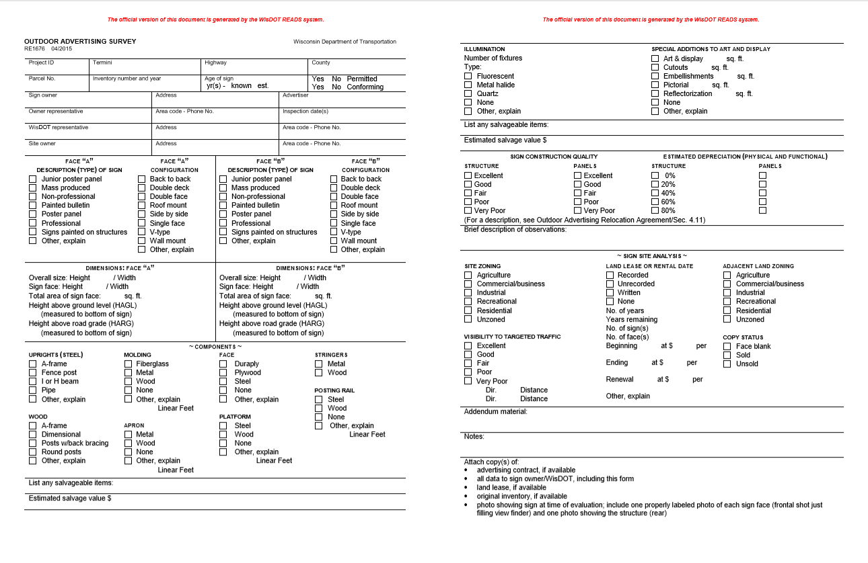
Figure 1: Outdoor Advertising Survey (RE1676)

PAYMENT SCHEDULE SUMMARY WORKSHEET
RE1677 04/2015 (READS template)

View full sized template from REPM/Forms page: https://wisconsindot.gov/dtsdManuals/re/repmforms/READS1677.pdf.
Actual document must be generated directly from READS.

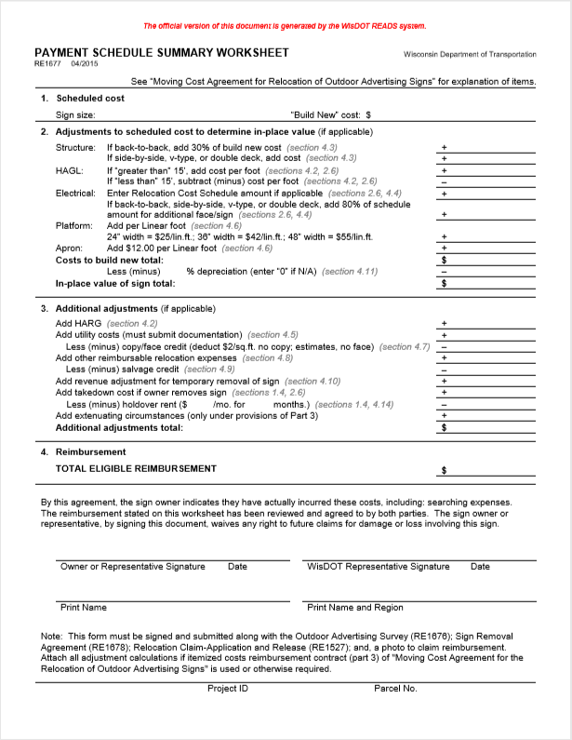
Figure 2: Payment Schedule Summary Worksheet (RE1677)

RELOCATION CLAIM - APPLICATION AND RELEASE
RE1527 08/2018 s. 32.19, 32.195 & 32.20 Wis. Stats.

View full sized template from REPM/Forms page: https://wisconsindot.gov/dtsdManuals/re/repmforms/READS1527.pdf.
Actual document must be generated directly from READS.

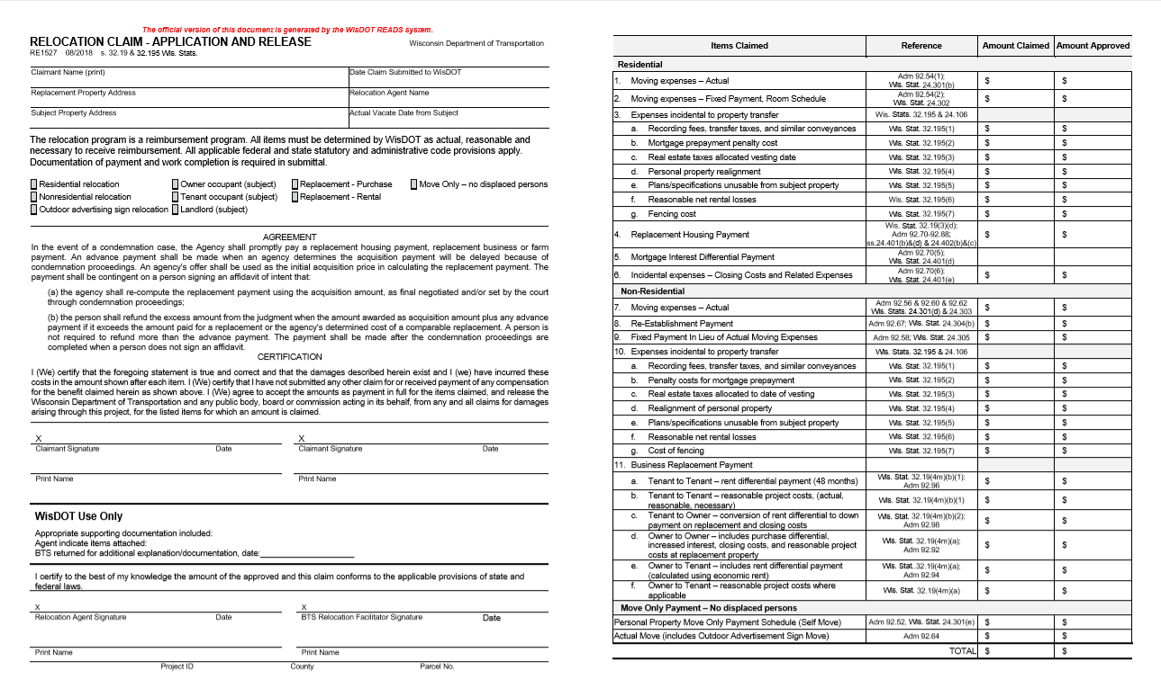
Figure 3: Relocation Claim – Application and Release (RE1527)

SIGN REMOVAL AGREEMENT
RE1678 04/2015

View full sized template from REPM/Forms page: https://wisconsindot.gov/dtsdManuals/re/repmforms/RE1678-sign-remov-agreement.docx.
Actual document must be generated directly from READS.

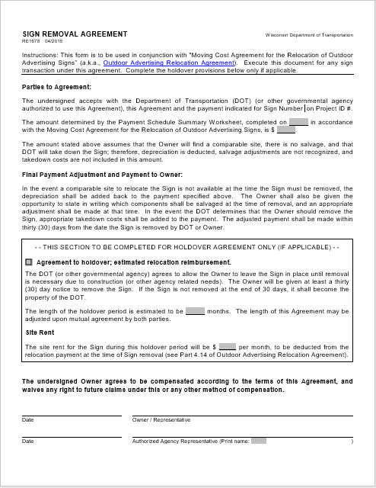
Figure 4: Sign Removal Agreement (RE1678)

SIGN SCHEDULE CLAIMS CHECKLIST

WisDOT Real Estate 01/2015 (unnumbered)

Attached is a recent photo(s) of the sign, date(s): .

Outdoor Adverting Survey (RE1676) - To be jointly filled out by WisDOT and Owner with copies provided for both parties. Be sure to complete in full to capture all necessary information on the sign.

Payment Schedule Summary Worksheet (RE1677) - Indicate appropriate cost on schedule with adjustments made as applicable.

Relocation Claim - Application and Release (RE1527).

Sign Removal Agreement (RE1678) - Holdover Agreement section to be completed if applicable.

Please attach the above data and supporting documentation, then forward to the WisDOT Regional Office/Central Office. If necessary, attach a memo to explain.

---------------------------------------------

