March 2015 Release of HSI
Primary Upgrades and Bug Fixes:

- Inspection Document PDF merge. This feature will merge attached PDF documents into a single inspection file when the inspection is completed. (Note: only PDF files can be merged with this feature. If you have Excel or Word documents that you want included the final inspection file, then you should upload that information as a PDF document.) Otherwise the non-PDF files will be mentioned in a table in the final report, but in order to access them you’ll need to navigate to the files Folder in HSI.

- Automated Actions based on Inspection Data Entry. On the edit tab, you will now see a section called “on complete actions”. This section alerts the inspector to actions that will occur when the inspection is completed. Typical actions include:
  - E-signature (explained later).
  - UW-Profile frequency and scheduling. Rules were added based on the latest UW-Profile policy
  - Routine Inspection frequency change. Rules were added based on the latest Load-Posted Bridge Inspection Policy.
  - Email triggers to BOS units (Rating, Inspection, etc.)
  - Etc.
- Electronic Signature (Coming soon). This version of HSI has the code developed to utilize electronic signatures for inspections. The actual use of this feature will be later this year, with documentation to still be developed by BOS Maintenance on implementation.

- Column Set. On the main page, you can find a new box that allows the user to change the columns shown on the screen (for non-report views). Default views are shown below, though others may be added in the future. Please contact BOS Development if you’re interested in user-specific column sets or would like for us to develop defaults for the whole community to use.
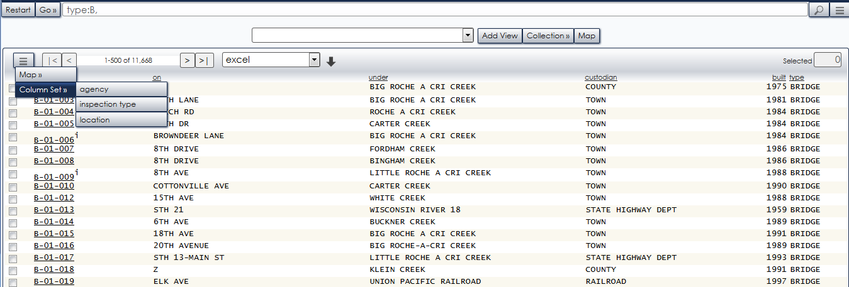

- Appraisal Tab. We’ve added condition specific data to the Appraisal Tab, so that the user can better see the condition of the structure that will be reported to FHWA via the NBI File.
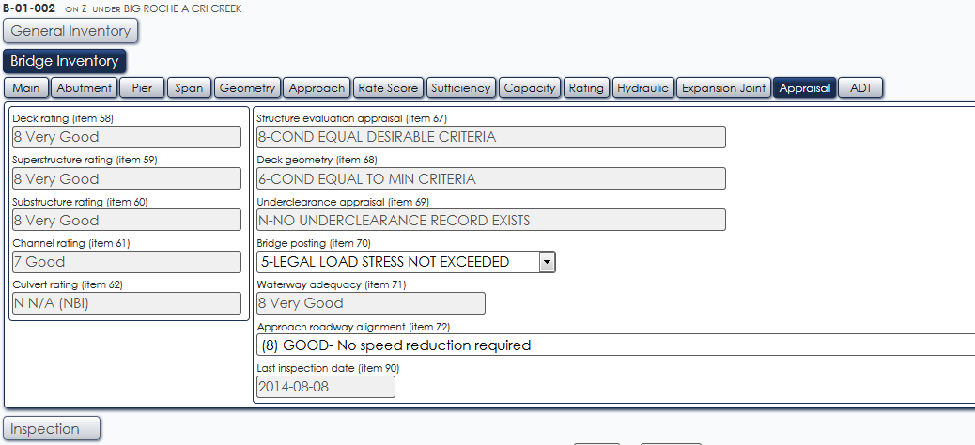

- Element Hide/Show Detail. We have added a button to either expand or collapse all elements, defects, and protective systems. It’s shown in the below screen print.
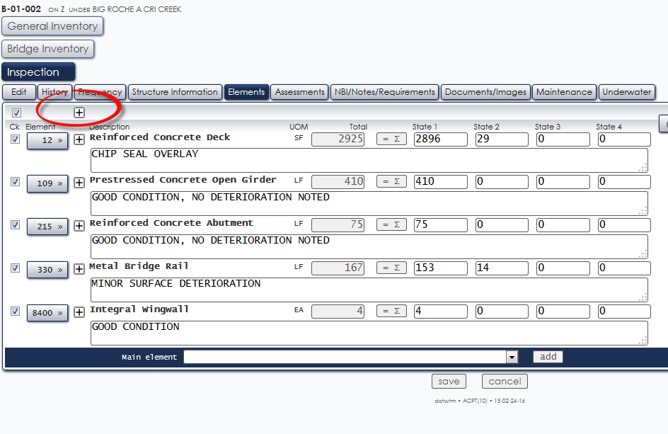

- Duplex Printing (ability to turn off). A few inspectors have requested a way to turn off duplex printing for PDF generation. If you want your generated PDF files to print w/o the blank pages to be added, click Go – Tools, then Preferences, then General. Note that this is not common and default will be set to Duplex.

- Underwater Visual Probe. The system was upgraded to automatically give the inspector the underwater probe tab if the structure is over water (and the inspection type is not Dive, in which case the dive inspection tab will appear instead). It is important to follow the policy concerning underwater probe activities and to properly document conditions when performing the probe activity. An example is shown below.
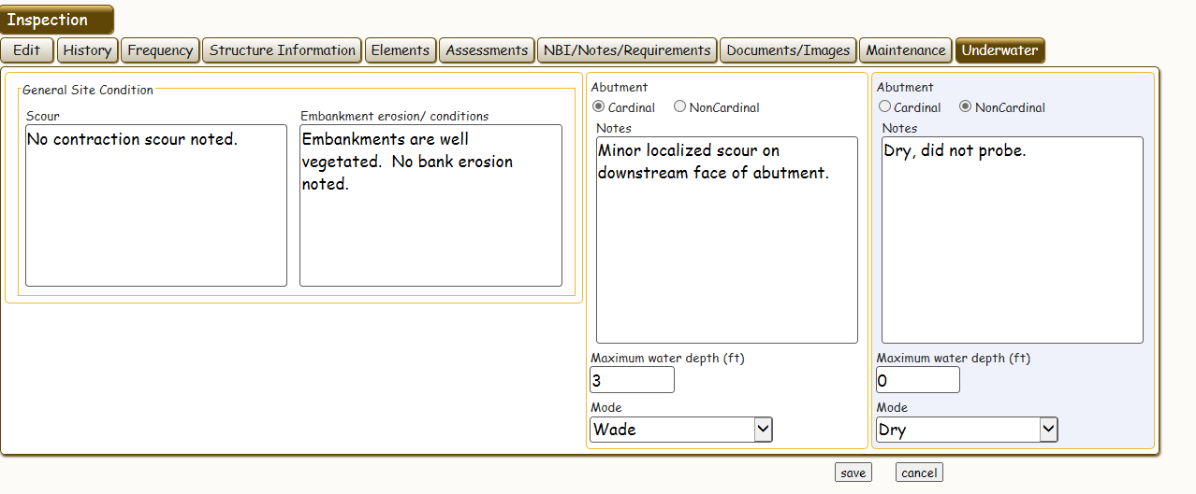
- Initial Inspections. When entering the initial inspection on a bridge, click Routine. HSI recognizes the first routine inspection as the initial inspection of the structure. If the structure is over water, also remember to check and perform a UW-Profile. And finally, remember to select SI&A on the initial inspection and make updates or changes as necessary.
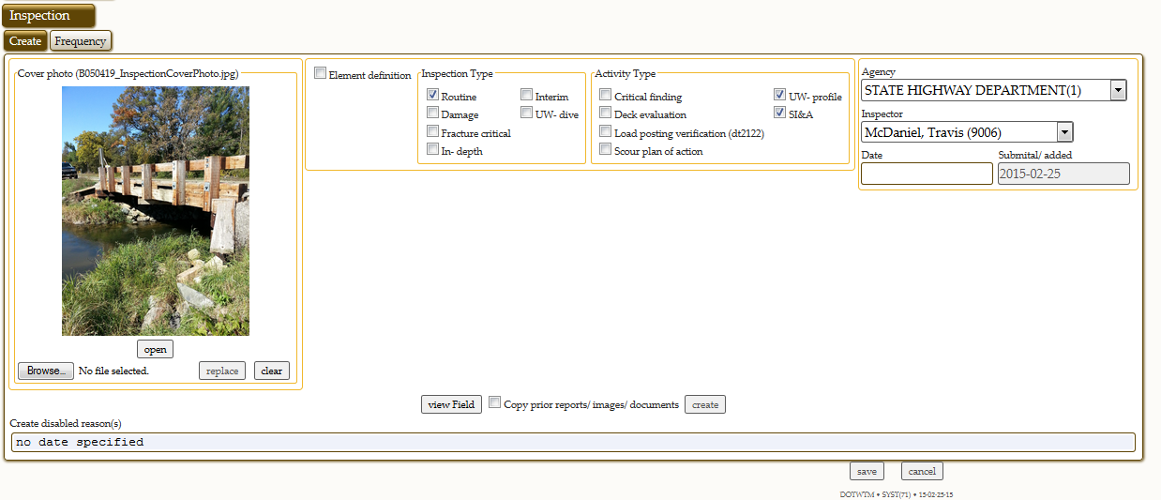

- New Activity Types. There are three new activities on the inspection tab that can now be uploaded, saved, and retrieved via the HSI system. They are deck evaluations (thermography, GPR scans, etc.), scour plans of action documentation, and critical findings (policy to be finalized and placed here: http://on.dot.wi.gov/dtid_bos/extranet/structures/inspection/index.htm)

- Various Error Fixes. Many errors have been found by the inspection community and addressed in this release. For detailed information, see the Release Notes in the Topics section of HSI (click Go – Help, then topics. Then click Release Notes).

