May 2016 Release of HSI
Primary Upgrades and Bug Fixes:
- Electronic Signature for Inspectors. This version of HSI enables electronic signatures for inspections. To sign an inspection, the user must have DT2085 on file with the WisDOT Bureau of Structures. To sign an inspection once it has been entered and all pertinent information has been added, and files upload, simply click the sign/complete button as shown below.
Please note that the auto-complete function no longer exists in HSI. Inspectors are now required to sign inspections electronically.
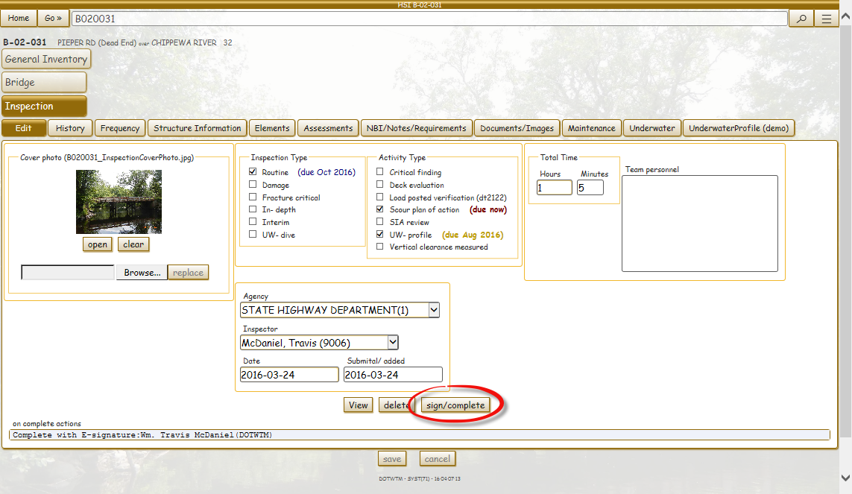

- Electronic Signature for Reviewers. Some owners chose to review inspections and sign them indicating the inspection has been reviewed. This functionality is also available. To sign as a reviewer, you have to meet three criteria:
  - You must have authorization to enter and electronically sign inspections (DT2085 form) for the structure(s) in question.
  - The inspection must be entered and signed by the inspector prior to review.
  - You cannot review an inspection where you were the team leader and thus also signed the inspection.
To sign as reviewer for a structure, click on the History tab and then select the inspection you would like to review. Then click “Sign as Reviewer” to sign as the reviewer. Once you’ve signed, the date of review will appear under the Reviewed column and a watermark stamp will be added to the inspection PDF.

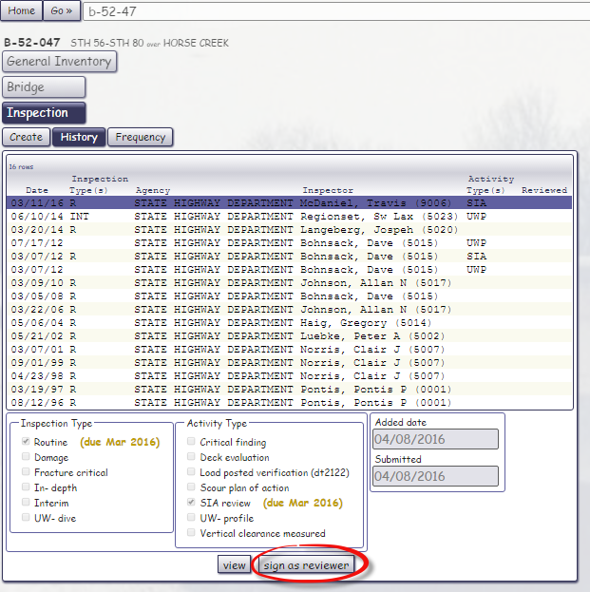

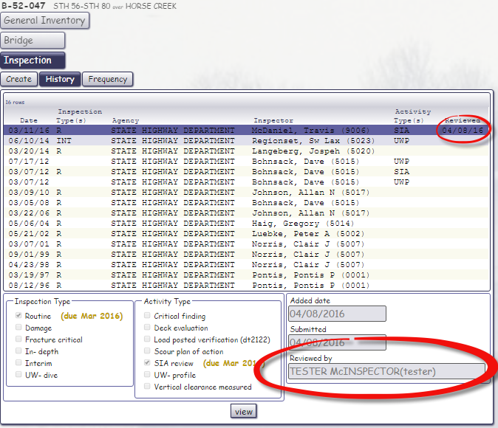

- Small Bridge (C-Structure) Inventory and Inspection Module Updates. The software has been updated to collect only information pertinent to these types of structures, including inspection entry.

- High Mast Lighting (L) Inventory and Inspection Module Updates. High mast lighting structure inventory has been entered for the 120 plus structures on the State System. Inspections are also enabled, allowing inspectors to enter using elements, defects, and assessments specific to this structure type. In addition, maintenance items specific to these structures are also included in this release.

- Retaining and Noise Wall (R/N) Inventory and Inspection Module Updates. Wall inventories have been updated to include relevant information for asset management of these structures. In addition, inspection capabilities have been enabled, allowing inspectors to enter using elements, defects, and assessments specific to walls. In addition, maintenance items specific to these structures are also included in this release.

- Upgraded Assist Feature. The basic and full assist have been consolidated down to simply “Assist”. When using this feature, click on the plus button to expand for more options.

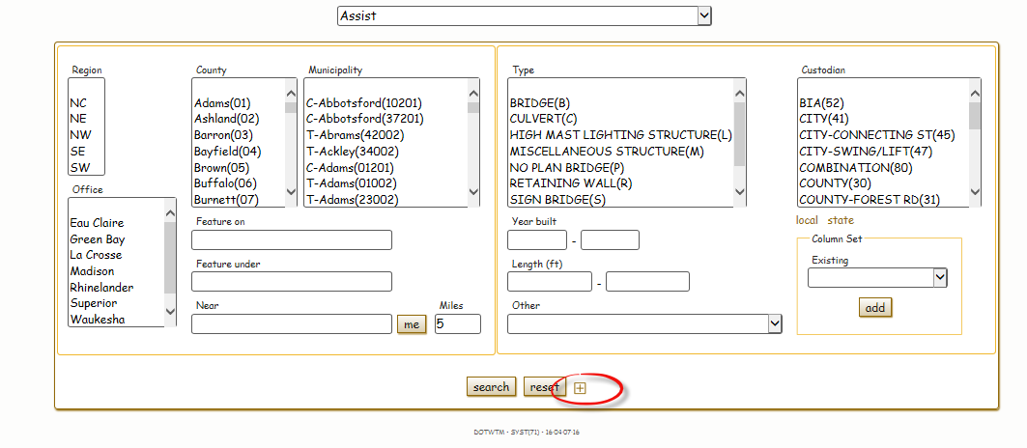

- Inspection Reminders. Labels have been added to the Create tab next to each inspection and activity to indicate when they are due. The label will show up if something is due within the inspection year. This is to serve as a reminder to inspectors about what boxes to check during inspection entry and what tasks to perform during the inspection.
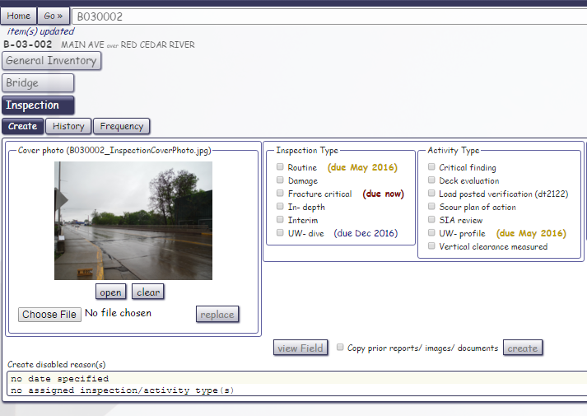

- Approach Roadway Alignment NBI Item 72 Added Back to Inspection. The ability for the inspector to update this NBI value is now available during the inspection entry. This item will appear under the NBI tab.

- Upgrade to Reinforcement for Concrete Decks/Slabs. Defining the reinforcement in our concrete decks and slabs is important for understanding the deterioration of those systems. To set the reinforcement type, click the element button and select SET REBAR. Then choose between epoxy, stainless, non-metallic, black or other.
Once selected, the label for the element will change to denote the selection.
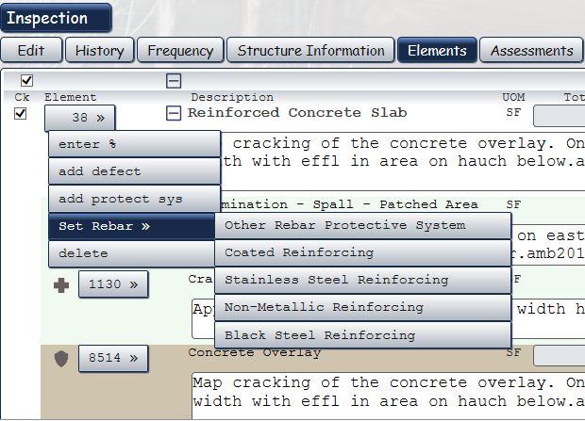
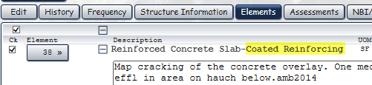

- Vertical Clearance Measured Activity. The new vertical clearance measured activity will allow inspectors to confirm and edit vertical clearances in HSI outside of completing an inspection. The vertical clearance measured activity should only be checked if a physical measurement was completed to confirm or record a new vertical clearance in HSI. It should be checked even if the clearance is measured, but no changes to file values are noted. It is highly encouraged to upload a diagram, image, or documentation showing where the vertical clearance was measured. Diagrams help everyone to know exactly where the measurement was taken for future measurement verifications.

- Reopen Inspections (Regional PM Level Only). Regional program managers now have the capability to re-open inspections after they have been previously closed. This can only be performed if the inspection being opened is the latest inspection, and has occurred in the current inspection year (inspection year is the period from is April 1st – March 31st). If an inspection needs to be opened in a previous inspection year, please contact BOS – Bridge Management for assistance.
To re-open the inspection, simply navigate to the History tab, highlight the inspection, and click the Reopen button.

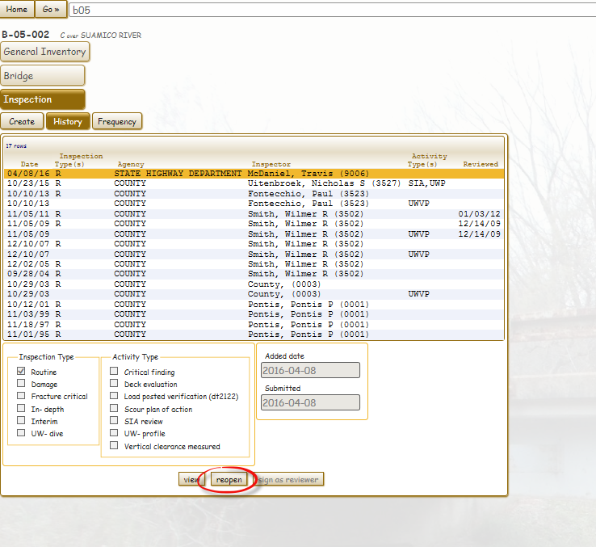

- Photo Upload Size Compression. Uploaded image files will have additional compression to limit the size saved in HSI, which in turn will reduce the size of the final PDF inspection report. Previous compression software reduced file sizes by about 5 times (i.e. a 3.5Mb file was reduced to 700Kb). New compression protocols will further reduce a 3.5Mb file to around 75Kb, without a significant loss in resolution.

- QA Review (Regional and Statewide PM’s only). Quality assurance reviews can now be recorded in the HSIS system, under the activity called QA Review. This must be accompanied by an interim inspection. This will allow documentation and tracking of structures that have had QA reviews.

- Mobile Improvements. In areas where connectivity may go in and out (for instance if you have connectivity on the roadway, but while walking through a box culvert you lose it, only to regain connectivity on the other side), code has been written to save that data until you regain connection.

- Various Error Fixes. Many errors have been found by the inspection community and addressed in this release. For detailed information, see the Release Notes in the Topics section of HSI (click Go – Help, then topics. Then click Release Notes).

