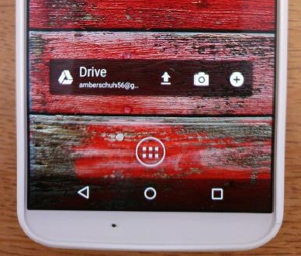

Sample of Set up on Phone:

Set up on your phone.

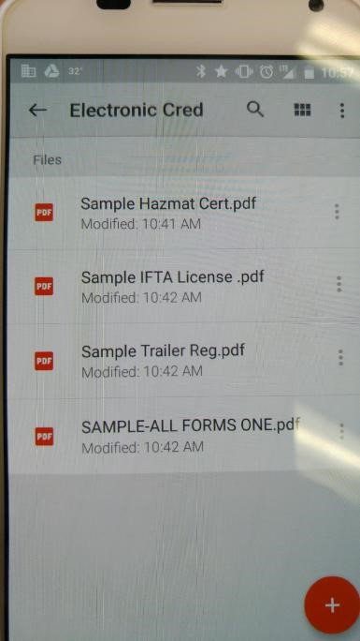

You can have all your PDF sent and downloaded as individual files or all credentials in one file.

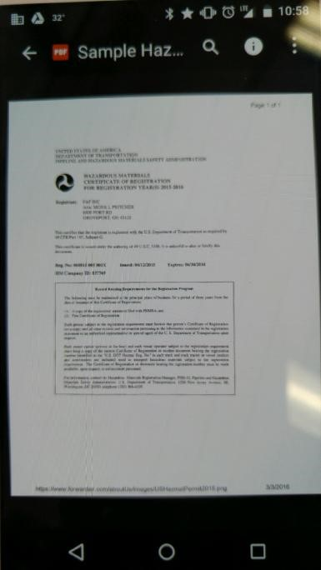

Once document is selected. The image of credential will appear.