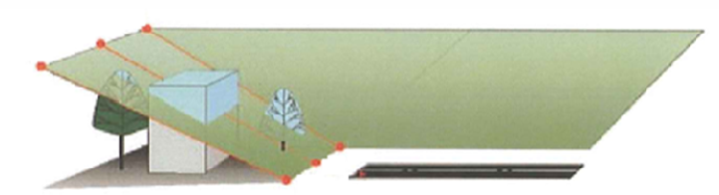



An easement is the right a property owner grants to another for a specific use of their property. Airports acquire easements to protect the airspace used by aircrafts during take-off and landing. Easements help ensure that objects such as trees or buildings do not penetrate this airspace, creating a flight safety hazard.
Avigation
Easements
Wisconsin Bureau of Aeronautics
P.O. Box 7914
Madison, WI 53707-7914
www.wisconsindot.gov
(608) 266-33092
Easements are a legal agreement between a Grantor (the owner of the property over which the easement right is purchased) and a Grantee (the holder of the easement rights, usually the airport owner).

Avigation Easements
Avigation Easements
An avigation easement is a property right acquired from a landowner for the use of airspace above a specified height. Avigation easements grant the right-of-flight including the right to noise and dust inherent in aircraft flight; the right to restrict or prohibit lights, electromagnetic signals and bird-attractants; the right to unobstructed airspace and the right of entry upon the land to exercise those rights.

Clear Zone & Avigation Easements
A clear zone & avigation easement is a property right acquired from a landowner that grants the above rights as well as the right to prohibit objects or improvements other than low-growth vegetation upon the property. Normal farming activities such as crops, and grazing are usually permitted.
Estimating the Value of Easements
Any property right acquired under Wisconsin State Statute Chapter 32; Eminent Domain must be appraised to establish its value. The compensation paid to the landowner for these rights is based on the fair market value of the property “before” the easement rights are considered compared to the fair market value of the property “after/as if” the easement rights are applied. The difference between the “before” and “after” value of the property is the value of the easement.

Is the landowner responsible for topping or clearing trees that are
obstructions to the easement airspace?  Who initiates the effort to clear obstructions or top or clear trees?  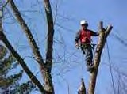  How should obstruction clearing be done?  As landowner, do I have a say in | No, the airport must top or clear such trees at its own cost.  The airport owner is responsible for identifying and arranging for the removal of obstructions.  The airport should regularly check for obstructions and contact the landowner to arrange for a convenient time to conduct on-site surveys to verify the existence of obstructions. The airport will also arrange for the least burdensome obstruction removal and assess and pay the landowner for any damage caused by such removal.  It depends on the easement. You and the airport owner should discuss how often the trees should be topped, the nuisance aspect for the landowner and the airport to repeatedly arrange for topping, the effect on the property for the landowner, and any other considerations.  These agreements vary based on the specific easement language. In general, the airport is responsible for removing trees and objects (buildings, antennas, etc.) existing when the easement was acquired, and the landowner is responsible for new trees or objects higher than the allowed heights after the easement is acquired. This practice may vary depending on the particular arrangement between the airport and the landowner.  Easements may permit use or occupation of the land for certain purposes such as crops and related agricultural activities. Other land uses may be prohibited, such as land uses attracting birds or other  wildlife which could pose a hazard to aircrafts. These  permissions and restrictions are stated in the easement.
whether my trees are topped or
cut down?
Who pays the cost of removing
easement obstructions?
How does an easement affect
the use of my land?


Wisconsin Bureau of Aeronautics - Avigation Easements –February 2026

