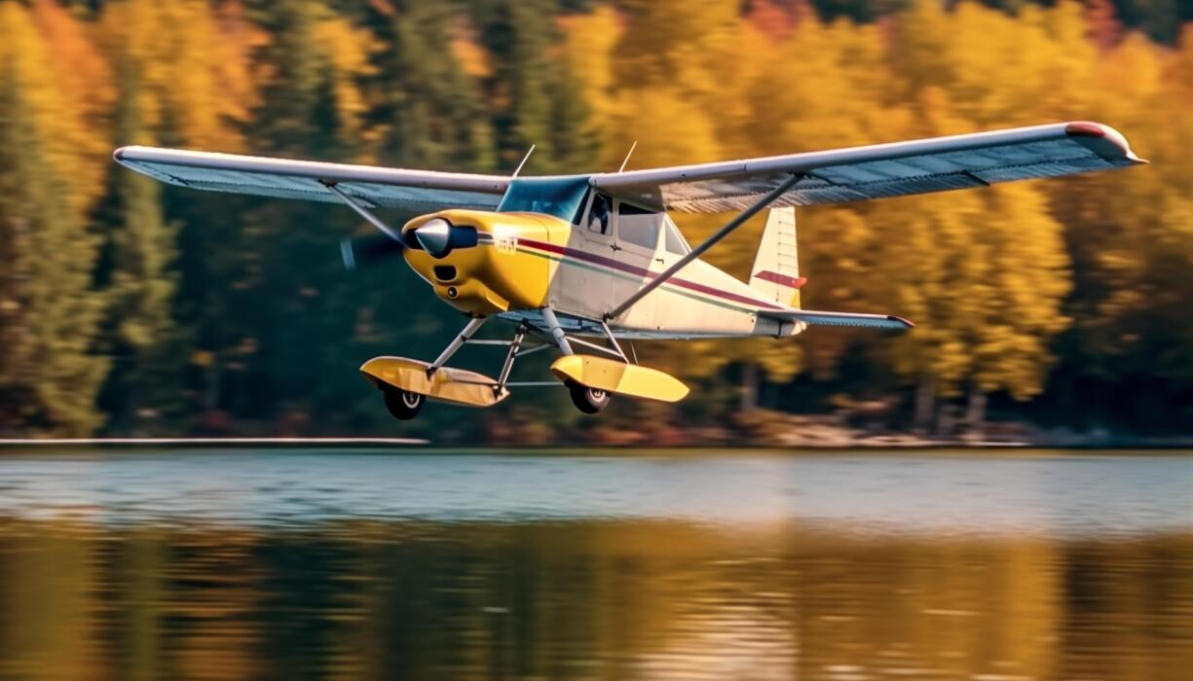  Fly Wisconsin  Sponsored by WisDOT/Bureau of Aeronautics  Youth Aviation Art Contest!  Flying in Wisconsin is different than other states. With our diverse geographic landscapes and our various seasons, flying and aviation is unique in our state. WisDOT’s Bureau of Aeronautics wants to know what flight and aviation in Wisconsin means to you. Calling all artists between the ages of 6-17 years old to submit your artwork that shows us what you love most about flying in Wisconsin. Is it the scenery, our beautiful lakes, winter flying, or something else? We know why we love flying in Wisconsin, what do you love about it?  
  Details!
  Contest dates:
  10/1/26 - 01/31/2027
  Entries must be post marked no later than Jan 31, 2027.
  Ages: 6-17 years old.
  More Info:
  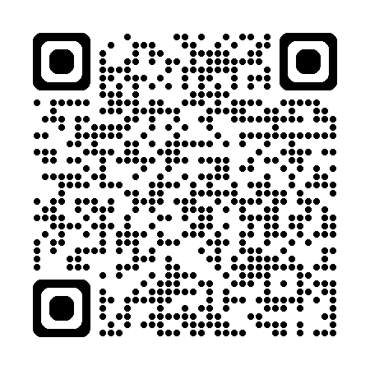
  Entries should be mailed to:
  WisDOT/BOA
  c/o Olivia Conklin (6th floor)
  4822 Madison Yards Way,
  Madison, WI 53705

Rules
The top three entries in each age group will be awarded prizes and receive one of the following:
Age Groups are:
Junior: Ages 6-9 years old
Intermediate: Ages 10-13 years old
Senior: Ages 14-17
*Age at time of contest closing
Prizes
(awarded to each age group)
​ 1st Place: Discovery flight! Or $100 gift card for aviation or art supplies
2nd Place: $75 gift card for aviation or art supplies
3rd Place: $50 gift card for aviation or art supplies​

Art Specs
Paper Size:
Entries should be 11.75 X 16.5 in. or the nearest possible equivalent. Artwork cannot be framed.
Permitted Mediums include:
Watercolor, colored pencils, acrylic, oil pain, indelible marker, pens, felt-tip or soft ball-point pens, indelible ink, crayons.
Prohibited Mediums:
Pencil, charcoal or other non-permanent medium, computer-generated or AI artwork, collage work involving the use of photos.

Contact information and Entry Submission:
Olivia Conklin, Aviation Education Program Manager
4822 Madison Yards Way, 6th Floor South (S631.05)
Madison, WI 53705
608-266-0775
Olivia.conklin1@dot.wi.gov

Certificate of Authenticity
This form is required and must be attached to the back of the artwork in order to qualify.

ARTIST NAME: _______________________________________________________________
ARTIST BIRTH NAME: _______________________________________________________________
ARTIST AGE: _______________________________________________________________
TEACHER, PARENT OR GUARDIAN PHONE NUMBER: _______________________________________
TEACHER, PARENT, OR GUARDIAN EMAIL ADDRESS: _______________________________________

“I certify the entrant named on this form is a resident of Wisconsin and this is their original and unassisted work. I understand that once received, entries become (and remain) the property of WisDOT and may be used for a variety of purposes.”

TEACHER, PARENT, OR GUARDIAN SIGNATURE: ___________________________________________

