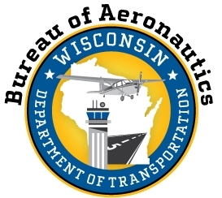

PUBLIC NOTICE ANNOUNCEMENT

WI DEPARTMENT OF TRANSPORTATION (WISDOT) – AVIATION SECTION
PUBLIC NOTICE OF FFY 2017-19
DISADVANTAGED BUSINESS ENTERPRISE (DBE GOAL)

The Wisconsin Department of Transportation (WisDOT), in accordance with regulations of the U.S. Department of Transportation, 49 CFR Part 26, hereby announces its three (3) year aviation FFY 2017-2019 goal of 6.04% for Disadvantaged Business Enterprise (DBE) airport construction projects. The goal is for DBE participation on contracts assisted by the Federal Aviation Administration (FAA).

The proposed goals and rationale is available for public inspection at its Hill Farms State Office Bldg., Bureau of Aeronautics between the hours of 8:00 a.m. and 4:30 p.m. Monday through Friday for 30 days following the publication of this notice. Written comments pertaining to this goal should be sent to the attention of:

Shannon Clary
WisDOT – Aeronautics Equal Rights Officer
4802 Sheboygan Ave, Rm 701
Madison, WI 53707-7914
Tel: (608) 264-7607 / Fax: (608) 267-6748
Shannon.Clary@dot.wi.gov

WisDOT is an Equal Opportunity Employer

