**AWP CRL List of Projects**

On the Payroll Dashboard go to Vendor Payrolls and click on Show first 10

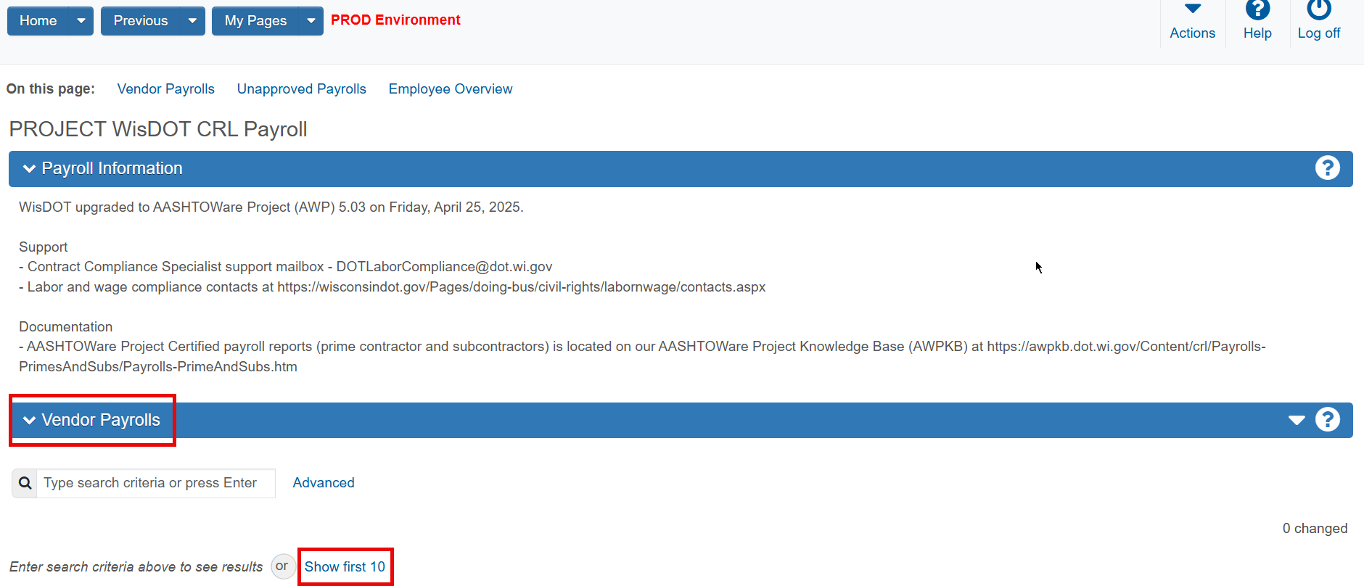

A list of all the projects your company is listed as a subcontractor on will show up. Up to 50 projects will be listed. If you have more than 50, click on Load next 50 at the bottom.

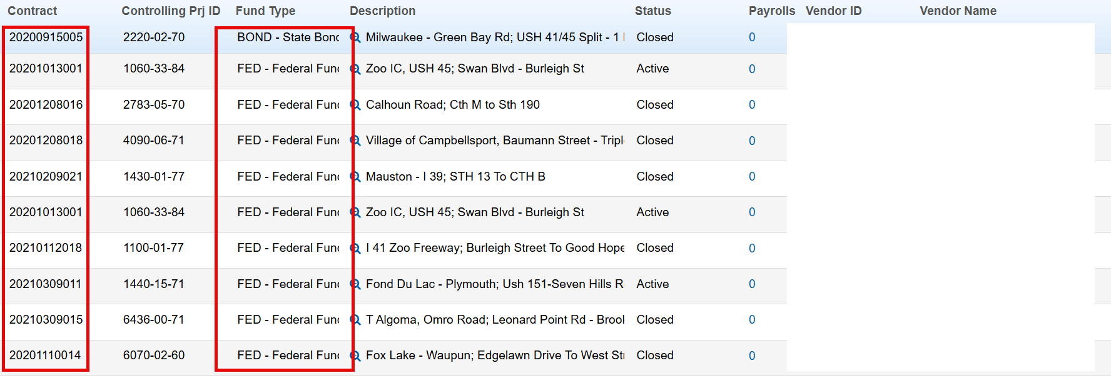

Only report for contracts that start with 2025. Only report for contracts with Fund Type is FED.

To see only those projects, apply a filter. Click on down arrow to the right of System Default.

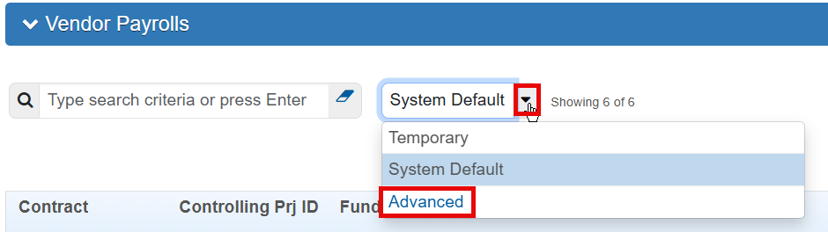

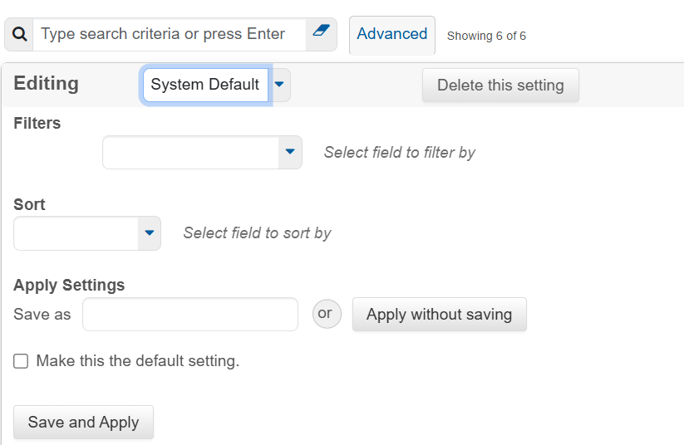

Under Filters click on the down arrow to the right of the field. Click on Contract ID

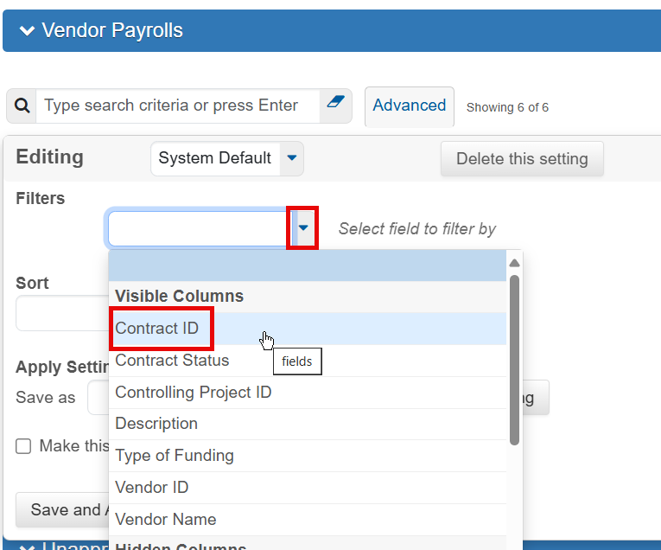

Click on the down arrow to the right. Click on Begins with.

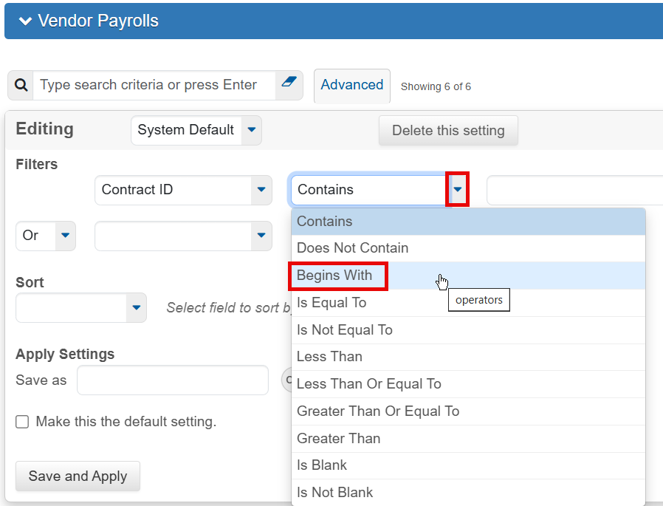

Enter 2025.

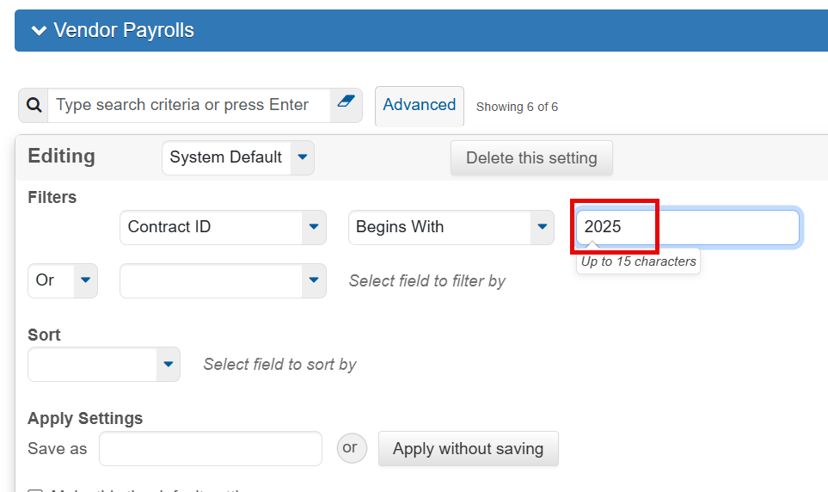

On next line go to the down arrow to the right of Or. Click on And.

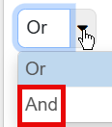

Then select Type of Funding, Contains, and FED. This will show just projects with Federal funding.

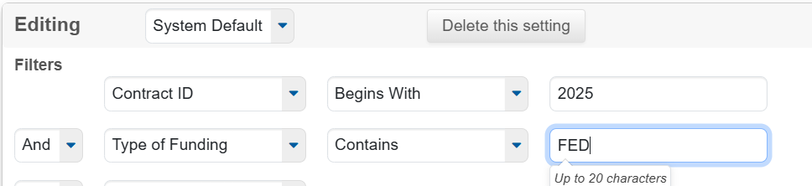

Do another And, Contract Status, Contains, Active. Click on Apply with saving.

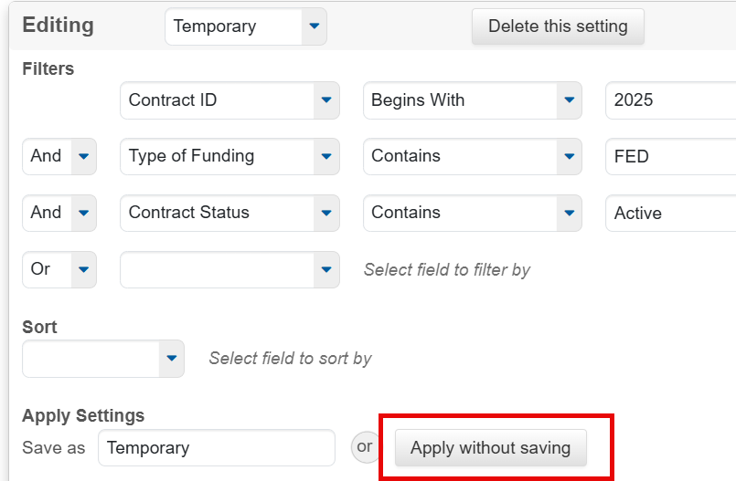

The results will be the projects that could require an FHWA-1391.