CRCS CPR History Report

Below are directions for a report from CRCS that can be run at the end of July or throughout July to show which projects your company worked on/submitted payroll, which projects are state funded, and which projects were active but you did not do any work on (submitted a Non-Performance).

**In CRCS on the main page click on Report.**

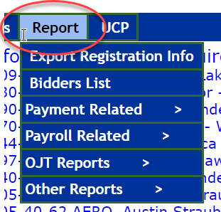

**Click on Payroll Related, then click on CPR History Report.**

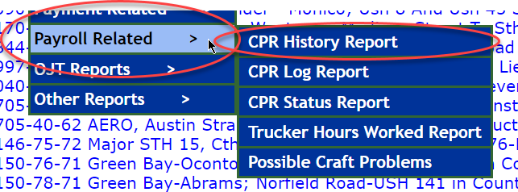

**This screen will come up. Fill in the time period – for example 7/1/2025 to 7/31/2025 will generate data for July.**

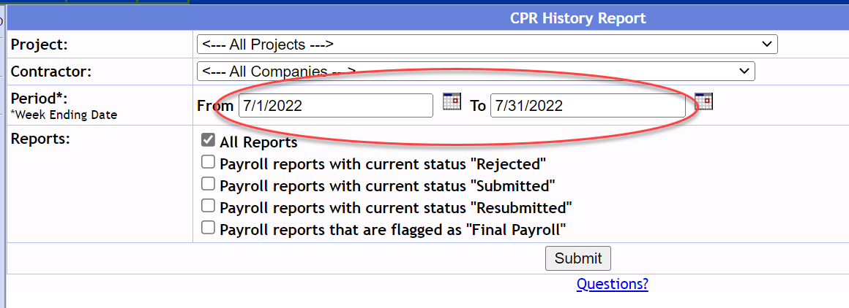

**This is the report. Notice that some of the project names start with SF – this means State Funded – do not include SF projects on the FHWA-1391.**

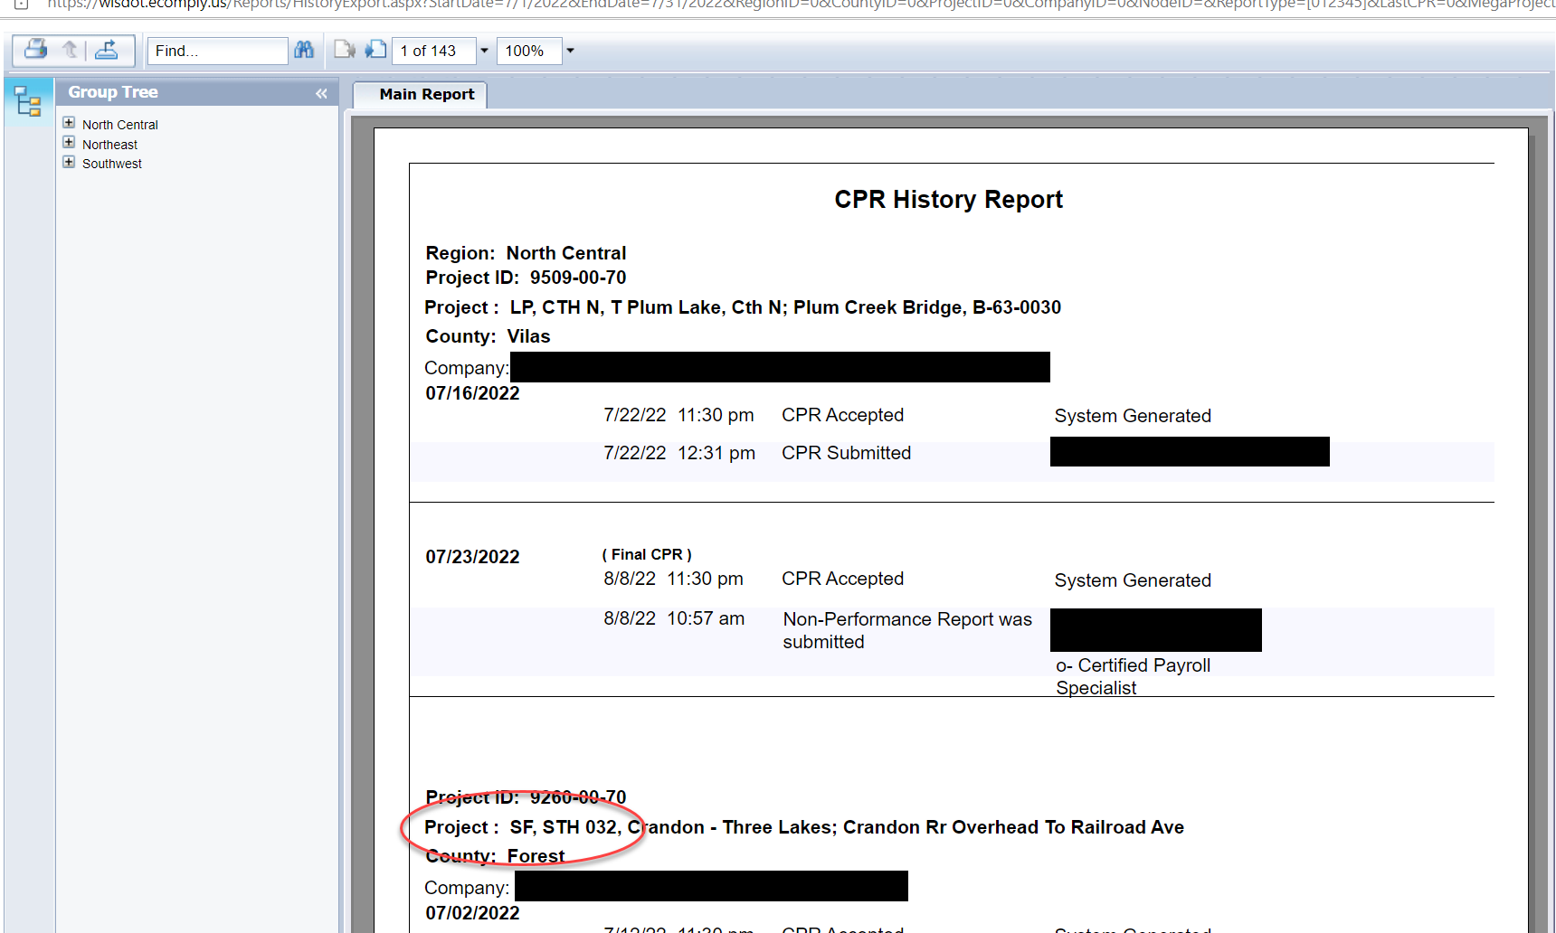

**To download the report, in the upper left-hand corner click on this.**

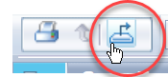

**The window shown below will open. File Format - click on the arrow to the right and select Character Separated Values (CSV). Click on Export. This will open in Excel.**

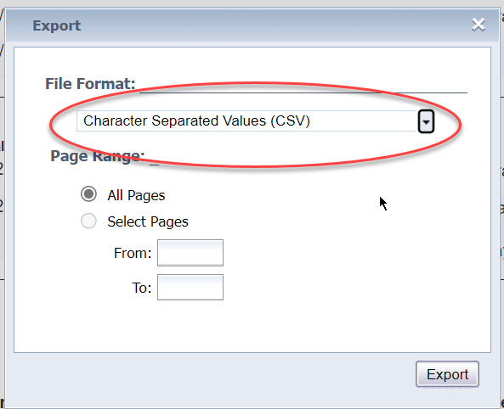

End.