TRAFFIC CONTROL TECHNICAL COMMITTEE (TC²) MEETING AGENDA

9:30 AM – 11:00 AM

May 21, 2025
TEAMS
- Introductions

- New Topics
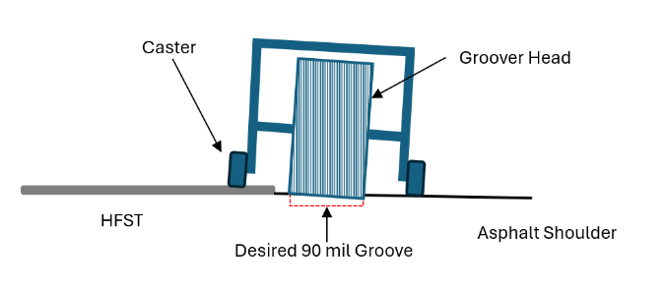
  - Pavement Marking
    - Design Guidance
      - Tape Removal
      - Waterblasting
    - Grooved Markings on HFST
- Work Zones
  - APL Updates
  - Status of Wanco Connected Arrow Boards
  - SDD 15C19
      - Updating to state nobody can be working off of a TMA vehicle.
- Other

- Next Meeting
  - Wednesday, August 27th, 9:30 AM – 11:30 AM

