TRAFFIC CONTROL TECHNICAL COMMITTEE (TC²) MEETING AGENDA

9:30 AM – 11:00 AM

May 27, 2026
TEAMS
- Introductions

- New Topics
  - Pavement Marking
    - Moving Operations Sub Task Force
      - Alert System
        - Jason (Century Traffic) did not think they had sounded the horn yet, but that they used the lights. They are tracking everything for us and are using the push activated alert system.
      - Mitigation
        - Current placement is in front of the trail vehicle.
        - Mike (Forward) stated that the state patrol officer as the trail vehicle was the only way people were getting over. However state patrol does not want to be the TMA.
        - Having the state patrol officer in front of the trail vehicle did not do any good. People were not moving over until they were already on top of the work zone. So they are canceling the pilot. 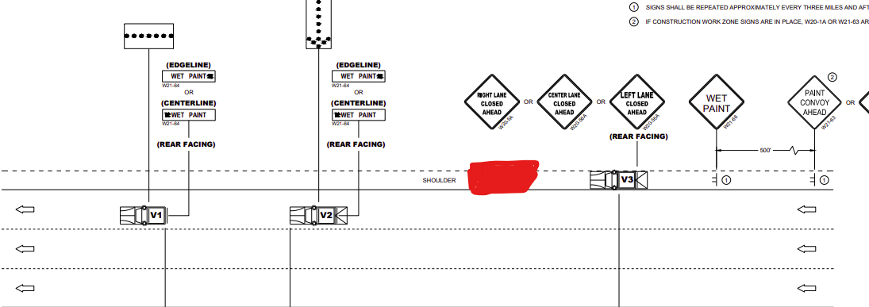
        - Potentially adding this to the NW LET as well. BTO will follow up with NW.
      - Discussion on Special Marking (June 17th)
        - Added discussion topic for Moving V3 back farther in the convoy.
    - November ASP 6
      - Glass beads allowed in Black Epoxy
      - Several other states use glass in their black epoxy. They do not have any issues and it is also easier for construction.
      - Brian Dupont asked if this is adding extra cost to the black epoxy?
        - Jeannie stated that Minnesota did not see any price changes while using glass beads over black aggregate.
        - Nick and Mike (Forward) both stated that we will not see a cost difference due to the cost being similar and ease of construction will allow them to be more efficient.
    - Permanent Tape Update
      - Plans for 2027
        - Tape will be removed from asphalt starting with the November 2026 letting.
        - 3M has conditional approval of the new formula for 2027.
      - Late Season 2026 Tape
        - 3M deadline to sell PFAS Tape in September. They have a new formula in production, but it does not have the NTPEP data required.
        - Tape maybe changed out on current projects. Work with PM to determine if you project will remain in tape or changed out to wet reflective epoxy.
      - TEOpS Policy for Tape
        - https://wisconsindot.gov/dtsdManuals/traffic-ops/manuals-and-standards/teops/03-10.pdf
        - 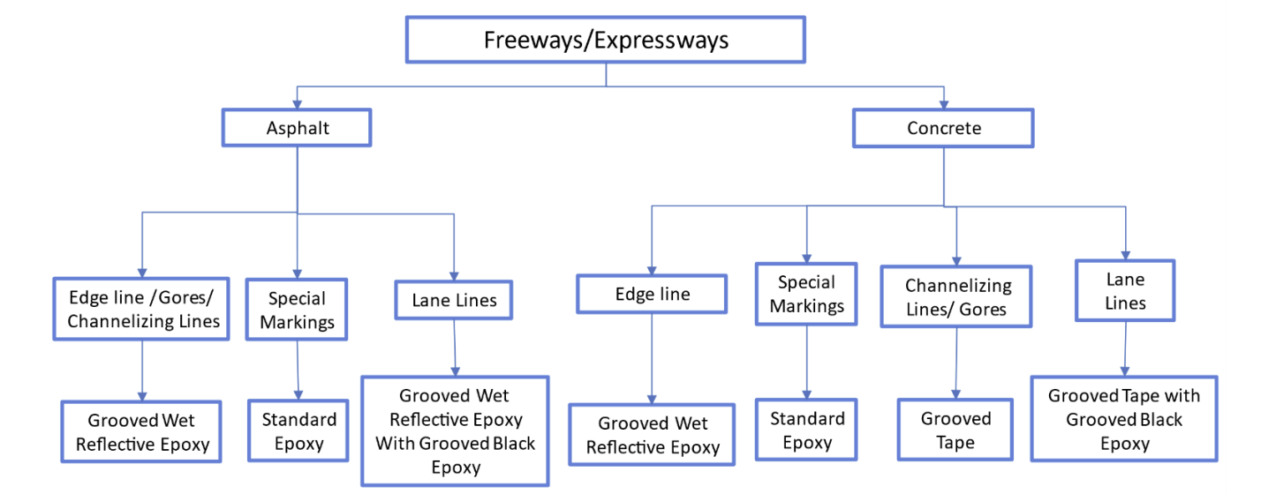
  - Work Zones
    - TMA Crashes Tracking
  - Other
    - Adam (Century) Is grooving bridge decks the new standard?
      - Do not groove into polymer overlay bridge decks.
      - Any deck that is not a polymer overly can be grooved into unless the plan specifically states not to.
    - Brian Dupont added a comment about traffic control contractors getting charged a lane rental fee when there are overlapping closures with different contractors, different work taking place and one taking longer than the other. Brian will reach out to Andy Heidtke about the issue.
    - Matt is retiring July 10th. He expressed his gratitude working with all the contractors.
  - Next Meeting
      - Date/time change due to conference room availability. Monday, August 17th, 2026 from 11-12:30
        - Hybrid

