Instructions for Completing a Wetland Impact Tracking Form
Wetland Impact Tracking Forms (WITFs) must be completed to track wetland impacts that require compensation. Such impacts may be permanent or temporary.

Instructions for Preparers
- Use the most recent version of the WITF by downloading it from the WisDOT website every time. Do NOT use a WITF from another project as a template, as this form will be revised as needed.
- Yellow highlighted portions are completed by the project team (project manager, design consultant, etc.)
- The WITF should not be completed until wetland impacts have been finalized.
  - Multiple versions of the WITF cause unnecessary work and potential confusion for WisDOT and agency staff.
- Impacts are entered on page 2 of the WITF.
  - Ensure that impacts are recorded using the wetland types outlined in the Wisconsin Mitigation Guidelines V2 (2025), not legacy WisDOT types. The V2 types, along with WisDOT’s preferred abbreviations, can be found in the Wetland Types, BSAs & Ratios tab of the WITF.
    - Degraded wetlands are determined by the delineator at the time of the delineation/determination. If degraded wetlands are to be impacted, this should be signified with by “(D)” after the wetland type.
  - A wetland area (ID) may be made up of multiple wetland types. Separate the impact area by type and report in separate rows.
    - If the delineation has combined communities for a wetland, impacts should be broken out proportionally into types. For example, a 0.1-acre impact with 60% SS cover and 40% WM cover would be listed as two impacts: 0.06 SS and 0.04 WM, NOT combined as 0.1 SS/WM.
    - Degraded impacts should be treated as their own wetland type and should not be reported in the same line as non-degraded types.
  - Individual wetland impacts should be reported to the nearest 0.001-acre.
- Send the completed WITF to the appropriate regional environmental coordinator (REC) for approval.

Instructions for Approvers
- Green highlighted portions are filled out by a WITF approver. For some regions, this is a single REC, for other regions, multiple RECs are approvers.
  - Any new WITF approver must speak to the CO Water Resource Specialist prior to beginning to approve WITFs to receive the most up to date training on WITFs and ledgers.
- Ensure that the latest version of the form is used.
- Check that the qualifications for the wetland delineator are entered.
- Rounding
  - The Wetland Impact/Replacement Summary table on page 1 automatically sums the impacts and mitigation by type and rounds to the nearest 0.01-acre. There should be no need to hard code this table to change the rounding.
  - Impacts/mitigation cannot be rounded down to 0. Any impacts or mitigation less than 0.01-acre after summing by type will be rounded to 0.01-acre in the summary table.
- Ensure there are credits for the bank in RIBITS. To do this, click Search for Banks & Sites, then type the name of the bank or “WisDOT” in the search bar. On the individual bank’s page, click Ledger. 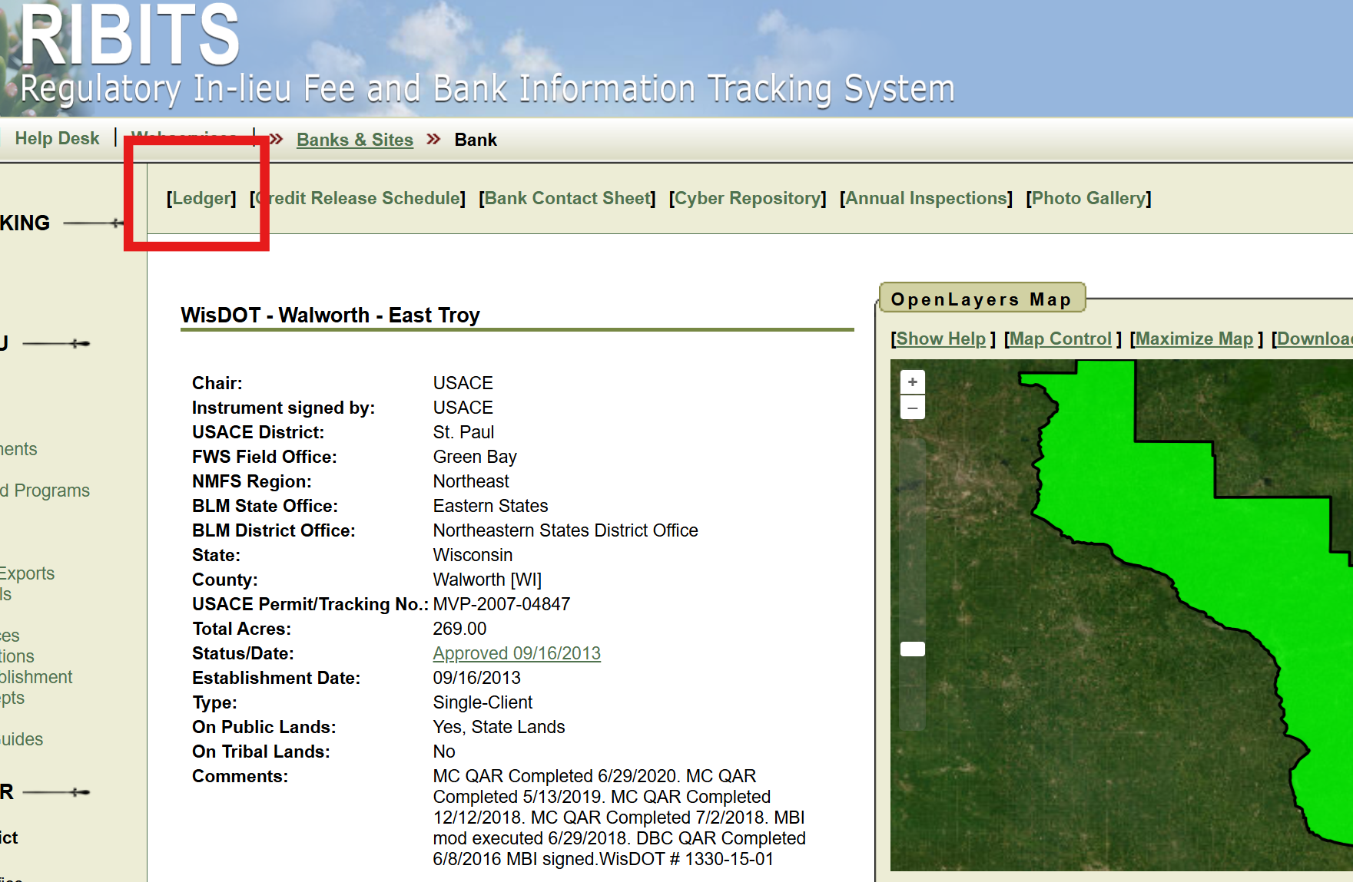
  - Review the table to ensure there are credits available to cover the mitigation. 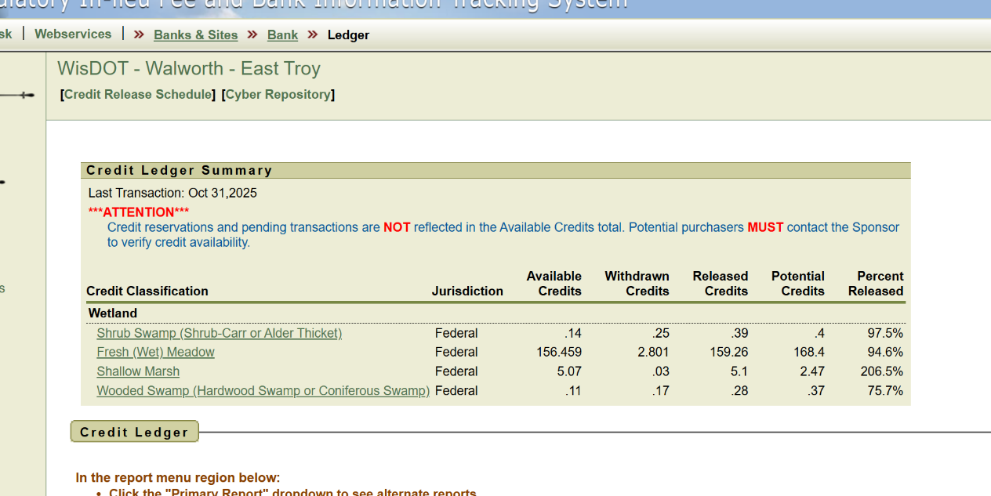
  - Check the box on tab 1 of the WITF certifying that you have checked that there are credits available in RIBITS

- Tab 3 - Wetland Types, BSAs & Ratios
  - Determining which bank to pull credits from:
    - Use the link for the Cooperative Agreement attachment to see the preferred hierarchy for WisDOT credit usage (#5).
    - Determine in which BSA the impacts occur, then check the ledger to see which banks can be used to compensate for that BSA.
    - If a bank held by a different region is used (for example, impacts in Price County debited to a NWR bank in the Chippewa BSA), the WITF should be sent to the appropriate contact in that region for approval. WITFs should not be approved by a REC in a different region from the bank.
  - Ensure the correct wetland types are used.
    - If the delineation was completed using the legacy WisDOT types, use the crosswalk table on this tab to convert to the V2 types.
    - If impacts to degraded wetlands are indicated, note that the degraded modifier was proposed by the field delineator within the Professional Discretion box on page 1.
  - Use the link for the Cooperative Agreement Compensatory Mitigation Attachment Appendix A to see the debit ratios to be applied to impacts for compensation. These ratios should be entered on page 2 of the WITF.
    - If professional discretion was used to determine the compensation ratio per the section below the ratio table in Appendix A, explain this in the Professional Discretion box on page 1.
- Recommended file name for approved WITF
  - Construction ID and approval date should be included in the file name.
  - It is recommended that only one WITF per project have “Approved” in the file name.
    - If an approved WITF needs to be modified, rename the original to include “old” and remove “approved.”
  - For example: 1937-00-71_WITF_Approved_7-26-2026
- Enter the transactions into the ledger at the same time as approval.
- Send the final approved WITF to the appropriate contact following the Section 404 Permitting flowchart. ALL final, approved WITFs must be submitted, including those for No-PCN projects.

