1. **Appendix A, Core Pilot Project.**

**Test Methods & Sampling for HMA PWL QMP Projects.**

The following procedures are included with the HMA Pavement Percent Within Limits (PWL) Quality Management Program (QMP) special provision:

* WisDOT Procedure for Nuclear Gauge/Core Correlation – Test Strip
* WisDOT Test Method for HMA PWL QMP Density Measurements for Main Production
* Sampling for WisDOT HMA PWL QMP
* Calculation of PWL Mainline Tonnage Example

**WisDOT Procedure for Nuclear Gauge/Core Correlation – Test Strip**

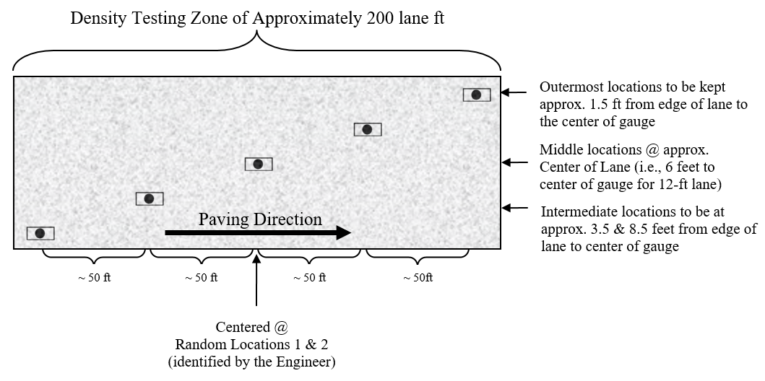

**Figure 1: Nuclear/Core Correlation Location Layout**

The engineer will identify two zones in which gauge/core correlation is to be performed. These two zones will be randomly selected within each *half* of the test strip length. (Note: Density zones shall not overlap and must have a minimum of 100 feet between the two zones; therefore, random numbers may be shifted (evenly) in order to meet these criteria.) Each zone shall consist of five locations across the mat as identified in Figure 1. The following shall be determined at each of the five locations within both zones:

- two one-minute nuclear density gauge readings for QC team*

- two one-minute nuclear density gauge readings for QV team*

- pavement core sample

*If the two readings exceed 1.0 pcf of one another, a third reading is conducted in the same orientation as the first reading. In this event, all three readings are averaged, the individual test reading of the three which falls farthest from the average value is discarded, and the average of the remaining two values is used to represent the location for the gauge.

The zones are supposed to be undisclosed to the contractor/roller operators. The engineer will not lay out density/core test sites until rolling is completed and the cold/finish roller is beyond the entirety of the zone. Sites are staggered across the 12-foot travel lane, and do not include shoulders. The outermost locations should be 1.5-feet from the center of the gauge to the edge of lane. [NOTE: This staggered layout is only applicable to the test strip. All mainline density locations after test strip should have a longitudinal- as well as transverse-random number to determine location as detailed in the *WisDOT Test Method for HMA PWL QMP Density Measurements for Main Production* section of this document.]



Individual locations are represented by the symbol as seen in Figure 1 above. The symbol is two-part, comprised of the nuclear test locations and the location for coring the pavement, as distinguished here:

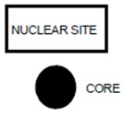

The nuclear site is the same for QC and QV readings for the test strip, i.e., the QC and QV teams are to take nuclear density gauge readings in the same footprint. Each of the QC and QV teams are to take a minimum of two one-minute readings per nuclear site, with the gauge rotated 180 degrees between readings, as seen here:

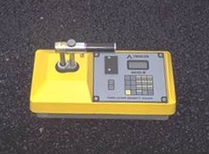 

1. (b)

**Figure 2: Nuclear gauge orientation for (a) 1st one-minute reading and (b) 2nd one-minute reading**

Photos should be taken of each of the 10 core/gauge locations of the test strip. This should include gauge readings (pcf) and a labelled core within the gauge footprint. If a third reading is needed, all three readings should be recorded and documented. Only raw readings in pcf should be written on the pavement during the test strip, with a corresponding gauge ID/SN (generalized as QC-1 through QV-2 in the following Figure) in the following format:

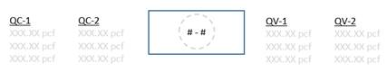

**Figure 3: Layout of raw gauge readings as recorded on pavement**

Each core will then be taken from the center of the gauge footprint and will be used to correlate each gauge with laboratory-measured bulk specific gravities of the pavement cores. One core in good condition must be obtained from each of the 10 locations. If a core is damaged at the time of extracting from the pavement, a replacement core should be taken immediately adjacent to the damaged core, i.e., from the same footprint. If a core is damaged during transport, it should be recorded as damaged and excluded from the correlation. Coring after traffic is on the pavement should be avoided. The contractor is responsible for coring of the pavement. Coring and filling of core holes must be approved by the engineer. The QV team is responsible for the labeling and safe transport of the cores from the field to the QC laboratory. Core density testing will be conducted by the contractor and witnessed by department personnel. The contractor is responsible for drying the cores following testing. The department will take possession of cores following initial testing and is responsible for any verification testing.

Each core 100 or 150 mm (4 or 6 inches) in diameter will be taken at locations as identified in Figure 1. Each random core will be full thickness of the layer being placed. The contractor is responsible for thoroughly drying cores obtained from the mat in accordance with AASHTO R79 as modified by CMM 836.6.10 prior to using specimens for in-place density determination in accordance with AASHTO T 166 as modified by CMM 836.6.5.

Cores must be taken before the pavement is open to traffic. Cores are cut under Department/project staff observation. Relabel each core immediately after extruding or ensure that labels applied to pavement prior to cutting remain legible. The layer interface should also be marked immediately following extrusion. Cores should be cut at this interface, using a wet saw, to allow for density measurement of only the most recently placed layer. Cores should be protected from excessive temperatures such as direct sunlight. Also, there should be department custody (both in transport and storage) for the cores until they are tested, whether that be immediately after the test strip or subsequent day if agreed upon between Department and Contractor. Use of concrete cylinder molds works well to transport cores. Cores should be placed upside down (flat surface to bottom of cylinder mold) in the molds, one core per mold, cylinder molds stored upright, and ideally transported in a cooler. Avoid any stacking of pavement cores.

Fill all core holes with non-shrink rapid-hardening grout, mortar, or concrete, or with HMA. When using grout, mortar, or concrete, remove all water from the core holes prior to filling. Mix the mortar or concrete in a separate container prior to placement in the hole. If HMA is used, fill all core holes with hot-mix matching the same day’s production mix type at same day compaction temperature +/- 20 F. The core holes shall be dry and coated with tack before filling, filled with a top layer no thicker than 2.25 inches, lower layers not to exceed 4 inches, and compacted with a Marshall hammer or similar tamping device using approximately 50 blows per layer. The finished surface shall be flush with the pavement surface. Any deviation in the surface of the filled core holes greater than 1/4 inch at the time of final inspection will require removal of the fill material to the depth of the layer thickness and replacement.

**WisDOT Test Method for HMA PWL QMP Density Determination for Main Production**

For mainline density determination beyond the test strip, typical sublot lengths are 1500 lane feet and lots typically consist of 5 sublots. Partial lots with less than three sublots remaining at the end of the project will be included in the previous lot, by the engineer. The PWL Density measurements do not include the shoulder and other appurtenances. Such areas are tested by the department and are not eligible for density incentive or disincentive.

**Determination by Cores**

For mainline density determination by cores, collect one core per sublot. Each core is tested for density according to AASHTO T166 as modified in CMM 836.6.5. Each core location is determined by the engineer using random numbers and represents the entire length and width of the sublot. The contractor is responsible for all work related to coring, testing of the cores, and filling of the core holes according to the guidance provided in the *WisDOT Procedure for Nuclear Gauge/Core Correlation – Test Strip* portion of this document. The engineer must always maintain custody of the cores during collection, transportation and testing. Figure 5 shows an example coring layout for a 12-foot-wide lane.

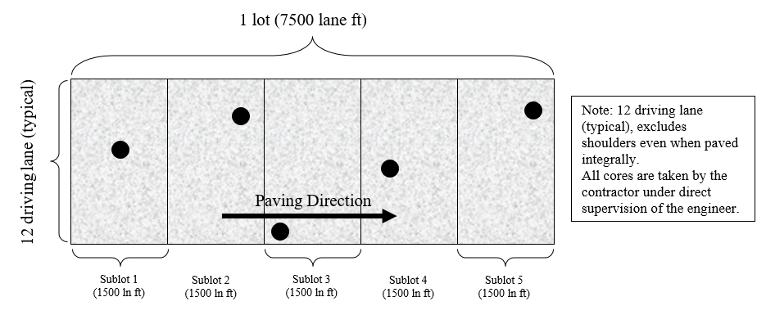

**Figure 5: Example core density locations for traffic lanes**

**Sampling for WisDOT HMA PWL QMP Production**

Sampling of HMA mix for QC, QV and Retained samples shall conform to CMM 836 except as modified here.

*Delete CMM 836.4 Sampling Hot Mix Asphalt and replace with the following to update sublot tonnages:*

**Sampling Hot Mix Asphalt**

At the beginning of the contract, the contractor determines the anticipated tonnage to be produced. The frequency of sampling is 1 per 750 tons (sublot) for QC and Retained Samples and 1 per 3750 tons (lot or 5 sublots) for QV as defined by the HMA PWL QMP SPV. A test sample is obtained randomly from each sublot. Each random sample shall be collected at the plant according to CMM 836.4.1 and 836.4.2. The contractor must submit the random numbers for all mix sampling to the department before production begins.

*Example 1*

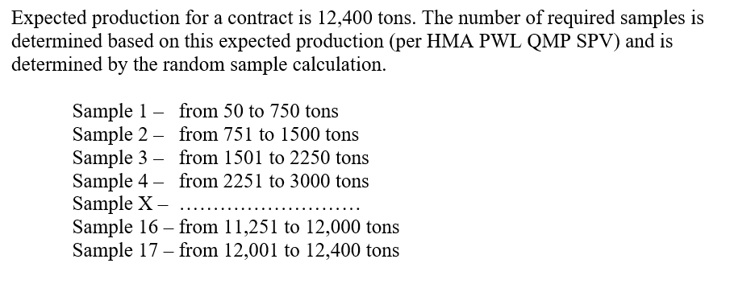

The approximate location of each sample within the prescribed sublots is determined by selecting random numbers using ASTM Method D-3665 or by using a calculator or computerized spreadsheet that has a random number generator. The random numbers selected are used in determining when a sample is to be taken and will be multiplied by the sublot tonnage. This number will then be added to the final tonnage of the previous sublot to yield the approximate cumulative tonnage of when each sample is to be taken.

To allow for plant start-up variability, the procedure calls for the first random sample to be taken at 50 tons or greater per production day (not intended to be taken in the first two truckloads). Random samples calculated for 0-50 ton should be taken in the next truck (51-75 ton).

This procedure is to be used for any number of samples per contract.

If the production is less than the final randomly generated sample tonnage, then the random sample is to be collected from the remaining portion of that sublot of production. If the randomly generated sample is calculated to be within the first 0-50 tons of the subsequent day of production, it should be taken in the next truck. Add a random sample for any fraction of 750 tons at the end of the contract. Lot size will consist of 3750 tons with sublots of 750 tons. Partial lots with less than three sublot tests will be included into the previous lot, by the engineer.

It’s intended that the plant operator not be advised ahead of time when samples are to be taken.

If belt samples are used during troubleshooting, the blended aggregate will be obtained when the mixture production tonnage reaches approximately the sample tonnage. For plants with storage silos, this could be up to 60 minutes in advance of the mixture sample that’s taken when the required tonnage is shipped from the plant.

QC, QV and retained samples shall be collected for all test strip and production mixture testing using a three-part splitting procedure according to CMM 836.5.2.

**Calculation of PWL Mainline Tonnage Example**

A mill and overlay project in being constructed with a 12-foot traffic lane and an integrally paved 3-foot shoulder. The layer thickness is 2 inches for the full width of paving. Calculate the tonnage in each sublot eligible for density incentive or disincentive.

**Solution:**

$$\frac{1500 ft × 12 ft}{9 sf/sy} × \frac{2 in ×112 lb/sy/in}{2000 lb/ton} =224 tons$$

Revised: 11/18/2021