Wisconsin Department Transportation
www.wisconsindot.gov
Real Estate - Land & Property for Sale

Project ID: 2788-00-22 Parcel 121

Asking price is $94,300.
+/- 0.5237 ACRES, Located at 345 Merrill Hills Road, City of Waukesha, Waukesha County. For more information, email: scott.dellenbach@dot.wi.gov or phone (414) 327-2607.
In an agreement with Waukesha County the Department of Transportation is selling this surplus land on the behalf of Waukesha County. The sale is subject to Governor’s approval per Wisconsin Statute 84.09(5). The district will recommend the purchaser whose offer is accepted be approved by the Governor.

Property is offered for sale in “AS IS” condition. It is the responsibility of the purchaser to secure firsthand information about the local real estate tax rate, utility services, allowable access, zoning ordinances and building codes, to determine the utility of the land.

AERIAL OF SUBJECT SITE

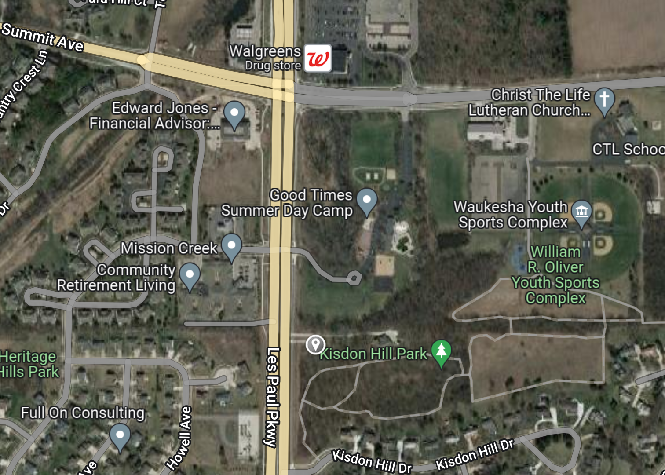

SUBJECT

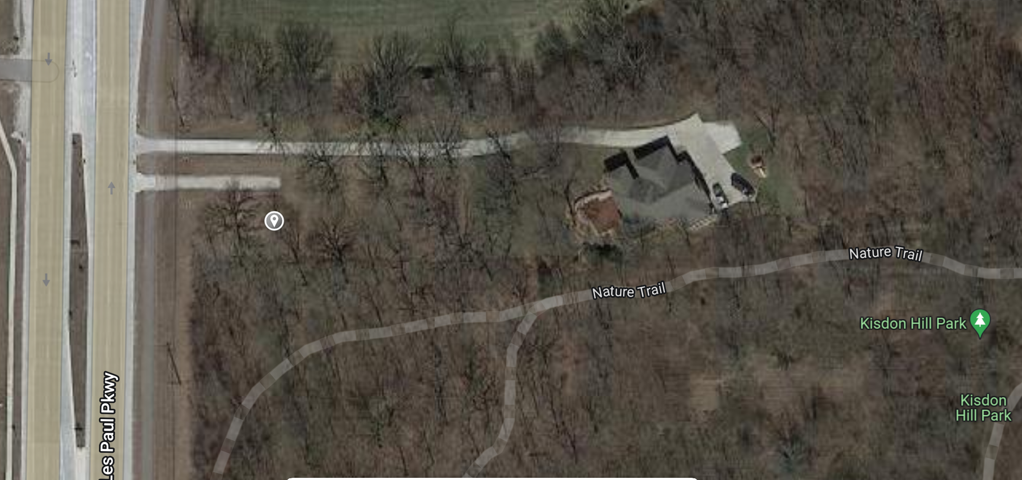

SUBJECT

General information about surplus land and property for sale or lease and more listings at: http://wisconsindot.gov/Pages/doing-bus/real-estate/landsales/default.aspx

