CONTRACT INFORMATION to be completed by prime consultant
1.Current Dollar Value of Contract  =original cost plus all amendments |  | 2.Solicitation Date (choose) |  | 3.Solicitation ID: |  | 4.Transportation Region/Bureau
$ |  | Month Year |  | Project ID: |  | Region/Bureau

5.Prime Consultant
6.DBE Goal set by |  | 7.Original Contract DBE Goal |  |  | 8.Revised Contract DBE Goal
Contract Project |  | % $ No DBE Goal |  |  | % $ No DBE Goal
9.Master Contract ID | 10.Work Order OOOrder # | 11.Stage | 12.Phase | 13.Amendment # | 14.Good Faith Effort form (DT1026)
M |  |  |  |  | required? No or Yes

DBE INFORMATION to be completed by DOT Contract Specialist
15.Please check the appropriate box to indicate the type of DBE contract.
For all: Send original copy of DBE commitment and original contract to Contract Administration Unit (CAU)
If there is Federal funding, also send this form to dbeconsultantservices@dot.wi.gov
Federal Funding – DBE Goal with DBE Participation Use subject line “ID XXXX-XX-XX DBE Goal Commitment”
Federal Funding – No DBE Goal with DBE Participation Use subject line “ID XXXX-XX-XX Commitment No Goal”
Federal Funding – DBE Goal Amendment Use subject line “ID XXXX-XX-XX consent to
Terminate/Reduce/Substitute DBE” and copy the Department Representative for the contract
State Funding – DBE Participation Do Not Submit DT1029 for State-funded only
This form fulfills the responsibility or responsiveness requirement for contract DBE goals on federally funded projects according to the Code of Federal Regulations (49 CFR § 26).
For each separate project ID, list all DBE consultants on page 2. Complete the DBE project information before completing the DBE Commitment Summary below. Include the prime consultant firm if the prime qualifies as a DBE. Attach additional sheets, if needed. A copy of Attachment A is required for each subconsultant.
DBE prime consultant dollar amounts are always considered as neutral DBE amounts. DBE subconsultants amounts may consist of conscious amounts, neutral amounts, or both. Use the UCP DBE Directory to confirm work type and NAICS codes for DBEs listed on the project https://wisconsindot.gov/Pages/doing-bus/civil-rights/dbe/certified-firms.aspx

DBE Commitment Summary to be completed by prime consultant
16. Contract DBE Amount (all projects combined)  include amounts from all pages | $
17. Contract DBE Goal (all projects combined)  Conscious amount | $
18. Difference between DBE Amount and DBE Goal  Calculate as DBE Amount - DBE Goal = Neutral amount | $

PRIME CONSULTANT CERTIFICATION
I certify that arrangements have been made for the foregoing work with the listed DBE consultants. I further understand that any willful falsification/fraudulent statement or misrepresentation will result in appropriate sanctions which may include debarment and/or prosecution under applicable State (Trans 504) and federal laws.
19.X |  | Date
Prime Consultant or Representative’s Signature |  | Date
20.X | Approve  Deny | Date
DOT DBE Office *see Instructions |  | Date

PROJECT INFORMATION to be completed by prime consultant
Project ID | Original Project DBE Goal |  |  | Revised Project DBE Goal
 | $ No DBE Goal |  |  | $ No DBE Goal
Name of DBE Consultant Firm | Consultant Type | NAICS Code | Total DBE Amount  =original plus all amendments |  | Total DBE Amount for this Amendment Only
 | Choose |  | $ |  | $
 | Choose |  | $ |  | $
 | Choose |  | $ |  | $
 | Choose |  | $ |  | $
 | Choose |  | $ |  | $
 | Choose |  | $ |  | $
 | Choose |  | $ |  | $
 | Choose |  | $ |  | $
 | Choose |  | $ |  | $
 | Choose |  | $ |  | $
Total DBE amount for this project |  |  | $
Project DBE Goal for this project  Conscious amount |  |  | $
Difference between DBE Amount and DBE Goal for this project  Calculate as DBE Amount - DBE Goal = Neutral amount |  |  | $

PROJECT INFORMATION to be completed by prime consultant
Project ID | Original Project DBE Goal |  |  | Revised Project DBE Goal
 | No DBE Goal |  |  | No DBE Goal
Name of DBE Consultant Firm | Consultant Type | NAICS Code | Total DBE Amount  =original plus all amendments |  | Total DBE Amount for this Amendment Only
 | Choose |  | $ |  | $
 | Choose |  | $ |  | $
 | Choose |  | $ |  | $
 | Choose |  | $ |  | $
 | Choose |  | $ |  | $
 | Choose |  | $ |  | $
 | Choose |  | $ |  | $
 | Choose |  | $ |  | $
 | Choose |  | $ |  | $
 | Choose |  | $ |  | $
Total DBE amount for this project |  |  | $
Project DBE Goal for this project  Conscious amount |  |  | $
Difference between DBE Amount and DBE Goal for this project  Calculate as DBE Amount - DBE Goal = Neutral amount |  |  | $

NAICS Codes can be found by visiting https://www.census.gov/naics/

ATTACHMENT A
Confirmation of Participation

CONTRACT INFORMATION to be completed by prime consultant
Current Dollar Value of Contract = original cost plus all amendments  $ |  | Solicitation Date:  Project ID:  Month Year
Name of DBE Firm Participating on this contract |  | Name of Prime or Subconsultant who hired the DBE Firm
Description of work to be performed by DBE firm | NAICS Code of work DBE is certified to perform |  | Total Subcontract Value  $

PROJECT INFORMATION to be completed by prime consultant
Master Contract ID  M | Work Order # |  | Amendment #
Project ID |  | Total DBE Amount  =original plus all amendments
 |  | $
 |  | $
 |  | $
 |  | $

For Prime Consultants Only
Arrangements have been made with the participating DBE Firm to perform the type of work listed above for the total subcontract value listed above. I understand that I may not perform the listed work with my own resources or replace this DBE sub-consultant without permission from the DBE Office.
Prime Consultant (Print Company Name) | X | Date
Prime Consultant or Representative’s Name (Print) | Prime Consultant or Representative’s Signature | Date

For Participating Consultant DBE Firms Only
Arrangements have been made with the Prime Consultant to perform the type of work listed above for the subcontract value listed above. I understand that failure to execute the work listed above will result in my company being replaced as a sub-consultant on this project.
Participating DBE Firm (Print) | X | Date
Participating DBE Representative’s Name (Print) | Participating DBE Firm Representative’s Signature | Date

INSTRUCTIONS
Form DT1029 is required for contracts with Federal funds only. If a project that previously had State funds-only has Federal funds added, and there is DBE participation, submit Form DT1029 at that time.
“CONTRACT INFORMATION” is to be completed by the prime consultant.
- The value of the contract with all amendments
- Date of the original contract solicitation, ex. May 2021. Leave blank for work orders and other unsolicited contracts.
- Solicitation ID and Project ID from the original contract solicitation, located in the solicitation header, ex. SE 01. Leave blank for work orders and other unsolicited contracts. If there are multiple Project IDs, enter the ID with the lowest number.
- The region or bureau for which services are being performed. The region/bureau is stated on the signature sheets of the contract.
- Name of the Prime Consultant
- The original solicitation states how the DBE Goal is set. Leave blank if no goal has been set.
- State the goal from the original solicitation.
- The revised goal is the amount that has been approved by WisDOT’s DBE office. Leave blank if the goal has not been revised.
- Fill in the master contract ID only for work orders. Leave blank for other contracts
- Fill in the work order number. Leave blank for other contracts.
- Fill in the stage number if multiple contracts are expected for this project and solicitation ID. Leave blank if only one contract is expected for the project and solicitation ID.
- Fill in the phase for phased contracts. Leave blank for non-phased contracts.
- Fill in the amendment number. Leave blank if this is not an amendment.
- If the DBE goal has been met check NO, otherwise check yes and include form DT1026

“DBE INFORMATION” is to be completed by the WisDOT contract specialist.
- Indicate if the project has a goal or not. Follow instructions in the DBE Information box for submitting forms.

“DBE COMMITMENT SUMMARY” is to be completed by the prime consultant
- Total amount of all contracts to all DBE firms performing services in an approved NAICS code.
- The solicitation goal amount, or revised goal amount, if applicable. If there is no DBE Goal, show as “0”.
- Subtract box 2 from box 1

“PRIME CONSULTANT CERTIFICATION” is to be completed by the prime consultant and WisDOT DBE office.
- To be signed and dated by the prime consultant.
- To be signed, dated, and approved/denied by the WisDOT DBE office. Note- for contracts without an assigned DBE goal, DBE Office signature is not required prior to contract execution.

“PROJECT INFORMATION” is to be completed by the prime consultant.
Boxes 4-8 must be completed for each DBE
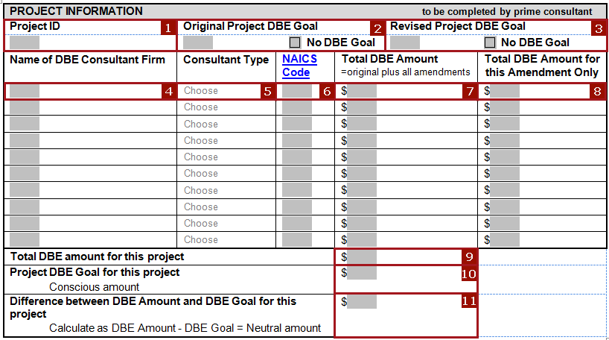
- Enter Project ID. If there are multiple Project IDs, enter the ID with the lowest number.
- The DBE Goal amount listed on the solicitation. If the goal amount was advertised as a percentage, multiply the percentage by the contract amount for the project ID given in box 1 to obtain the dollar amount. Because WisDOT is only able to set DBE Goals on federal funds the goal may not exceed the total amount of federal funds on the project. If the DBE goal is set at the contract, not project level contact your WisDOT contract specialist to obtain amount to be given.
- The revised DBE Goal amount approve by the WisDOT DBE Office. If the goal amount was advertised as a percentage, multiply the percentage by the contract amount for the project ID given in box 1 to obtain the dollar amount. Because WisDOT is only able to set DBE Goals on federal funds the amount give may not exceed the total amount of federal funds on the project. If the DBE goal is set at the contract, not project, level contact your WisDOT contract specialist to obtain amount to be given. If the goal has not been revised, leave blank.
- Name of DBE firm
- Select Consultant Type from the drop down menu
- Add the NAICS code listed in the DBE Directory for the firm - https://wisconsindot.gov/Pages/doing-bus/civil-rights/dbe/certified-firms.aspx
- Enter the total amount for committed for each firm including amendments if applicable
- Enter the amount for this amendment only, if applicable
- Enter the amount of all DBE commitments listed
- Enter the amount of conscious dollars (the amount that applies towards the assigned goal)
- Subtract the amount on line 10 from the Assigned DBE goal (if applicable) and enter the result in box 11.

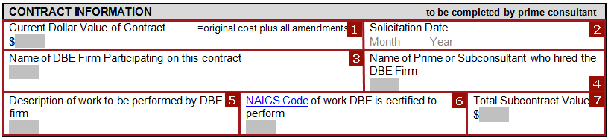
ATTACHMENT A INSTRUCTIONS
Project ID

1. Enter the number of the current contract dollar value for DBE credit including amendments if applicable
2. Enter Solicitation date month and year and Project ID. If there are multiple Project IDs, enter the ID with the lowest number.
3. Enter the name of the DBE sub-consultant
4. Enter the name of the hiring consultant
5. Enter a brief description of the work to be performed by the DBE in Box 1– for credit to apply the DBE must have the associated NAICS code
6. Enter the NAICS code from the UCP DBE Directory https://wisconsindot.gov/Pages/doing-bus/civil-rights/dbe/certified-firms.aspx
7. Enter the Total Subcontract Value – this amount may be more than the amount listed for credit in Box 1

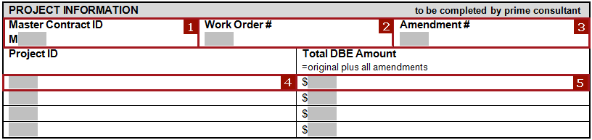

1. Enter the Master Contract ID
2. Enter the Work Order number
3. Enter the Amendment number if applicable
4. Enter Project ID(s)
5. Enter the total amount of DBE commitment for credit including amendments if applicable

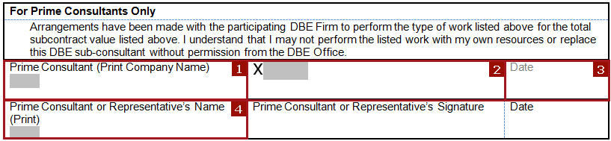
1. Enter the Prime Consultant’s company name
2. Signature of the Prime Consultant’s representative (the Prime must sign the Attachment A even if not the hiring sub)
3. Enter the date the Prime signs the Attachment A
4. Print the Prime representative’s name

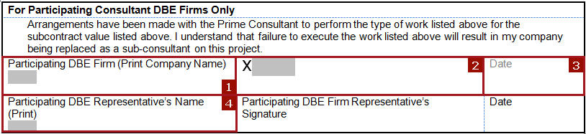
1. Enter the DBE firm’s company name
2. Signature of the DBE firm’s representative
3. Enter the date the DBE signs the Attachment A
4. Print the DBE representative name

