
STH CONNECTION SITE DESIGN CHECKLIST Wisconsin Department of Transportation
DT1247 3/2026 Wis. Stat. §§ 86.07(2)(a), 84.09, 84.25, 84.295 & Ch. Trans 231 Wis. Adm. Code

Applicant Name |  | Property Owner Name (if not applicant) |  |  | 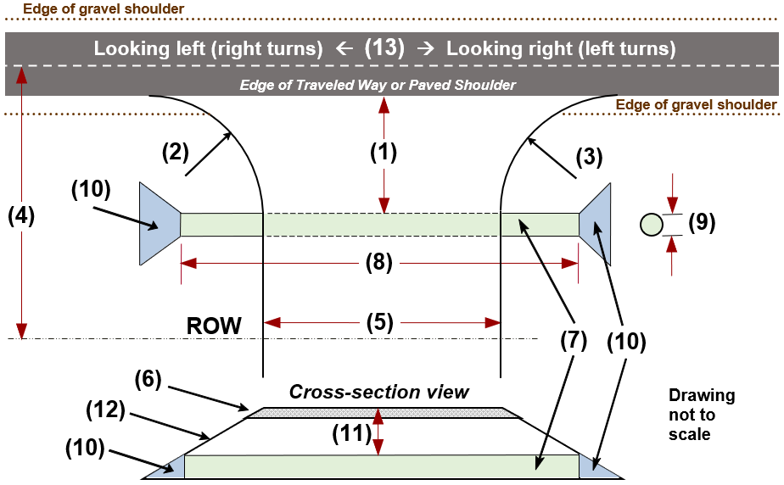
Highway(s) | Speed limit (mph) |  | County
(1) Culvert distance from edge of traveled way or paved shoulder

(2) Left return radius | (3) Right return radius |  |  | (4) ROW width from C  L
(5) Proposed width at ROW line |  | (5b) Proposed use  Select One
(5c) Trail Description |  | (5d) Other Use(s)
(6) Proposed surface  Select One |  |  |  | (6b) Proposed thickness
(7) Culvert required?  Yes No | (8) Culvert length |  |  | Culvert length comps
(7b) Culvert material | (9) Culvert diameter
(10) Endwalls required?  Yes No | (11) Distance from top of culvert to surface top
(10b) Grates required?  Yes No | (12) Minimum slope: Horizontal to vertical distance  :1 (FDM 11-45-30.6.2, Table 30.20)
Nearest side road (name) |  |  |  | Distance from side road | (13) Intersection Sight Distance: | Looking left (right turns) | Looking right (left turns)
 |  |  |  | Distance from side road | Measured
Latitude |  | Longitude |  |  | Desirable
 |  |  |  |  | Minimum

WisDOT reviewer | Comments
Site review date | Comments
(13) For intersection sight distance guidance, go to: https://wisconsindot.gov/rdwy/fdm/fd-11-10.pdf#fd11-10-5
- See Table 5.2: Intersection Sight Distance Criteria for Intersection Control Cases B1, B2 and B3 – Stop on Minor Road
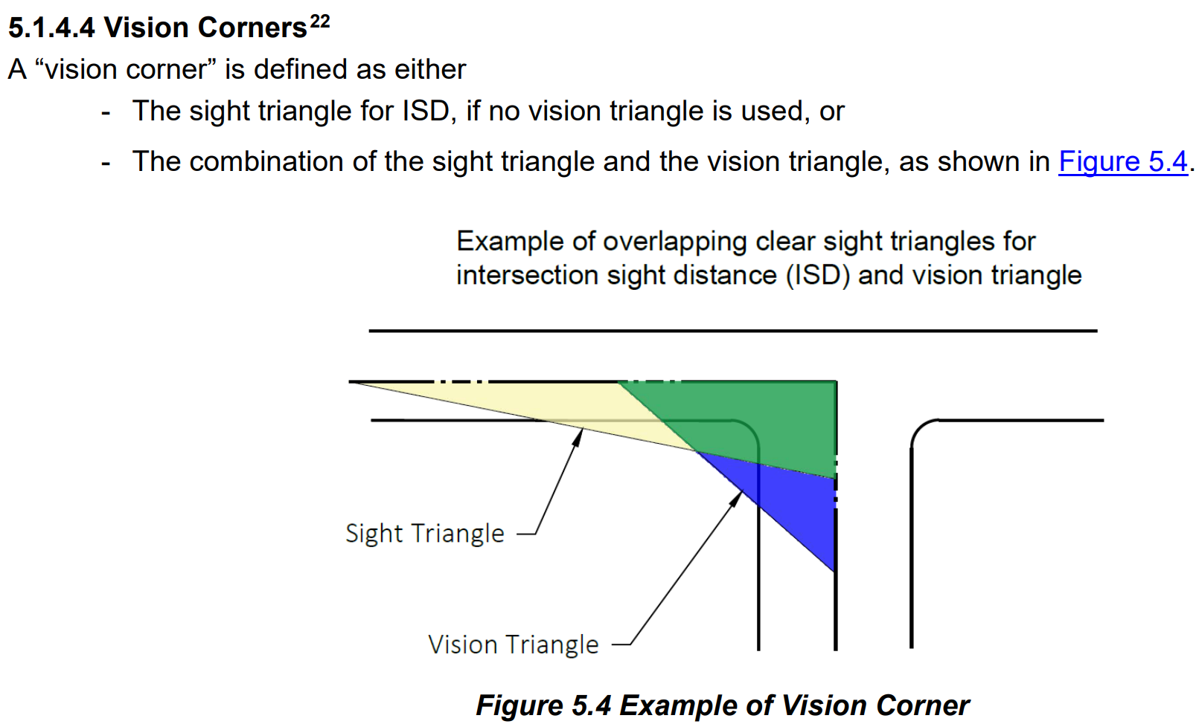
- Additional guidance:
5.1.4.2 Clear Sight Triangles,
5.1.4.3 Design Guidance for Vision Triangles
5.1.4.4 Vision Corners
