SELLER NOTIFICATION
Wisconsin Department of Transportation
MV2870 6/2022 s.342.41 Wis. Stats. wisconsindmv.gov/sellernotify

This form must be completed if the vehicle is sold between individuals (businesses and trusts should not submit a Seller Notification Form). Any fields left blank will result in your Seller Notification not being entered. The Vehicle Identification Number (VIN) can be found on proof of insurance documents, previous Certificates of Vehicle Registration or previous renewal notices. Keep a copy of this completed form for your records.

This form does not replace the titling process; you will be listed on DMV records as the owner of the sold vehicle until the buyer titles it in his/her name.

Go to wisconsindmv.gov/sellernotify to enter the Seller Notification online.
 | SELLER IDENTITY INFORMATION
 | Seller Name (first, middle, last) – NOT A BUSINESS OR TRUST NAME |  |  |  |  |  |  |  |  |  |  | Birth Date  – –  M M D D Y Y Y Y
 | Driver License Number  – – –  1 2 3 4 5 6 7 8 9 10 11 12 13 14 |  | AND |  | Last 4-digits of your Social Security Number  6 7 8 9
 | Street Address | City |  |  |  | State |  | ZIP Code |  |  | (Area Code) Telephone Number (daytime)
 | VEHICLE INFORMATION
 | Vehicle Identification Number  1 2 3 4 5 6 7 8 9 10 11 12 13 14 15 16 17 |  |  | Standard VIN for vehicles manufactured after 1980 has 17 characters. |  |  |  |  | Year | Make |  |  | Model
 | SALE INFORMATION
 | Date of Sale (date cannot be more than one year ago or in the future) |  |  |  |  |  | Sale Price (please enter $0.00 if no money was exchanged)
 | BUYER IDENTITY INFORMATION (at least one buyer name is required)
 | Buyer Name (first, last) – NOT A BUSINESS OR TRUST NAME
 | Buyer Name (first, last) – NOT A BUSINESS OR TRUST NAME

If you have all required information but do not have access to complete the form online, you can mail the completed form to:

DMV Communication Center
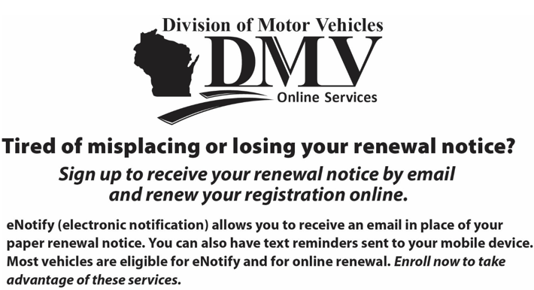
P.O. Box 7949
Madison, WI 53707-7949

To access eNotify, please visit wisconsindmv.gov/enotify

