**Public Involvement Meeting Handout**

**WIS 35 Improvements  
City of Hudson and Village of North Hudson**

**St. Croix County**

**I.D. 8080-02-30**

**City of Hudson, Second Street**

**Front Street to Vine Street**

**WIS 35**

**St. Croix County**

**I.D. 8080-05-02**

**Village of North Hudson, Sixth Street**

**Lake Mallalieu Bridge to Sommers Street**

**WIS 35**

**St. Croix County**

**I.D. 8080-07-02**

**City of Hudson, Second Street**

**Vine Street to Willow River**

**WIS 35**

**St. Croix County**

**I.D. 8080-02-72**

**City of Hudson, Second Street**

**Coulee Road intersection**

**WIS 35**

**St. Croix County**

**I.D. 8080-02-73**

**Village of Hudson, Sixthth Street**

**Sommers Street to North End Road**

**WIS 35**

**St. Croix County**

**Feb. 26, 2020**

**5 p.m. – 9 p.m.**

**Hudson City Hall**

**Council Chambers**

**505 Third St.**

**Hudson, Wis.**

**Purpose of the Meeting**

The purpose of the meeting is to present information regarding the proposed improvement project along WIS 35 in St. Croix County. The Wisconsin Department of Transportation is planning to do a rehabilitation, two reconstruction and two safety improvement projects on WIS 35. This meeting will involve presenting proposed plans of the scheduled work and discussing the project schedule, traffic control and staging.

The meeting will be held in an open house format and provide an overview of the project. Project team representatives are available to discuss project details, address comments and answer questions.

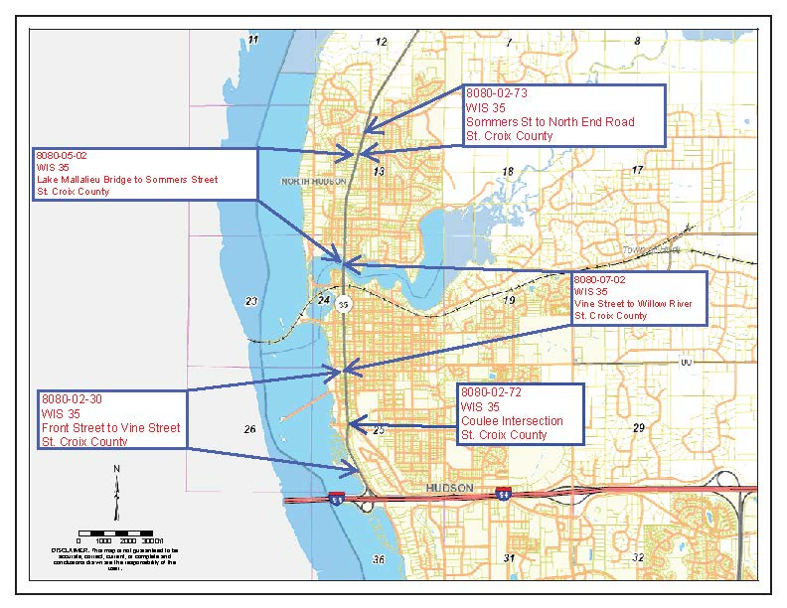

**Project Information**

The limits of the project extend from the WIS 35 intersection with Front Street on the south in the city of Hudson and extend northerly to the intersection of WIS 35 with North End Road in the village of North Hudson. Work will include:

* Pavement rehabilitation including joint repair, grinding and asphaltic overlay from Front Street to Vine Street.
* Roadway reconstruction including curb and gutter, storm sewer, water, sanitary sewer and new pavement from Vine Street to Sommers Street.
* Traffic signal and lighting improvements at select locations.
* Curb ramp improvements throughout the project.
* Polymer overlay of the Lake Mallalieu Bridge.
* Safety improvements at the Coulee Road, Buckeye Street and WIS 35 intersection.
* Safety improvements on WIS 35 between Sommers Street and North End Road.

An environmental document that assesses the impacts to various environmental factors within the project limits has been prepared and approved. Coordination with staff from the Department of Natural Resources is ongoing and will continue throughout the design phase of the project.

**Proposed Traffic Impacts**

Construction is currently scheduled to occur in the summer of 2021.

During construction, WIS 35 will either be open to traffic, staged or detoured. It is anticipated that the southerly projects from Front Street to Vine Street will be staged and constructed under traffic. It is anticipated that the northerly projects from Vine Street to Sommers Street will be constructed under a detour. The segment from Sommers Street to North End road will be done under traffic. Temporary traffic signals and staged construction will be utilized across the Lake Mallalieu Bridge from Division Street south of the bridge to South Street north of the bridge. These temporary traffic signals will allow for a single lane of traffic across the structure during construction of this segment. Once this segment is completed, the structure will be opened to two lanes of traffic across it.

**Real Estate**

Some small areas of additional right of way are required for this project, generally for curb ramp upgrades and sidewalk replacement. Real estate acquisitions consist of both fee acquisition and temporary limited easements. The acquisition process has been started and effected property owners have been notified. There will be an upcoming meeting in March to allow property owners to come in and ask questions of design and real estate staff members.

**Project Milestones**

Initiate project design Summer 2018

Public involvement meeting #1 Sept. 10, 2018

Public involvement meeting #2 April 2019

Environmental document approved September 2019

Begin right-of-way acquisitions Winter 2019

Public involvement meeting #3 February 2020

Complete final plans May 2020

Construction Summer 2021

**Public Input/Comments**

We encourage you to talk to the project representatives and ask them questions. A comment sheet is provided for your written comments and input regarding the proposed project. Please mail any written comments about the project before March 30, 2020, or leave them in the comment box tonight. You may also email your comments to the contacts listed below.

Your comments assist us in developing a project that will serve the needs of the traveling public as well as the needs of the local community. Your input is welcome and appreciated throughout the design process.

For more information, please contact:

Mohamad Hayek, PE

Wisconsin Department of Transportation

718 West Clairemont Ave.

Eau Claire, WI 54701

Phone: (715) 836-2065

Email: [Mohamad Hayek@dot.wi.gov](mailto:Mohamad%20Hayek@dot.wi.gov)

Jeff Abramson, PE

Ayres Associates

3433 Oakwood Hills Parkway

Eau Claire, WI 54701

Phone: (715) 834-3161

Email: [AbramsonJ@AyresAssociates.com](mailto:AbramsonJ@AyresAssociates.com)