Connecting DOT Laptops to the Internet (without VPN)

In Internet Explorer,

Tools > Internet Options > Connections > LAN Settings

At a DOT Facility  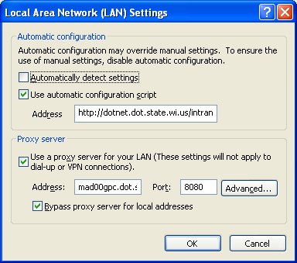  mad00gpc.dot.state.wi.us  http://dotnet.dot.state.wi.us/intranet/msie6.ins | At a Non-DOT Facility  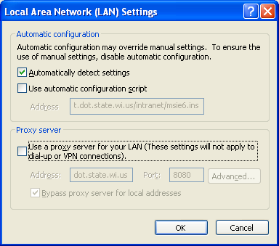

Note: Addresses should not need to be changed. They are included for completeness.

