July 14th 2014 Release of HSI
Primary Upgrades and Bug Fixes:

- Tracking of Notes/Comments by HSI. During the June 2014 release, we added an auto-track feature to highlight when comments and/or notes were changed. We’ve since upgraded so issues that were discovered after the release were resolved.

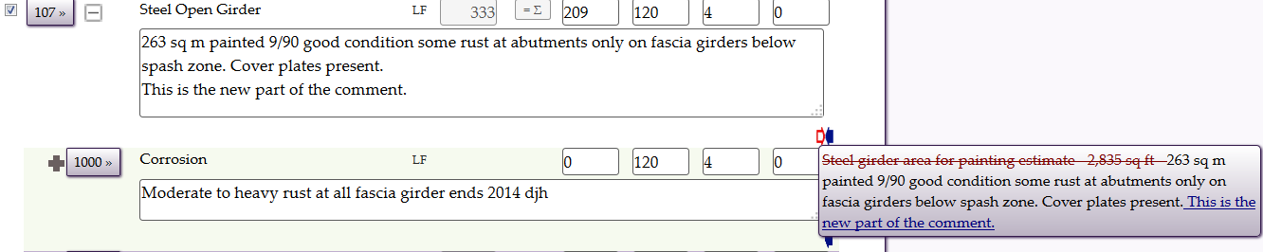

- File Sandbox. This feature allows the user to gather requested files (most often Field Inspections) into a folder system that can be accessed directly in HIS by the user, rather than having the files emailed in a separate process. This is particularly useful when file sizes exceed limits in the email system.
For example, say you want to print the field inspection forms for the Bong Bridge in Superior. To do this, you would add those 19 structure ID’s into a collection, and click Collection – Print – Field Inspection as shown below (same as before).
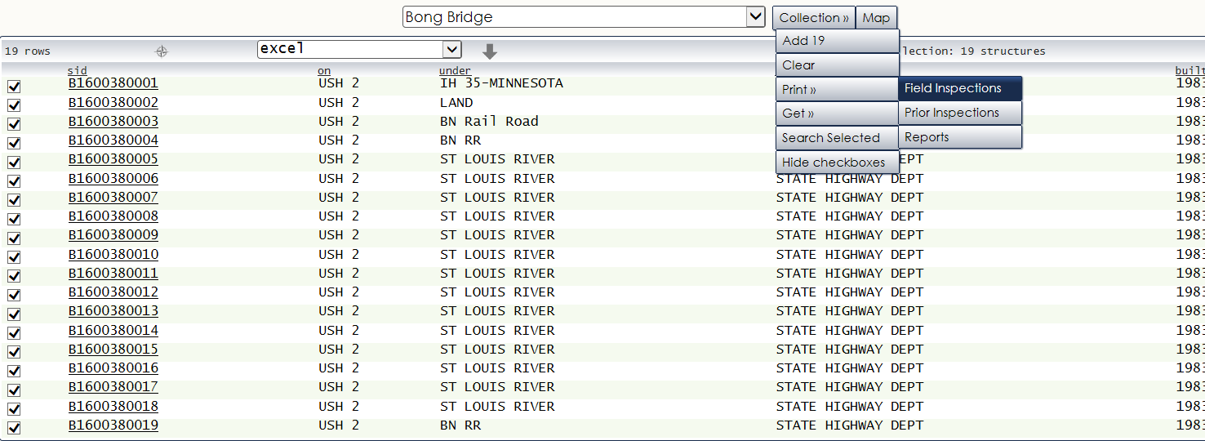
The system takes you to the Structure Collection tab in Tools (same as before). The difference is the checkbox just to the right of your email address (see circled item below)
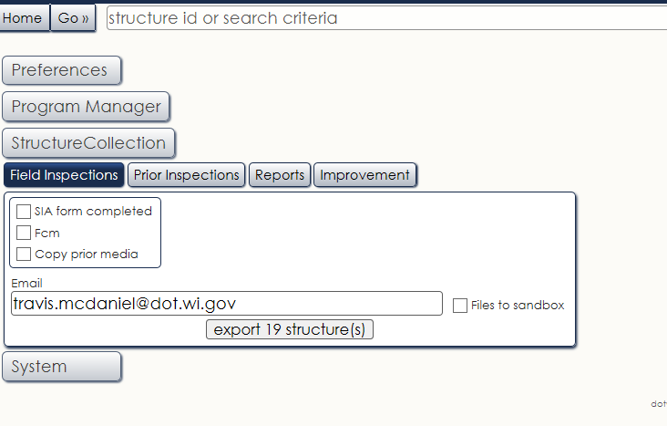
By checking “Files to Sandbox” and clicking export, you will start a process where the reports are gathered in a batch process internally by the system. You can continue to work while the system is building your request. When the system completes the request, it will send you a confirmation email. When you see that email, you have a few different ways to get to your “sandbox”. The first way is to Navigate by clicking Go – Tools, and then clicking the System tab and then the Sandbox Tab . The second way is to click the “X” Sandbox Folder in the upper right hand portion of your screen (see below for both.
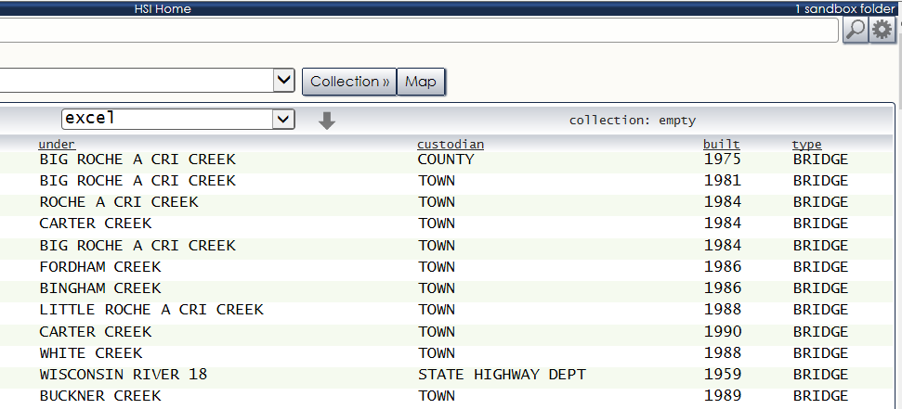
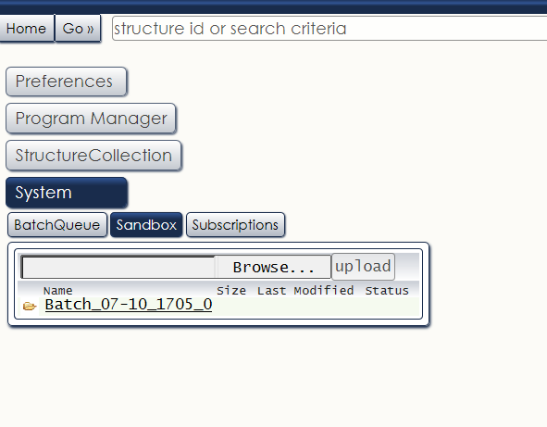
As you can see, there is one folder available called “Batch_07_10_1505_0”. The 07 is the month (July), 10 is the day, and 1705 is the time (i.e. 5:05pm). If you do multiple requests on the same day, the last number will simply increment by the request #.
When you click on the Folder, it will take you to the file(s) requested. In this example, there is a single pdf that contains the 19 inspection forms.
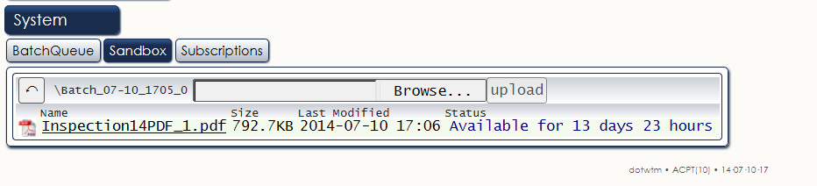
Also note that these files are not permanent; they will be removed after 14 days.
- Updated Visuals on Element/Assessment Tab
There have been some small upgrades to help improve the visuals on the element/assessment tabs. This includes highlighting the text box where the cursor is located, bolding the element description, and other small enhancements.
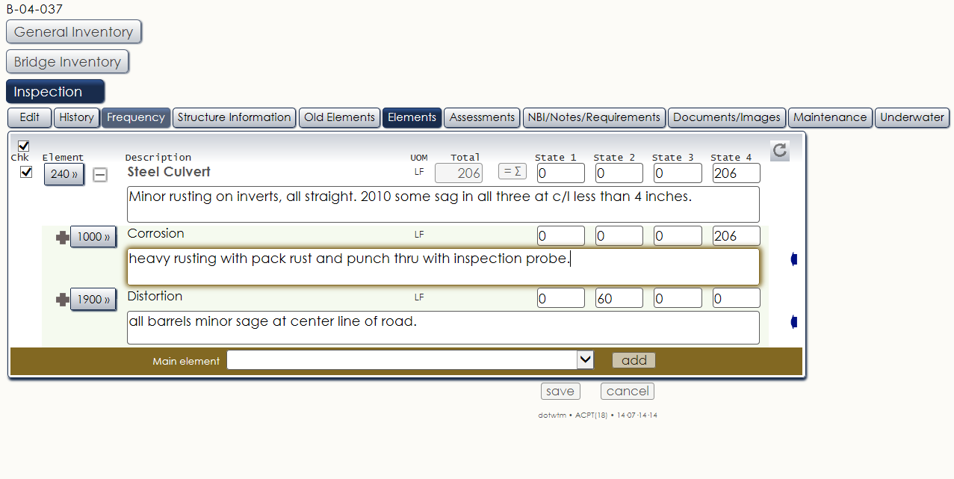

- Element/Defect rules for Elements that are not inspected
Previously the system enforced rules for elements in Condition States 2/3/4 to have corresponding defects in those condition states, regardless of the inspection type. That rule specified if those quantities were not in sync, the report could not be completed.

We have since relaxed that rule to only be enforced on elements that are inspected (and thus “checked” during the inspection entry). This should help resolve issues with non-typical inspections (i.e. Damage) where only small subsets of elements are reviewed.

- Report Updates
Several inspection-related reports have been updated to accurately handle the new element system. Included in this list are the scheduling and performance reports. More reports will be upgraded in the following weeks.

- And many other fixes that can be found in G0 – HELP – TOPIC – RELEASE NOTES

