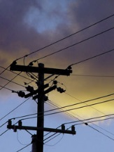
WisDOT Utility Coordination News Bulletin
For WisDOT utility coordination staff, associates and business partners
Email questions, comments and news tips to: DOTDTSDCOUtilityCoordination@dot.wi.gov

UB#02 | Volume 2 Published 070716
UB#01 | Volume 1 Published 052516
This bulletin has been developed to provide updates, clarifications, job aides and news pertaining to WisDOT utility coordination and related WisDOT programs, policy and services. Information published in this bulletin will be of interest to those who work closely with utility coordination. WisDOT’s Division of Transportation Services Development/Bureau of Technical Services (DTSD/BTS) - Utilities will review each submission prior to publication. Questions, suggestions and comments may be sent to the DTSD/BTS-Utilities shared mailbox at DOTDTSDCOUtilityCoordination@dot.wi.gov.

