Public Involvement Handout

WIS 64
Mountain - Pound
N 17th Road to US 141
Marinette County

Project ID: 9160-21-00

Handout date: August 2022
This handout and other items are available on this project’s design website at
https://wisconsindot.gov/Pages/projects/by-region/ne/64marint/default.aspx

We appreciate your feedback and look forward to hearing from you.

Purpose of handout
The Wisconsin Department of Transportation (WisDOT) is in the process of developing plans for proposed improvements on 0.8 miles of WIS 64 in Oconto County. The purpose of this handout is to provide information regarding the proposed improvements, describe the potential impacts it would have on the community, and offer an opportunity for public comment.

Public input/comments
Your comments assist us in developing a project that will serve the needs of the traveling public
as well as the needs of the local community and are welcomed and appreciated throughout the design process. Included at the end of this handout, as well as on the project website, is a comment form that may be used for written comments regarding the proposed improvements. You are encouraged to fill out this form and return using the pre-paid mailer attached. Comments may also be submitted via email or phone to any of the contacts listed below.

Project location
WIS 64 from 17th Road to US 141 near the village of Pound in Oconto County.

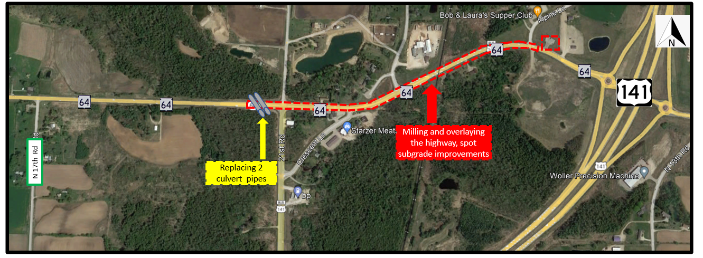

Project purpose and need
The purpose of the project is to extend the service life and improve the riding surface of WIS 64. Currently, the existing pavement is showing signs of deterioration including longitudinal and transverse cracking.

Proposed improvements
This is a resurface-level project. Proposed improvements include:

- Mill two inches of the existing surface and pave two inches of hot mix asphalt
- Culvert replacement
- Pavement marking

Traffic impacts
WIS 64 will be closed for one week during the culvert replacement. Detour will follow County Road Q and County Road CP. WIS 64 will remain open to traffic for paving with lane closures and flagging operations.

Real estate
No right of way is anticipated as part of the project.

Business Resource: WisDOT’s In This Together program
WisDOT recognizes businesses located in work zones or impacted by detour routes have special needs. WisDOT's In This Together program is offered to business, organizations and community leaders as an idea source as they plan for road construction in their area. It includes promotional examples, case studies and a specially designed Business Coordination Guide with information on:
- Planning ahead
- Staying informed
- Keeping customers informed
- Tips for businesses
- Temporary Business Signing
WisDOT’s In This Together website is located at www.wisconsindot.gov/Together

Project contact
Kurt Vogel, P.E.
Wisconsin Department of Transportation
944 Vanderperren Way
Green Bay, WI 54304
920-362-1732
Kurt.vogel@dot.wi.gov

SCROLL DOWN FOR COMMENT FORM

WisDOT Highway Project Public Comment Form

Project ID 9160-21-00
Highway 64
N 17th Rd – USH 141
Marinette County

Please place this form in the comment box or mail by mid-September 2022 to the address on the back of this sheet. Comments can also be e-mailed to kurt.vogel@dot.wi.gov. Your comments assist us in developing a project that will serve the needs of the traveling public as well as the needs of the local community. Your input is welcome and appreciated throughout the design process.
Name: _____________________________________________________________

Address: ___________________________________________________________

Daytime Phone Number (optional): ______________________________________

Email Address (optional): ______________________________________

Please Print Comments (attach additional sheets if necessary)

The information in this document including names, addresses, phone numbers, e-mail addresses, and signatures is not confidential, and may be subject to disclosure upon request, pursuant to the requirements of the Wisconsin open records law, sections 19.31 - 19.39 of the Wisconsin Statutes.

--------------------------------------------------------- Fold Here -----------------------------------------------------------
Attention: Kurt Vogel
------------------------------------------------------------- Fold Here ----------------------------------------------------------------------

