Project ID _________________ Parcel # _______

CONDEMNATION PROCESS

_____ If unknown, deceased or there is no contact information for owner, proceed to page 5 for publishing.

PRE - JO
_____ Request title search update. Update should be less than 3 months old.
_____ Upload title update to READS Parcel log.
_____ Enter any new or updated information in READS. Include all parties of interest (i.e., easement holders, life estate, mortgagees, SIGN COMPANIES, Utilities if applicable, etc.) and enter their addresses.
_____ Confirm that tax id #s in READS parcel screen is correct.
_____ Confirm interest screen in READS is correct.
_____ Confirm latest approved offer in READS is correct.
_____ Meet with Supervisor and Litigation Coordinator for Jurisdictional Offer (JO) approval and discussion.
_____ Contact or attempt to contact the owner again before making the JO. Document in READS diary.

JO Process
*Negotiations should continue until the JO expires!

_____ If improved, coordinate JO expiration date and occupancy date with Relocation Agent. Confirm 90, 60, and 30-day letters were delivered. Agency cannot occupy improvements until those are given.
_____ Create JO Offering Price in READS.
_____ Generate JO Document in READS. Document date should be the mailing date. Find the public purpose on the READS Project Screen.
_____ Enter JO Expiration Date (must be a minimum of 20 calendar days after service – cannot end on a holiday/weekend).
_____ Enter “Additional Days” (allow time to send certified mail, issue payment, and record Award).
_____ Fill all blank fields. If allocation is $0, enter 0.00.
_____ Occupancy Date should be at least 10 days after JO expires but cannot occur until payment is made. Occupancy date cannot be a holiday/weekend.
_____ Confirm that Relocation Order (RO) date on JO agrees with RO date on latest plat.
_____ Item “O” - Personal property should NEVER be purchased as part of the acquisition
_____ Item “L” - taxes MUST be prorated for all fee acquisitions. Strike L box in READS only when the acquisition is less than fee.
_____ If publishing, proceed to page 5 (Jurisdictional Offer)
_____ Print JO Document.
_____ Have Real Estate Supervisor sign JO and date it the day it will be sent certified mail.
_____ Enter Supervisor’s name and date of approval into the offer details screen in READS.
_____ Upload a copy of the signed & dated JO to READS parcel log.

Lis Pendens Process
_____ Generate a Notice of Lis Pendens (LP) from READS.
_____ Confirm all parties of interest are listed WITH mailing addresses.
_____ If publishing, proceed to page 5 (Lis Pendens).
_____ Sign and notarize with the same date as JO. This document must be notarized, so the Agent can be the signor, OR the Notary Public, but NOT both.
_____ Record LP with the JO attached as one document within 14 days of JO’s mailing date. As best practice, it should be recorded same day as JO sent. SimpliFile (no e-return needed) or send Lis Pendens with letter to Register of Deeds. If using Simplfile: Grantor is acquiring agency and grantee is property owner.
_____ Upload a copy of the Record LP with the signed JO attached to the READS parcel log.

JO Letter Process
**JO letter, JO and Lis Pendens should all have the same date.
_____ Generate JO letter from READS. If an Administrative Revision was made, edit letter to reflect the latest offer. Ensure CCs are correct on bottom of the letter.
_____ Deadline is same as on JO.
_____ Owner and all parties of interest receive (by CERTIFIED mail):
_____ JO letter,
_____ JO with attached legal description,
_____ Conveyance Document,
_____ Copy of unrecorded Lis Pendens,
_____ “Rights of Landowners Under Eminent Domain Law” brochure,
_____ Self-Addressed, postage paid envelope.
_____ JO Parties of Interest letter to Parties of Interest explaining the JO package. This is NOT a standard READS letter. It must be created using the template in the addenda.
*If owner is represented by an attorney, also send the JO package to them.
_____ Enter a READS diary stating the date the JO was sent, the date the Lis Pendens was recorded, certified mail tracking numbers, who sent the letters and to whom they were sent.

- Any error in description, offer amount, dates, or other relevant information can only be corrected by service of a revised JO. New deadline for acceptance will be 20 days thereafter. Original Lis Pendens must be discharged and revised Lis Pendens with revised JO must be filed.
- If JO is accepted within the 20-day deadline, you MUST close within 60 days.
- Rejection or non-response by one is rejection by all. A single owner or party of interest cannot accept or reject the JO for all parties.
- If all owners/parties of interest expressly reject the JO in writing, you may move to award before the 20-day timeline is up.
- If Owner does not accept JO, they have 40 days from the date of service, postmark, or publication to bring a right to take (s.32.05(5) Wis. Stats). That is for anything OTHER than compensation. If the owner accepts or retains the payment (compensation), they forfeit that right. Depositing the compensation check at the clerk of courts does NOT constitute acceptance of the payment.

Post JO / Pre-Award Process
_____ Prorate taxes (all fee acquisitions) using Occupancy date. Check amount should include tax proration.
_____ Create Payment Request (expect 2 weeks to get check, check with BTS Financial Specialist). Request check be sent to region/consultant.
_____ If the owner is the only party of interest, payee is the property owner.
_____ If there are multiple parties of interests and/or multiple owners, payee is the appropriate county clerk of courts. Add them as a participant, create and submit the payment request.
_____ Generate Payment Request, have RE supervisor approve and submit for payment.
_____ Contact or attempt to contact the owner again during the 20-day period. Document in READS diary.
- There is no requirement to move to AWARD immediately following the 20-day period. If schedule allows and there is a valid business reason, recording the award can be delayed.

Award of Damages (Award) Process
**Award CANNOT be recorded until payment is made. Occupancy can be on the same date as the recording but cannot be before the recording date.
____ Generate the Award of Damages (RE1584) in READS. DO NOT date until it is being sent for recording.
____ Occupancy date should be the same as on the JO.
_____ Ensure the Relocation Order date, all names of parties of interest and legal description are the same on the Award and JO.
_____ If publishing, proceed to page 5 (Award of Damages)
_____ Print Award Document
_____ Supervisor signs Award. DO NOT DATE until ready to record.
____ Generate Award of Damages letter in READS once JO expires and occupancy date has been reached.

____ Send (CERTIFIED MAIL) to owner(s) and all parties of interest before recording the Award:
____ Award letter,
_____ If under $600 - eliminate the W-9 paragraph and do not send W-9 or return envelope.
____ Payment details,
____ If owner is only party of interest, send check to owner (cc attorney, if applicable).
____ If there are multiple owners and/or multiple parties of interest, list them as CCs on the letter and send a copy of the check to them.
____ Generate Clerk of Courts letter listing all the party of interests and their addresses. Send actual check to clerk of courts in this instance.
____ UNRECORDED signed Award (RE1584),
____ Closing statement (RE1617),
____ Disposition of Real Estate Taxes (RE1616),
____ W-9 form (if over $600 minus TLE amount),
____ Postage paid envelope.
____ Award Parties of Interest letter to parties of interest explaining Award. This is NOT a standard READS letter. It must be created using the template in the addenda.
_____ Enter a READS diary stating the date the Award and check were sent, certified mail tracking numbers, who sent the letters and to whom they were sent.

Closing Process
_____ If publishing, proceed to page 5 (Closing Process)
____ After the JO has expired, payment has been made, and occupancy date has been reached: complete Real Estate Transfer through Department of Revenue portal for Award.
____ After completing transfer return record the Award.
____ Generate the Two-Year Award letter. This is NOT a standard READS letter. It must be created using the template in the addenda.
____ Send (CERTIFIED MAIL) to owner(s) and all parties of interest:
____ Closing by Mail Letter
____ RECORDED Award
____ Enter a READS diary stating the date the recorded Award was sent, certified mail tracking numbers, who sent the letters and to whom they were sent
_____ Upload a copy of the Recorded AWARD to the READS parcel log.

UNKNOWN, DECEASED, NO CONTACT INFORMATION FOR OWNER PARCELS

PUBLISHING LEGAL NOTICES - Offer Letter, Jurisdictional Offer, Award

When unable to locate or identify a property owner, the offer letter, Jurisdictional Offer and Award of Damages must be published in a local newspaper. If the property is in the Town of Washington, Door County, special publication statutes apply. See Wis Stats 985.01(1m)(b)

- Contact the County Clerk of Courts asking if there is an official newspaper for the county.
- Publish the condemnation documents in a newspaper local to the parcel to be acquired.
- The offer letter, JO and Award must be published in the same newspaper.
- Contact the newspaper
  - Provide them with the notice
  - Coordinate the publication dates. Ensure the date of the JO is the same date that it is published.
  - Ask for a confirmation and an affidavit of publication. An affidavit of publication is required.

Offer Letter (published) - The offer letter requires a Class 3 notice and must be published three consecutive weeks. Publish it in the legal section. Using the template, prepare it for submission to the newspaper. The letter summarizes the project, states the owner is unknown or cannot be located and lists the allocated offer amount. An appraisal must be completed and approved before publishing. The property owner (if found) has the right to obtain their own appraisal within 60 days of the date of the initial publication of the offer letter.

Jurisdictional Offer (published) - The JO requires a Class 1 notice and is published once. It cannot be published until 67 days after the initial publication of the offer letter. Create the JO in READS. Using the template, prepare it for submission to the newspaper. Check the submission against the JO created ensuring they have the same information. The date of the JO must be on the same date you are publishing. List the RE supervisor as the issuer. The JO must be published in the same newspaper as the offer letter. Get an affidavit of publishing from the newspaper. Wis Stats 32.05(4)

Lis Pendens: Record the Notice of Lis Pendens (RE1547) with JO attached within 14 days of the date of publication of the JO. Wait 27 days

Award of Damages - The Award requires a Class 3 notice and must be published three consecutive weeks. It cannot be published until 7 days after the JO expiration date. Create the Award in READS. Using the template, prepare it for submission to the newspaper. Check the newspaper submission against the Award created ensuring they have the same information. The Award cannot be published until one week after the final publication of the JO and one week after the expiration date. The Award must be published in the same newspaper as the offer letter. Get an affidavit of publishing from the newspaper. Wis Stats 32.05(7)(b)

Closing Process: Make check payable to Clerk of Courts. Send payment to the Clerk of Courts one week after the final Award publication. The Award of Damages cannot be recorded until you receive the Affidavit of Publication and send payment to clerk of courts. This can take 7-10 days.

Wis Stats 985 - Publication of Legal Notices for definition of Class 1 & 3 notices
- 985.02(1) - Any legal notice not otherwise designated shall be a class 3 notice
- 985.01 - Definition of “insertion”
- 985.07 - Classes and frequency of legal notices.

Back

JO Offering Price

On Offer/Negotiation Screen:
- Click “Create Offer”
- Offer Type: select “Jurisdictional Offer”
- Based on Existing Offer: select most updated offer or Administrative Revision
- Click Save
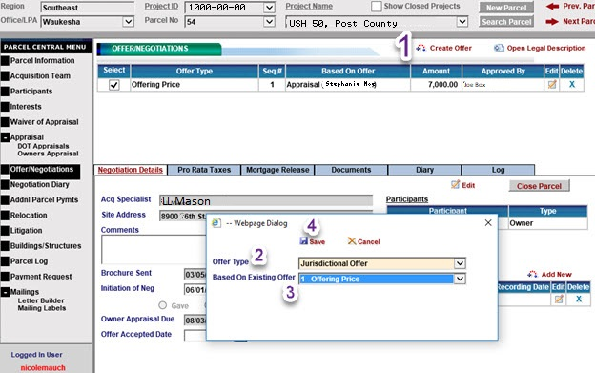
- Update allocations as needed
- Click Save
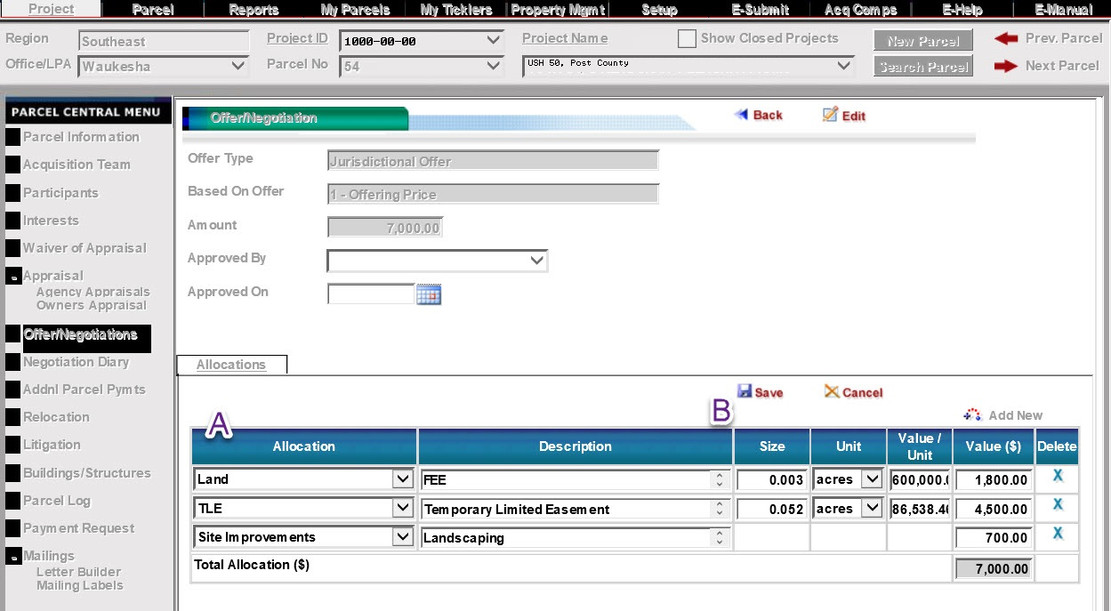
Back
Generate JO Document

On Offer/Negotiation Screen:
- Select “Jurisdictional Offer”
- Click “Documents”
- Scroll to “Jurisdictional Offer (RE1786)”
- Click “Generate”
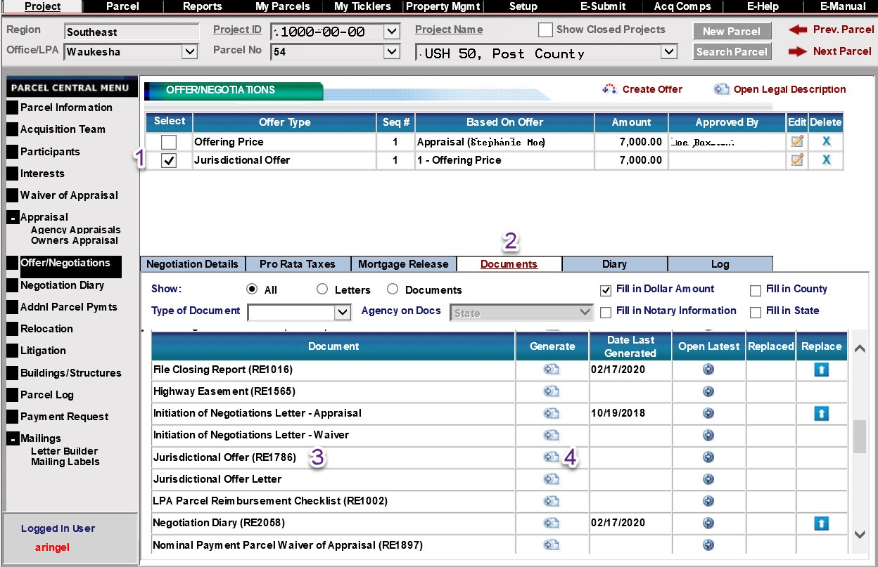

- Enter date JO will be sent
- Confirm Public Purpose matches Relocation Order
- Enter JO expiration date – must be a minimum of 20 days after JO date, cannot fall on a weekend or holiday
- Add at least 10 additional days
- Confirm Occupancy date does not fall on a weekend or holiday. Verify date with relocation agent if applicable
- Confirm allocations are correct
- Confirm details are accurate, revise if needed
- Drop down to appropriate Supervisor
- Check only if acquiring less than fee interests
- Include any personal property included
- Click “Generate Document”
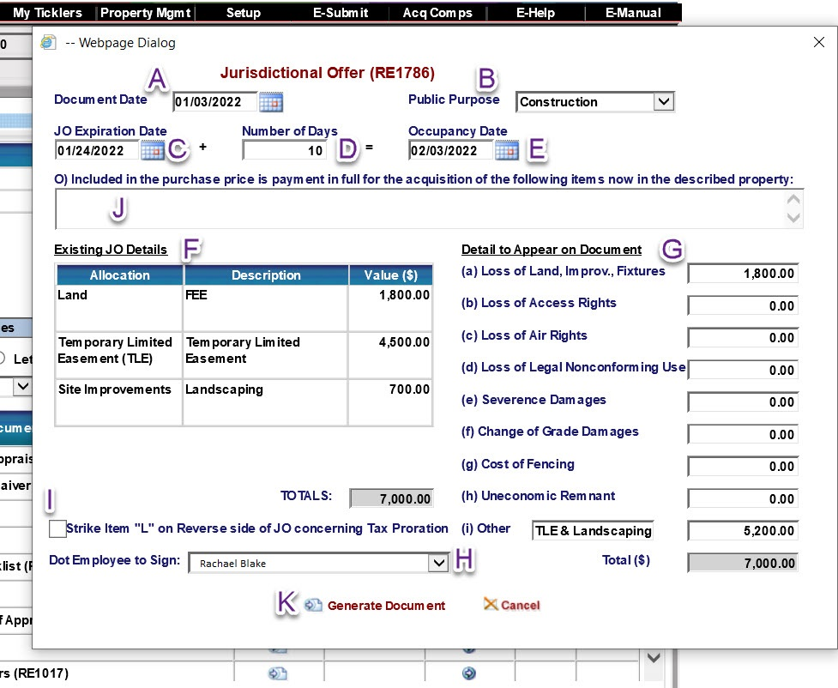

Back
JO Approval Details

- Ensure Jurisdictional Offer is selected
- Click Edit. A new screen will pop up
- Click Edit
- Dropdown to approving authority
- Enter approval date
- Click Save
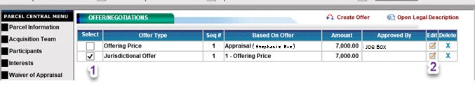

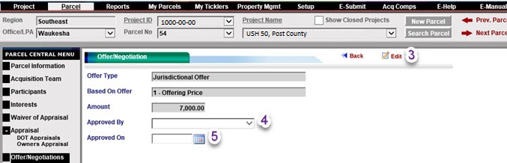

Back

JURISDICTIONAL OFFER Wisconsin Department of Transportation
RE1786 10/2018 s.32.05 Wis. Stats.

Date: 01/03/2022
To: Ruth & Ethan Clark, Bank of the Area, Tanace Franklin (easement holder), hereinafter referred to as Owner.
Relocation Order date(s)
07/26/2018
Relocation Order | County  Post | Public purpose for property  Construction of USH 50
Wisconsin Department of Transportation, hereinafter referred to as Purchaser, offers to purchase a parcel of real estate and/or rights therein in which you own an interest as described on attached page, and within 60 days from the acceptance of this offer agrees to pay the sum of: Seven Thousand and 0/100 Dollars ($7,000.00)
A. The said property, and/or rights as described, is required by the State of Wisconsin for the public purpose stated above, as more fully described in the Relocation Order, date and place of filing specified above. The State of Wisconsin in good faith intends to use the above-described property for such public purpose.
B. The State of Wisconsin proposes to occupy and the Owner will vacate the premises on this date: 02/03/2022
C. Pursuant to s.32.05(3)(d) Wis. Stats., the above purchase price is allocated as follows:
(a) Loss of land, including improvements and fixtures actually being acquired $ 1,800.00
(b) Damages caused by loss of existing rights of access $ 0.00
(c) Damages caused by loss of air rights $ 0.00
(d) Damages caused by loss of legal nonconforming use $ 0.00
(e) Damages resulting from actual severance of land including damages resulting from severance of improvements or fixtures and proximity damage to improvements remaining on Owner's land $ 0.00
(f) Damages to property abutting on a highway right of way due to change of grade $ 0.00
(g) Cost of fencing reasonably necessary to separate land taken from remainder $ 0.00
(h) Market value of uneconomic remnant $ 0.00
(i) Other: TLE & Landscaping $ 5,200.00
Compensation for additional items of damage listed in s.32.19 Wis. Stats. has not been included. If any such items are shown to exist the owner may file claims as provided in s.32.20 Wis. Stats.
D. The purchase price is based upon an appraisal of the owner's property of which a copy of the appraisal report has been provided to the owner.
E. Owner has 20 days from the date of personal service of this offer, if personally served, or 20 days from the date of postmark of the certified mail envelope transmitting this offer, if transmitted by mail, or 20 days from the date of publication of this offer, if published, in which to accept this offer, unless such time is extended by mutual written consent of Owner and Purchaser. Acceptance shall be as follows: Owner must execute the acceptance clause on back (second page) of this offer on or prior to 01/24/2022; and the offer and acceptance must be delivered to Purchaser, Attn: LL Mason, WisDOT, Waukesha WisDOT SE Region 141 NW Barstow Street, Waukesha, WI 53187 not later than regular office closing time on 01/24/2022, or mailed to Purchaser at the last above stated address in an addressed, postage prepaid envelope bearing postmark of not later than 12:00 midnight on 01/24/2022.
F. If the Owner does not accept this offer as set forth, Owner has 40 days from the date of service, postmark or publication of this offer to commence a court action to contest the right of condemnation as provided in s.32.05(5) Wis. Stats. provided that the acceptance and retention of any compensation resulting from an award made prior to the commencement of such an action shall be an absolute bar to such action.
G. If owner agrees to accept the Jurisdictional Offer, it is considered a negotiated purchase; therefore, the condemnor must record the conveyance with the Register of Deeds in the county where the land is located. Also, all owners of record should receive by certified mail a copy of the conveyance and a notice of their right to appeal within 6 months after the date of the recording of the conveyance. Such an appeal would challenge the amount of compensation received by the property owner from an accepted Jurisdictional Offer.
H. Owner has 2 years from the date of the recording of an award, as described in s.32.05(7) Wis. Stats., in the office of the Register of Deeds in which to appeal for greater compensation without prejudice to Owner's right to use the compensation given to Owner by the award. Owner's right of appeal is subject to the provisions of s.32.05(9)(a) and (11), Wis. Stats.
I. The law provides for the payment of litigation expenses by the condemnor and these costs are defined in Ch. 814 of Wisconsin Statutes.
J. If this offer is accepted by Owner, the transfer of title shall be accomplished within 60 days after acceptance including the payment to Owner of said purchase price; provided, however, that notwithstanding any provision herein to the contrary, said 60-day period may, at the request of the Owner, be extended by mutual written agreement of the Owner and Purchaser.
K. This offer may be withdrawn by Purchaser at any time prior to its acceptance by Owner.
L. Real estate taxes for the current year shall be prorated as of the date of proposed occupancy set forth, said proration to be based upon the latest available tax assessment.

M. Purchaser will prepare necessary instruments to accomplish said transfer. Transfer shall be by Warranty Deed unless a lesser conveyance is accepted by Purchaser. Transfer shall be free of defects and encumbrances but subject to ordinances and restrictions of record.
N. If all persons or entities designated as Owner do not accept this offer within the time specified, this offer will be deemed to have been rejected by all such persons or entities notwithstanding the acceptance by one or more of such persons or entities.
O. Included in the purchase price is payment in full for the acquisition of the following items now on the described property. Description on additional page(s) .
P. This offer, if accepted by Owner, shall constitute a binding contract.
Wisconsin Department of Transportation |  |  | Rachel Blake 01/03/2022
 |  |  | Real Estate Management |  |  | Date
 |  |  | Rachel Blake
 |  |  | Print Name
 |  |  | Real Estate Supervisor
 |  |  | Title
If owner is not a firm or corporation, check and sign here: |  |  |  | If owner is a firm or corporation, check and sign here:
Accepted Rejected |  |  |  | Accepted Rejected
Owner Signature | Date |  |  | Firm or Corporation Name
Ruth Clark
Print Name |  |  |  | Officer Signature |  | Date
Owner Signature | Date |  |  | Print Name
Ethan Clark
Print Name |  |  |  | Title
Owner Signature | Date |  |  | Officer Signature |  | Date
Print Name |  |  |  | Print Name
Owner Signature | Date |  |  | Title
Print Name
This instrument was drafted by  Wisconsin Department of Transportation |  | Project ID  1000-00-00 |  |  | Parcel No.  54

Back

Notice of Lis Pendens

Offer/Negotiations DocumentsNotice of Lis Pendens (RE1547)
- Click Generate. Another screen will pop up
- Ensure the correct office is listed
- Ensure the proper signer is listed. If not, drop down to the correct individual
- Click Generate
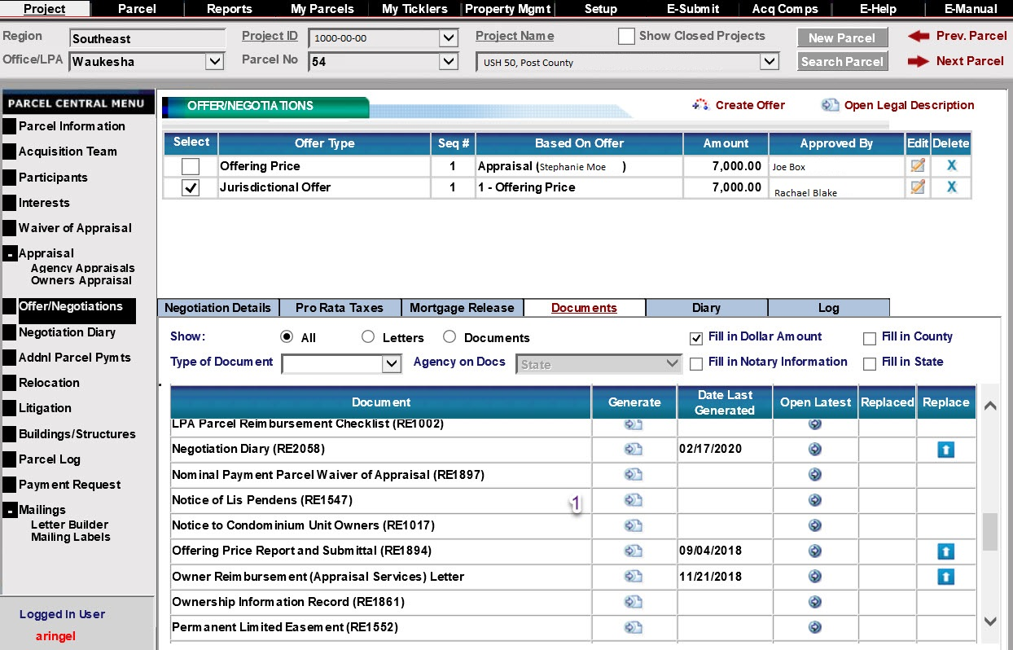
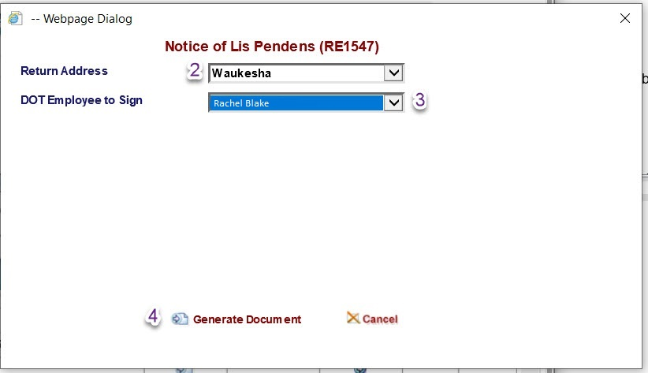

Back
Lis Pendens Document
This space is reserved for recording data
Return to
Wisconsin Department of Transportation
WisDOT SE Region 141 NW Barstow Street
Waukesha, WI 53187-0798
Parcel Identification Number/Tax Key Number
867-5308
NOTICE OF LIS PENDENS
Wisconsin Department of Transportation
Exempt from filing transfer form [s. 77.21(1), 77.22(1) Wis. Stats.]
RE1547 05/2020 Ch.32 Wis. Stats.

State of Wisconsin, County of Post

In the matter of acquisition of real property of Ruth and Ethan Clark, Bank of the Area, Tanace Franklin

By Wisconsin Department of Transportation
You are notified that the Wisconsin Department of Transportation, has caused to be served upon or mailed to Ruth and Ethan Clark, 1323 Cactus Court, Point, WI 55555 as provided in s.32.05(4) Wis. Stats., a jurisdictional offer, a copy of which is attached and incorporated by reference. The premises affected by the jurisdictional offer and by the operation of s.32.05(4) Wis. Stats., are described in the attached and incorporated offer.

Wisconsin Department of Transportation

Rachel Blake 01/03/2022 |  |  |  | January 3, 2022
Signature |  | Date |  | Date
Rachel Blake |  |  |  | State of Wisconsin )  ) ss.  Waukesha County )  On the above date, this instrument was acknowledged before me by the named person(s).  The signer was: X____ Physically in my presence. OR  ____ In my presence involving the use of communication technology.  Abigail Anderson
Print Name
Real Estate Supervisor
Title
 |  |  |  | Signature, Notary Public, State of Wisconsin
 |  |  |  | Abigail Anderson
 |  |  |  | Print Name, Notary Public, State of Wisconsin
 |  |  |  | 06/01/2023
 |  |  |  | Date Commission Expires

LEGAL DESCRIPTION IS ATTACHED AND MADE A PART OF THIS DOCUMENT BY REFERENCE.

LEGAL DESCRIPTION

Parcel 54 of Transportation Project Plat 1000-00-00 – 4.11, recorded in Document 1800275 recorded in Post County, Wisconsin.
Property interests and rights of said Parcel 54 consist of:
Fee Simple
Temporary Limited Easement
Any interest or rights not listed above for said parcel but shown as required on said Transportation Project Plat are hereby incorporated herein by reference.

JURISDICTIONAL OFFER Wisconsin Department of Transportation
RE1786 10/2018 s.32.05 Wis. Stats.

Date: 01/03/2022
To: Ruth and Ethan Clark, Bank of the Area, Tanace Franklin, hereinafter referred to as Owner.
Relocation Order date(s)
07/26/2018
Relocation Order | County  Post | Public purpose for property  Construction of USH 50
Wisconsin Department of Transportation, hereinafter referred to as Purchaser, offers to purchase a parcel of real estate and/or rights therein in which you own an interest as described on attached page, and within 60 days from the acceptance of this offer agrees to pay the sum of: Seven Thousand and 0/100 Dollars ($7,000.00)
A. The said property, and/or rights as described, is required by the State of Wisconsin for the public purpose stated above, as more fully described in the Relocation Order, date and place of filing specified above. The State of Wisconsin in good faith intends to use the above-described property for such public purpose.
B. The State of Wisconsin proposes to occupy and the Owner will vacate the premises on this date: 02/03/2022
C. Pursuant to s.32.05(3)(d) Wis. Stats., the above purchase price is allocated as follows:
(a) Loss of land, including improvements and fixtures actually being acquired $ 1,800.00
(b) Damages caused by loss of existing rights of access $ 0.00
(c) Damages caused by loss of air rights $ 0.00
(d) Damages caused by loss of legal nonconforming use $ 0.00
(e) Damages resulting from actual severance of land including damages resulting from severance of improvements or fixtures and proximity damage to improvements remaining on Owner's land $ 0.00
(f) Damages to property abutting on a highway right of way due to change of grade $ 0.00
(g) Cost of fencing reasonably necessary to separate land taken from remainder $ 0.00
(h) Market value of uneconomic remnant $ 0.00
(i) Other: TLE & Landscaping $ 5,200.00
Compensation for additional items of damage listed in s.32.19 Wis. Stats. has not been included. If any such items are shown to exist the owner may file claims as provided in s.32.20 Wis. Stats.
D. The purchase price is based upon an appraisal of the owner's property of which a copy of the appraisal report has been provided to the owner.
E. Owner has 20 days from the date of personal service of this offer, if personally served, or 20 days from the date of postmark of the certified mail envelope transmitting this offer, if transmitted by mail, or 20 days from the date of publication of this offer, if published, in which to accept this offer, unless such time is extended by mutual written consent of Owner and Purchaser. Acceptance shall be as follows: Owner must execute the acceptance clause on back (second page) of this offer on or prior to 01/24/2022; and the offer and acceptance must be delivered to Purchaser, Attn: LL Mason, WisDOT, Waukesha WisDOT SE Region 141 NW Barstow Street, Waukesha, WI 53187 not later than regular office closing time on 01/24/2022, or mailed to Purchaser at the last above stated address in an addressed, postage prepaid envelope bearing postmark of not later than 12:00 midnight on 01/24/2022.
F. If the Owner does not accept this offer as set forth, Owner has 40 days from the date of service, postmark or publication of this offer to commence a court action to contest the right of condemnation as provided in s.32.05(5) Wis. Stats. provided that the acceptance and retention of any compensation resulting from an award made prior to the commencement of such an action shall be an absolute bar to such action.
G. If owner agrees to accept the Jurisdictional Offer, it is considered a negotiated purchase; therefore, the condemnor must record the conveyance with the Register of Deeds in the county where the land is located. Also, all owners of record should receive by certified mail a copy of the conveyance and a notice of their right to appeal within 6 months after the date of the recording of the conveyance. Such an appeal would challenge the amount of compensation received by the property owner from an accepted Jurisdictional Offer.
H. Owner has 2 years from the date of the recording of an award, as described in s.32.05(7) Wis. Stats., in the office of the Register of Deeds in which to appeal for greater compensation without prejudice to Owner's right to use the compensation given to Owner by the award. Owner's right of appeal is subject to the provisions of s.32.05(9)(a) and (11), Wis. Stats.
I. The law provides for the payment of litigation expenses by the condemnor and these costs are defined in Ch. 814 of Wisconsin Statutes.
J. If this offer is accepted by Owner, the transfer of title shall be accomplished within 60 days after acceptance including the payment to Owner of said purchase price; provided, however, that notwithstanding any provision herein to the contrary, said 60-day period may, at the request of the Owner, be extended by mutual written agreement of the Owner and Purchaser.
K. This offer may be withdrawn by Purchaser at any time prior to its acceptance by Owner.
L. Real estate taxes for the current year shall be prorated as of the date of proposed occupancy set forth, said proration to be based upon the latest available tax assessment.

M. Purchaser will prepare necessary instruments to accomplish said transfer. Transfer shall be by Warranty Deed unless a lesser conveyance is accepted by Purchaser. Transfer shall be free of defects and encumbrances but subject to ordinances and restrictions of record.
N. If all persons or entities designated as Owner do not accept this offer within the time specified, this offer will be deemed to have been rejected by all such persons or entities notwithstanding the acceptance by one or more of such persons or entities.
O. Included in the purchase price is payment in full for the acquisition of the following items now on the described property. Description on additional page(s) .
P. This offer, if accepted by Owner, shall constitute a binding contract.
Wisconsin Department of Transportation |  |  | Rachel Blake 01/03/2022
 |  |  | Real Estate Management |  |  | Date
 |  |  | Rachel Blake
 |  |  | Print Name
 |  |  | Real Estate Supervisor
 |  |  | Title
If owner is not a firm or corporation, check and sign here: |  |  |  | If owner is a firm or corporation, check and sign here:
Accepted Rejected |  |  |  | Accepted Rejected
Owner Signature | Date |  |  | Firm or Corporation Name
Ruth Clark
Print Name |  |  |  | Officer Signature |  | Date
Owner Signature | Date |  |  | Print Name
Ethan Clark
Print Name |  |  |  | Title
Owner Signature | Date |  |  | Officer Signature |  | Date
Print Name |  |  |  | Print Name
Owner Signature | Date |  |  | Title
Print Name
This instrument was drafted by  Wisconsin Department of Transportation |  | Project ID  1000-00-00 |  |  | Parcel No.  54

Back

Generate JO Letter

Offer/Negotiations Documents Jurisdictional Offer Letter
- Click Generate. Another screen will pop up
- Select all parties of interest
- Enter letter date. Should be same date as JO and Lis Pendens
- Enter deadline date. Must be the same as deadline date on JO
- Click Certified Mail. All condemnation documents must be sent certified
- Ensure appropriate office is listed. If not, dropdown to correct office.
- Click Generate
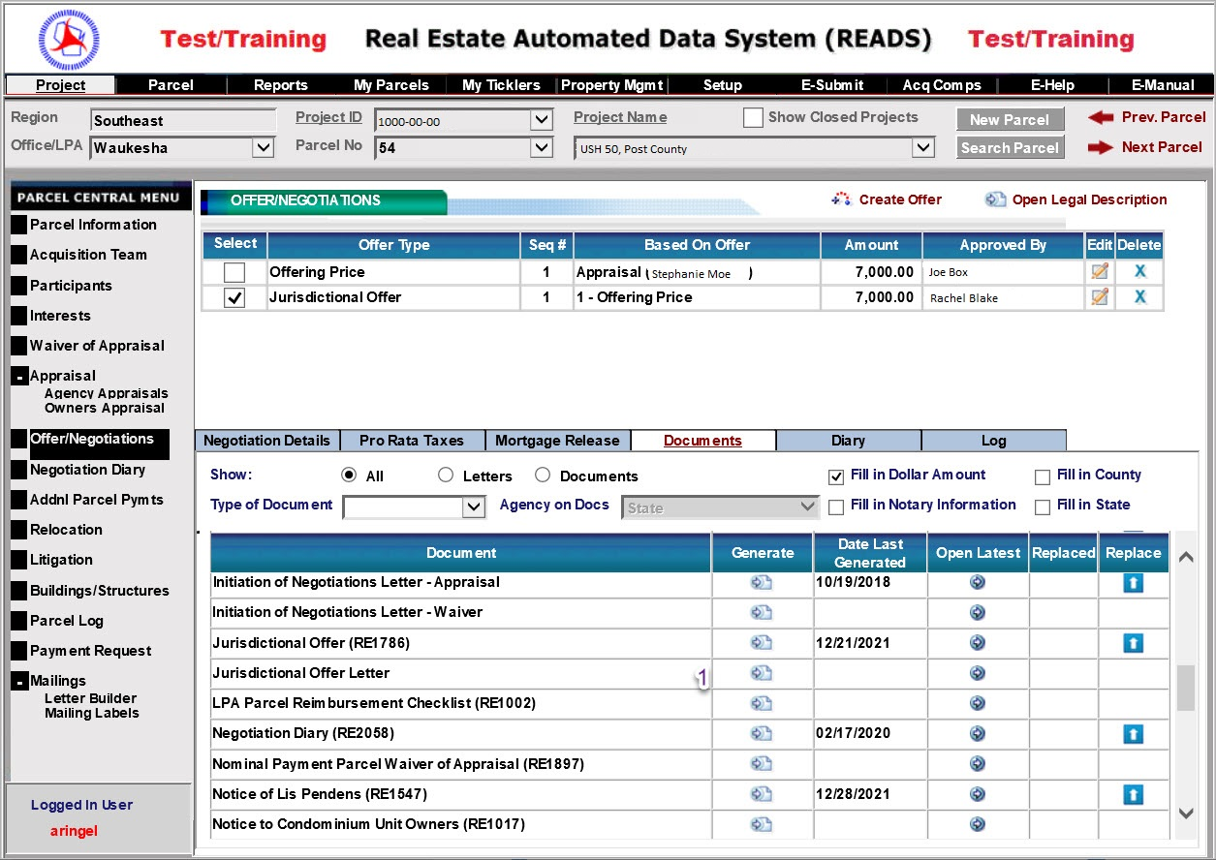
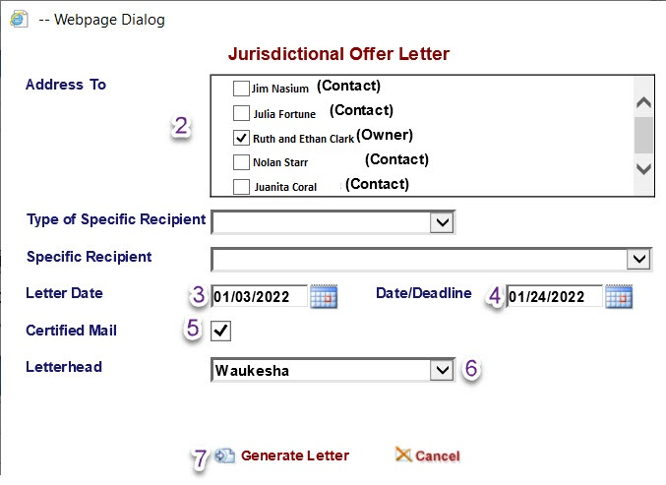
Back
JO Letter

January 3, 2022 CERTIFIED MAIL

Ruth and Ethan Clark
1323 Cactus Court
Point, WI 55555

Reference: Jurisdictional Offer
Project ID: 1000-00-00, Parcel No. 54
USH - 050, Post County

Dear Ruth and Ethan Clark

On 10/19/2018, the agency made an initial offer of $7,000.00 to purchase 0.003 acres of your property and/or property interest needed for the highway project cited above. This offer was based upon an appraisal prepared by Stephanie Moe (Moe Appraisal, LLC). This letter rescinds and replaces any previous offers presented to you during our negotiations.

Because we failed to reach a negotiated agreement, it is now necessary to present a Jurisdictional Offer to purchase the needed property and/or property interest. "The Rights of Landowners under Wisconsin Eminent Domain Law," previously provided, explains this process. You have twenty (20) days from the postmark date of this letter to either accept or reject the offer.

Please carefully consider this Jurisdictional Offer. It remains the department’s desire to reach a negotiated settlement. You have twenty (20) days from the postmark date of this letter to either accept or reject the offer.

If you accept the terms, you must sign both page 2 of the offer and the enclosed conveyance. The conveyance must be signed before a notary public. Return both documents in the enclosed self-addressed postage paid envelope. If you need a notary public, please call me.

It remains the agency’s desire to reach a negotiated settlement. If there is no response from you by 01/24/2022, the agency will assume you have rejected the offer. The agency will then proceed to acquire this parcel by issuing an Award of Damages as per Sec 32.05(7) Wis. Stats.

Please call me at 555-333-4444 if you have any questions.

Sincerely,

LL Mason

LL Mason
Real Estate Specialist

Enclosures: Jurisdictional Offer, conveyance, self-addressed postage paid envelope

Back
JO Parties of Interest Letter

CERTIFIED MAIL

January 3, 2022

Bank of the Area
1796 Mastodon Drive
Maple, WI 54444

Reference: Jurisdictional Offer
Project ID: 1000-00-0, Parcel No. 54
USH - 050, Post County

You are being sent the attached package because you have been listed as a party of interest in the property identified within. Your specific interest is as a (insert party of interest type). Recorded Document (Insert Document Type) # (Insert Document Number) recorded in (Insert Appropriate County) county.
Should you have any questions, please contact me at (Insert Phone Number).

Sincerely,

LL Mason

LL Mason
Real Estate Specialist

Cc: Tanace Franklin

Back

Payment Request

*Enter as much information into comments as necessary. This is for BTS Finance information only.
*Even though if check is to be sent to the Region, Peoplesoft will require a mailing address. If this information is not correct, this will delay payment.

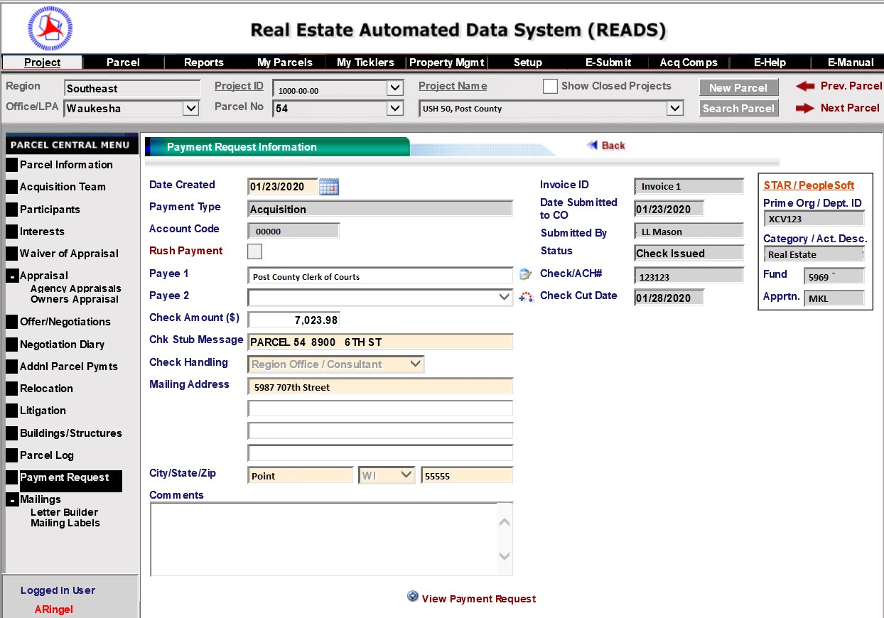
Back

Generate Award of Damages

Offer/Negotiations Documents Award of Damages (RE1584)
- Click Generate. A new screen will pop up.
- Ensure the correct office is listed.
- Ensure the correct approving authority is listed. If not, dropdown to the correct name.
- Enter the occupancy date. This should be the same as on the JO
- Click Generate Document
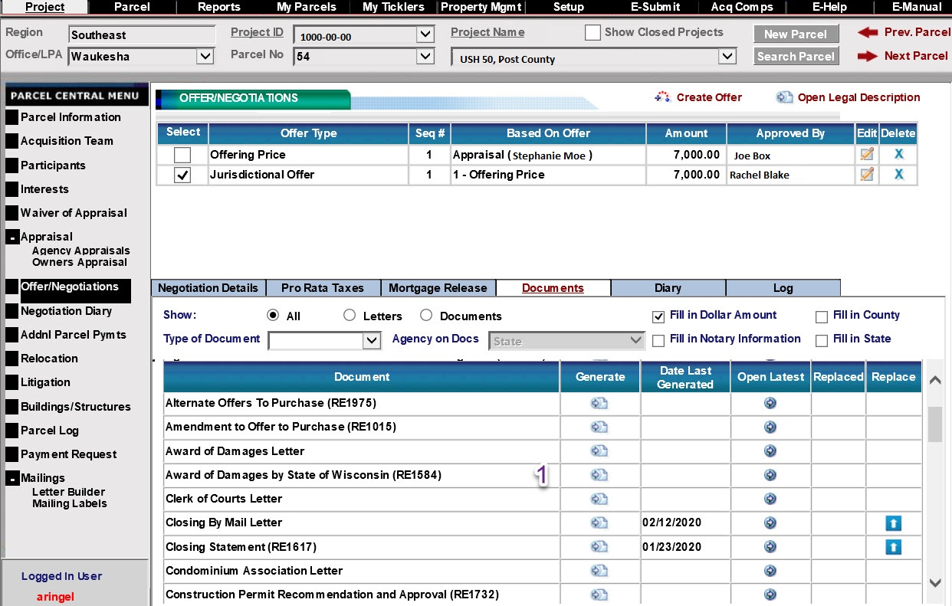
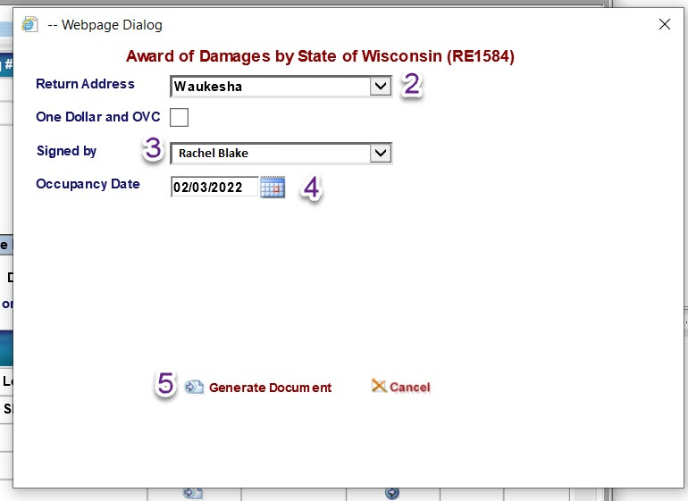
Back
Generate Award of Damages Letter

Offer/Negotiations Documents Award of Damages Letter
- Click Generate. A new screen will pop up.
- Select all parties of interest.
- Enter date the letter will be sent. This is after JO expires and occupancy date has been reached.
- Enter the date the JO was sent/presented.
- Click Certified Mail
- Enter the occupancy date. This should be the same as on the JO but must be after payment and recording of the Award.
- Ensure the correct office is listed.
- Click Generate Document
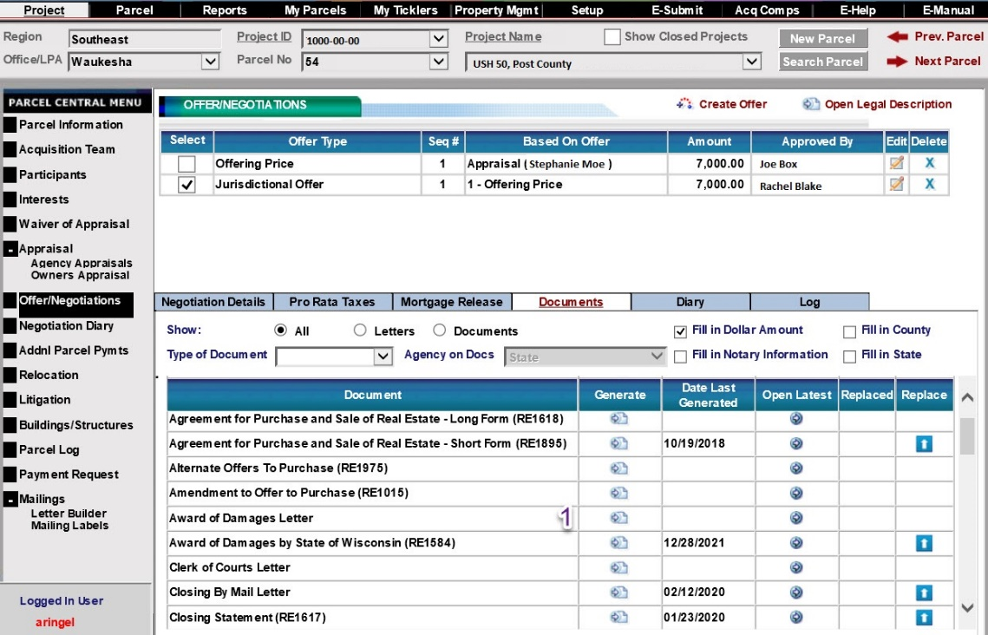
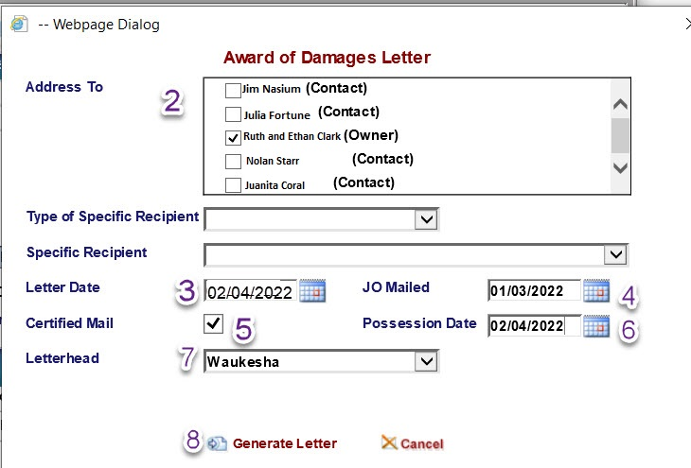
Back
Award Letter

February 4, 2022 CERTIFIED MAIL

Ruth and ethan clark
1323 Cactus court
point, wi 55555

Reference: Award of Damages
Project ID: 1000-00-00, Parcel No. 54
USH - 050, Post County

Dear Ruth and ethan clark:

The Agency regrets we are unable to reach a negotiated settlement with you to acquire your property needed for the above highway project and that it is now necessary to acquire the needed property through condemnation. Sec 32.05(7) Wis. Stats.

As required, we will now record an Award of Damages naming all interested parties of record in the property. Your copy of the Award of Damages, along with check number 1001657600 in the amount of $7,023.98 is enclosed. Title to the property will transfer to the (insert correct agency) at the time of recording and we will take possession of the property on 02/04/2022.

Any named party of interest may appeal the Award of Damages within two years of the recording date. The right to appeal is summarized in the Jurisdictional Offer mailed to you on 01/03/2022.

I am also enclosing a Request for Taxpayer Identification Number and Certification (IRS Form W-9). Please complete, sign, date and return the form in the enclosed postage-paid envelope. If you are exempt, please furnish a copy of your exempt status. If the property is owned by more than one owner (other than husband and wife), please provide the same information on a separate sheet for each owner. This information is required by the IRS and failure to provide your social security number or employer identification number could lead to civil and criminal penalties.

If you have any questions regarding the Award of Damages, please contact me at 555-333-4444.

Thank you.

Sincerely,

LL Mason

LL Mason
Real Estate Specialist

Enclosures: Award of Damages; check for property; IRS W-9; postage paid envelope

Back
Generate Clerk of Courts Letter
Offer/Negotiations Documents Clerk of Courts Letter
- Click Generate. A new screen will pop up.
- Select all parties of interest.
- Select Clerk of Courts from drop down
- Enter date the letter will be sent. This is after JO expires and occupancy date has been reached.
- Click Certified Mail
- Ensure the correct office is listed.
- Select the correct payment request from the drop down.
- Click Generate Document
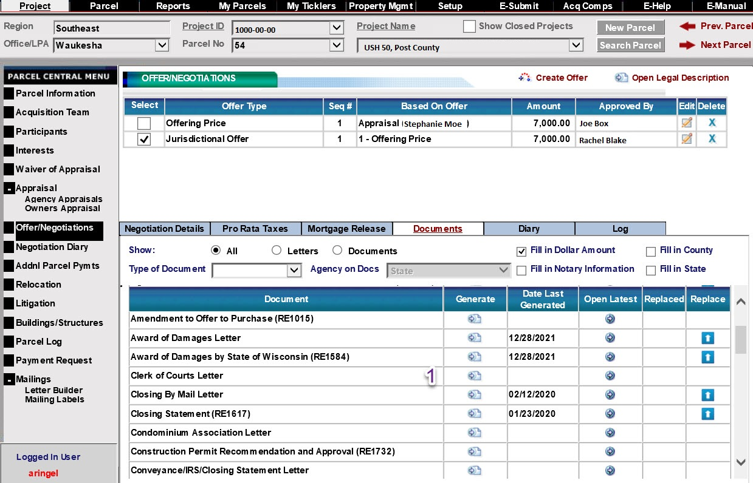
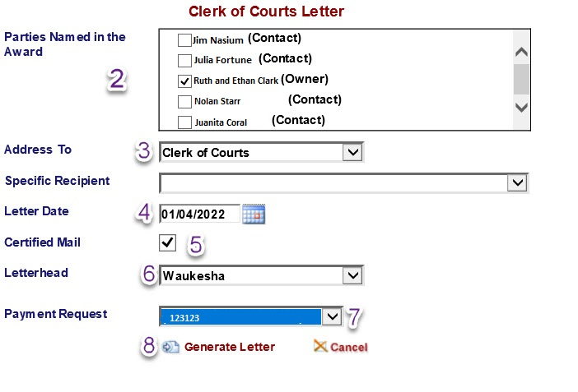
Back
Award Parties of Interest Letter

CERTIFIED MAIL

January 4, 2022

Bank of the Area
1796 Mastodon Drive
Maple, WI 54444

Reference: Award of Damages
Project ID: 1000-00-00, Parcel No. 54
USH - 050, Post County

You are being sent the attached package because you have been listed as a party of interest in the property identified within. Your specific interest is as a (insert party of interest type). Recorded Document (Insert Document Type) # (Insert Document Number) recorded in (Insert Appropriate County) county shows this interest.
Should you have any questions, please contact me at (Insert Phone Number).

Sincerely,

LL Mason

LL Mason
Real Estate Specialist

Cc: Tanace Franklin

Back

Generate 2 Year Award Letter

CERTIFIED MAIL

February 4, 2022

RE: Appeal Rights
Project ID: 1000-00-00, Parcel No. 54
USH - 050, Post County

Ruth and Ethan Clark

Enclosed is a copy of the recorded conveyance/document required to be submitted to you under Sec. 32.05(2a), Wisconsin Statutes.
Section 32.05(2a), Wisconsin Statutes, provides that within two years after the date of the recording of this conveyance, you have the right to appeal from the amount of compensation stated on this conveyance in the manner set forth in Sec .32.05(9) to (12), and Ch. 808 and 809, Wisconsin Statutes for appeals from an award under Sec. 32.05(7), Wisconsin Statutes.
For purposes of any such appeal, the amount of compensation stated on the conveyance shall be treated as the award, and the date the conveyance is recorded, shall be treated as the date of the taking and the date of evaluation.
Any party having an interest may appeal from this Award of Damages for greater compensation within two years from the date of recording of this document. This right to appeal was summarized in the Jurisdictional Offer, which you previously received.

Sincerely,
LL Mason

LL Mason
Real Estate Specialist

Enclosures: Award of Damages
Cc: Bank of the Area, Tanace Franklin
Back

Award
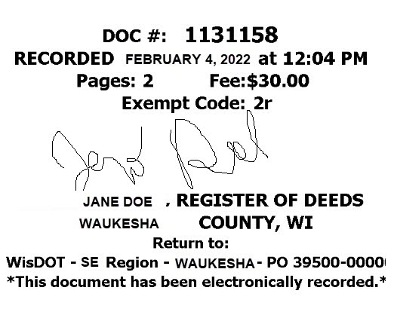This space is reserved for recording data
Return to
Wisconsin Department of Transportation
WisDOT SE Region 141 NW Barstow Street
Waukesha, WI 53187-0798
Parcel Identification Number/Tax Key Number
867-5308
AWARD OF DAMAGES
By State of Wisconsin
Wisconsin Department of Transportation
Exempt from fee: s.77.25(2r) Wis. Stats.
RE1584 05/2020 s.84.09(2) Wis. Stats

This award of damages is made pursuant to a relocation order of the Wisconsin Department of Transportation dated 07/26/2018 and in Post County, for the improvement of USH 50, in Post County.

The State of Wisconsin has determined it necessary to acquire, for the purpose set forth in and in accordance with said relocation order, a parcel of real estate and/or rights therein as set forth, in and to which the following persons have an interest: Ruth and Ethan Clark, Bank of the Area, Tanace Franklin

The interest acquired by this award is:

LEGAL DESCRIPTION IS ATTACHED AND MADE A PART OF THIS DOCUMENT BY REFERENCE.

Said parcel or real estate and/or interests therein will be occupied by the State of Wisconsin or its agents on 02/03/2022 (date).

The State of Wisconsin, having complied with all jurisdictional requirements pursuant to law, makes this award of damages to the above persons having an interest in said parcel of real estate, in the sum of Seven Thousand and 00/100 Dollars ($7,000.00), for the acquisition of said parcel for real estate and/or interests therein as set forth.
Rachel Blake 02/03/2022
Signature Date
Rachel Blake |  | February 3, 2022
Print Name |  | Date
State of Wisconsin
)
) ss.
Waukesha County )
Signature Date
Print Name
On the above date, this instrument was acknowledged before me by the named person(s).

The signer was: _x___ Physically in my presence. OR

____ In my presence involving the use of communication technology.
Abigail Anderson
Signature Date
 |  | Signature, Notary Public, State of Wisconsin
 |  | Abigail Anderson
 |  | Print Name, Notary Public, State of Wisconsin
 |  | June 1, 2023
 |  | Date Commission Expires

LEGAL DESCRIPTION

Parcel 54 of Transportation Project Plat 1000-00-00 – 4.11, recorded in Document 1800275 recorded in Post County, Wisconsin.
Property interests and rights of said Parcel 54 consist of:
Fee Simple
Temporary Limited Easement
Any interest or rights not listed above for said parcel but shown as required on said Transportation Project Plat are hereby incorporated herein by reference.

Back

Publishing Offer Letter Template

Items in RED must be replaced with project & parcel specific information

October 3, 2021
Project ID 1000-00-00, Parcel No. 54
Highway Project: USH 50
Post County

The Wisconsin Department of Transportation is proposing to replace existing bridge on USH 50 over Smoothie Brook. The existing bridge will be replaced with a single span prestressed concrete girder bridge in approximately the same location. The roadway of USH 50 will be reconstructed from approximately 200 feet west and 250 feet east of the existing bridge. New beam guard will be constructed in all four quadrants adjacent to the shoulders. The project is scheduled for 2027 construction.

This publication letter is to initiate negotiations for the acquisition of the property and/or property interests needed for the referenced highway project. A search of public records indicates title to the property is unknown. The portion of land affected is indicated as Parcel 54 on the right of way plat. The acquisition involves 0.003 acres of land and 241 sq. ft. of Temporary Limited Easement (TLE) for sloping and grading. The TLE will terminate at the end of construction.

Based on a real estate appraisal report prepared by Stephanie Moe, the allocation of damages is:
Land - 0.003 acres $1,800.00
TLE - 0.049 acres $4,500.00
Landscaping - $700.00
Total Rounded $7,000.00

If you, the owner, are not satisfied with the above-stated conclusions of value for the property, you are eligible to obtain an additional appraisal from a qualified appraiser of your choice. If the owner elects to have an appraisal report prepared, there are certain steps to qualify for reimbursement. Eligibility for appraisal cost reimbursement will expire 60 days from the date of this notice’s initial publication, which is estimated to be on April 18, 2022.

If the owner’s appraisal report is submitted after the 60-day statutory date, the agency may consider it for negotiation purposes, however, it will not be eligible for reimbursement.

The Agency wants you to be satisfied that your property and your rights have been fully considered. If you have any questions, please call me at 555-333-4444 before October 1, 2018.
Sincerely,
LL Mason
Real Estate Specialist

Sample Offer letter confirmation

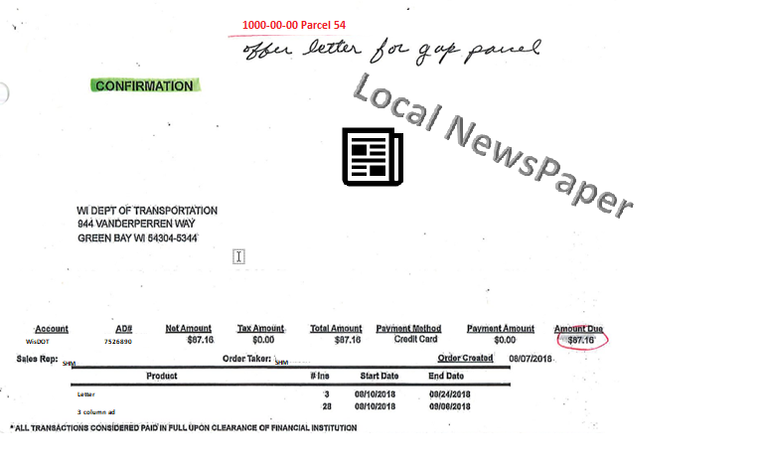

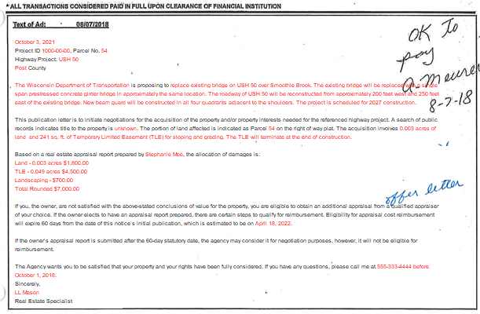

Sample Affidavit of publication
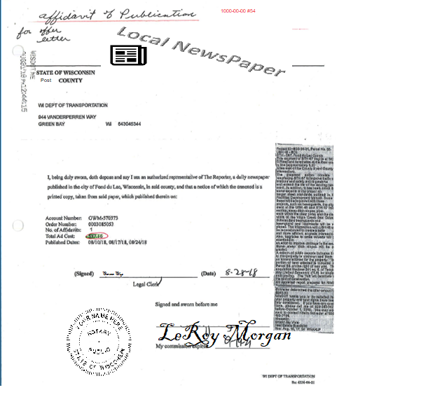

Publishing Jurisdictional Offer Template

Items in RED must be replaced with project & parcel specific information

JURISDICTIONAL OFFER
s.32.05 Wis Stats
Date: 1/03/2022 Ruth and Ethan Clark, Bank of the Area, Tanace Franklin (include all parties of interest), hereinafter referred to as Owner.
Relocation Order Date: 07/26/2018
Relocation Order Filed or Recorded at Register of Deeds of POST County.
Public Purpose for Property: Construction of USH 50
Wisconsin Department of Transportation, hereinafter referred to as Purchaser, offers to purchase a parcel of real estate and/or rights therein as described in the legal description, and within 60 days from the acceptance of this offer agrees to pay the sum of:
Seven Thousand and 00/100 Dollars ($7,000.00)
A. The said property, and/or rights as described, is required by the State of Wisconsin for the public purpose stated above, as more fully described in the Relocation Order, date and place of filing specified above. The State of Wisconsin in good faith intends to use the above-described property for such public purpose.
B. The State of Wisconsin proposes to occupy and the Owner will vacate the premises on this date: 2/03/2022
C. Pursuant to s.32.05(3)(d) Wis. Stats., the stated purchase price is allocated as follows:
(a)Loss of land, including improvements and fixtures actually being acquired $1,800.00; (b)Damages caused by loss of existing rights of access $0.00;(c)Damages caused by loss of air rights $0.00;(d) Damages caused by loss of legal nonconforming use $0.00;(e)Damages resulting from actual severance of land including damages resulting from severance of improvements or fixtures and proximity damage to improvements remaining on Owner’s land $0.00;(f)Damages to property abutting on a highway right of way due to change of grade $0.00;(g)Cost of fencing reasonably necessary to separate land taken from remainder $0.00;(h) Market value of uneconomic remnant $0.00;(i)Other – $5,200.00;
Compensation for additional items of damage listed in s.32.19 Wis. Stats. has not been included. If any such items are shown to exist the owner may file claims as provided in s.32.20 Wis. Stats.
D. The purchase price is based upon an appraisal of the owner's property of which a copy is available for inspection at the Wisconsin Department of Transportation 141 NW Barstow Street, Waukesha, WI 53187 by persons having an interest in the lands sought to be acquired.
E. Owner has 20 days from the date of publication of this offer, in which to accept this offer, unless such time is extended by mutual written consent of Owner and Purchaser. Acceptance shall be as follows: Owner must by returning this publication and a written acceptance statement on or prior to 01/24/2022 and the offer and acceptance must be delivered to Purchaser, Attn: LL Mason, Wisconsin Department of Transportation 141 NW Barstow Street, Waukesha, WI 53187 not later than regular office closing time on 01/24/2022, or mailed to Purchaser at the last above-stated address in an addressed, postage prepaid envelope bearing postmark of not later than 12:00 midnight on 01/24/2022.
F. If the Owner does not accept this offer as set forth, Owner has 40 days from the date of publication of this offer to commence a court action to contest the right of condemnation as provided in s. 32.05(5) Wis. Stats. provided that the acceptance and retention of any compensation resulting from an award made prior to the commencement of such an action shall be an absolute bar to such action.
G. If owner agrees to accept the Jurisdictional Offer, it is considered a negotiated purchase; therefore, the condemnor must record the conveyance with the Register of Deeds in the county where the land is located.
H. Owner has 2 years from the date of the recording of an award, as described in s. 32.05(7) Wis. Stats., in the office of the Register of Deeds in which to appeal for greater compensation without prejudice to Owner's right to use the compensation given to Owner by the award. Owner's right of appeal is subject to the provisions of s. 32.05(9)(a) and (11), Wis. Stats.
I. The law provides for the payment of litigation expenses by the condemnor and these costs are defined in Ch. 814 of Wisconsin Statutes.
J. If this offer is accepted by Owner, the transfer of title shall be accomplished within 60 days after acceptance including the payment to Owner of said purchase price; provided however, that notwithstanding any provision herein to the contrary, said 60-day period may, at the request of the Owner, be extended by mutual written agreement of the Owner and Purchaser.
K. This offer may be withdrawn by Purchaser at any time prior to its acceptance by Owner.
L. Real estate taxes for the current year shall be prorated as of the date of proposed occupancy set forth, said proration to be based upon the latest available tax assessment.
M. Purchaser will prepare necessary instruments to accomplish said transfer. Transfer shall be by Warranty Deed unless a lesser conveyance is accepted by Purchaser. Transfer shall be free of defects and encumbrances but subject to ordinances and restrictions of record.
N. If all persons or entities designated as Owner do not accept this offer within the time specified, this offer will be deemed to have been rejected by all such persons or entities notwithstanding the acceptance by one or more of such persons or entities.
O. Included in the purchase price is payment in full for the acquisition of the following items now on the described property. Description on additional pages(s). None
P. This offer, if accepted by Owner, shall constitute a binding contract.

Wisconsin Department of Transportation

Rachel Blake,
Real Estate Supervisor

Legal Description:
Parcel 54 of Transportation Project Plat 1000-00-00 recorded in Document 1800275 recorded in Post County, Wisconsin. Property interests and rights of said Parcel 54 consist of: Fee Simple and Temporary Limited Easement. Any interest or rights not listed above for said parcel but shown as required on said Transportation Project Plat are hereby incorporated herein by reference.

Tax Parcel Number:
867-5308

Award of Damages for publishing Template
Items in red must be updated for your current document (names, dates, amounts, legal description etc).
.
AWARD OF DAMAGES
By State of Wisconsin
Wisconsin Department of Transportation
Exempt From fee: s.77.25(2) Wis Stats.
s.84.09(2) Wis. Stats

This award of damages is made pursuant to a relocation order of the State of Wisconsin, Department of Transportation, dated 07/26/2018 and recorded at the Register of Deeds Office in Post County, for the improvement of USH 50, in Post County.

The State of Wisconsin has determined it necessary to acquire, for the purpose set forth in and in accordance with said relocation order, a parcel of real estate and/or rights therein as set forth, in and to which the following persons have an interest:
Ruth and Ethan Clark, Bank of the Area, Tanace Franklin (include all parties of interest).

The interest acquired by this award is Legal Description: Parcel 54 of Transportation Project Plat 1000-00-00 recorded in Document 1800275 recorded in Post County, Wisconsin. Property interests and rights of said Parcel 54 consist of: Fee Simple and Temporary Limited Easement. Any interest or rights not listed above for said parcel but shown as required on said Transportation Project Plat are hereby incorporated herein by reference.

Tax Parcel Number:
867-5308

Said parcel or real estate and/or interests therein will be occupied by the State of Wisconsin or its agents on 02/03/2022.

The State of Wisconsin having complied with all jurisdictional requirements pursuant to law, makes this award of damages to the above persons having an interest in said parcel of real estate, in the sum of Seven Thousand and 00/100 Dollars ($7,000.00) for the acquisition of said parcel for real estate and/or interests therein as set forth.

State of Wisconsin. Department of Transportation
Rachel Blake, (Real Estate Supervisor)
02/03/2022

