June 12th 2014 Release of HSI
Primary Upgrades and Bug Fixes:
- There is a new Map button (see below) that the user can toggle on/off. When on, the bridges will appear in a map with pushpins. By clicking the pushpin, you will be taken to the structure page for that item. Clicking home will bring you back to the Map.
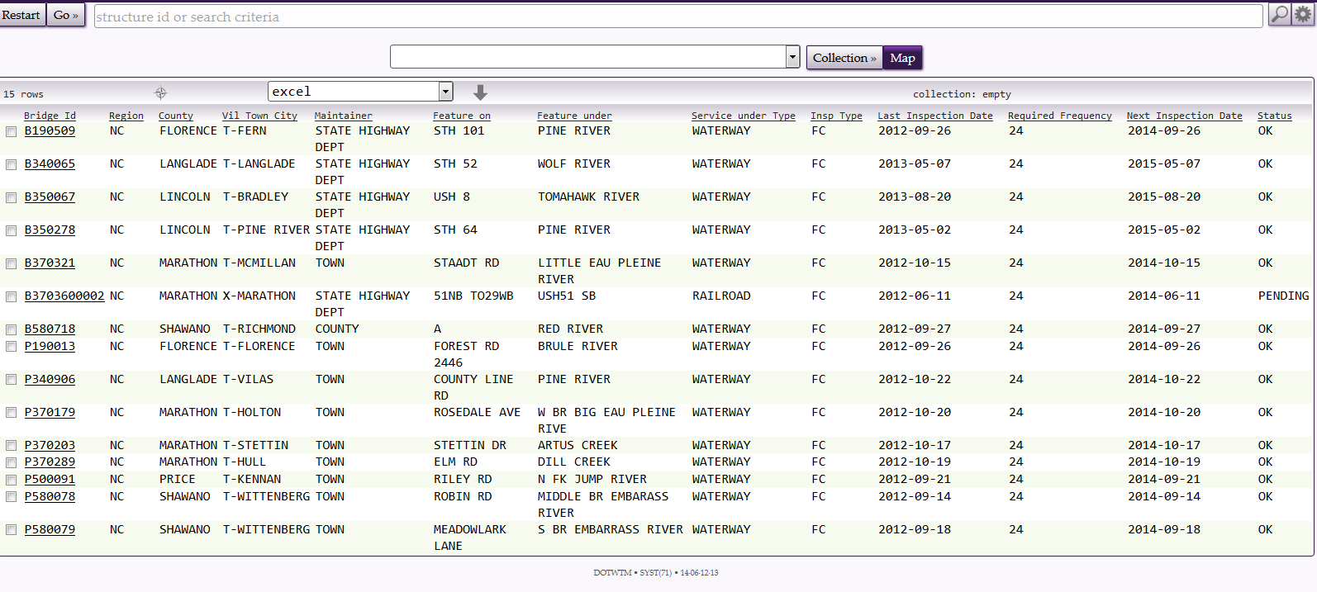
- A system logout feature has been added, and can be found in the “GO” dropdown shown below.
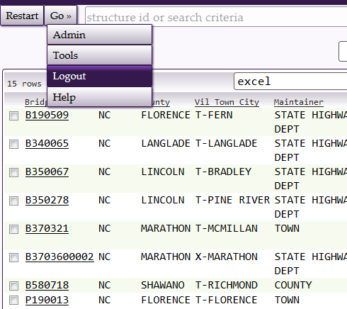

- Image files are being scaled down to improve overall system performance. It’s been noted that many users are uploading very large image files (5Mb plus). Though we still strongly encourage you to change camera settings to a much lower resolution, we now have the software scaling the images you load down to a more reasonable file size. Thus, the PDF created by the system with images you upload will be smaller as well.

- When entering notes for inspection related items, the HSI system will now auto-track the changes for you (see below example for Element 107; in the system, click on the arrow next to the comment to see underlined / crossed out changes). So this can eliminate the need for initialing and dating comments. There are exceptions, however, where the need to date may still be necessary.

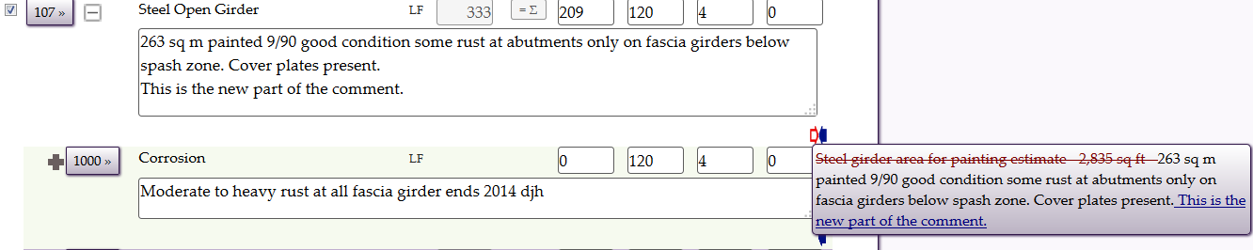

- Just to note: Inspections will not auto-complete (nor can the inspector manually complete the inspection) until all errors noted on the Edit Tab (listed under “complete disabled reason(s)”) have been addressed. In the example below, the inspection time has yet to be filled out and there are two elements that do not have defect information filled out even though they have condition states less than CS1.
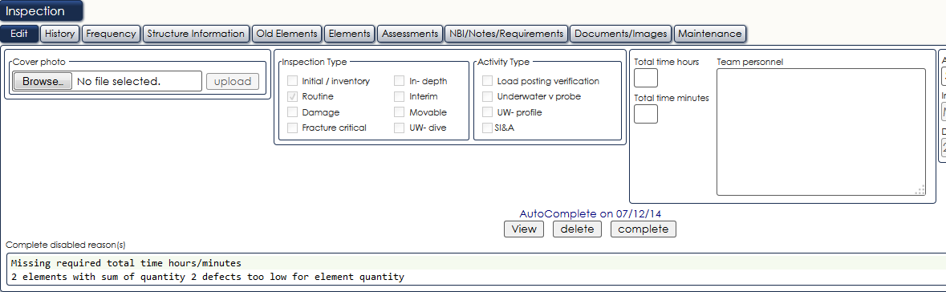

- And many, many other fixes that can be found in G0 – HELP – TOPIC – RELEASE NOTES

