September 2014 Release of HSI
Primary Upgrades and Bug Fixes:

- Inspection Documents/Photos. This feature allows users to copy images from prior documents.

- Load Posted Bridges. The requirement for load posted bridges has changed. No longer is there a “Load Posted Inspection” type. Inspections are all now Routine, per Policy documents found on the inspection website, and the frequency varies based on the condition of the bridge as well as the posting level:
http://on.dot.wi.gov/dtid_bos/extranet/structures/inspection/index.htm

- DT2122 Load Posted Field Verification Form – Bridge owners, per the above website, are now required to have a copy of this form on file in HSI if the bridge has a load posting. This can be entered by selecting activity type “DT2122 Load Posting Verification Form” and entering the date. Then click on the Documents/Images tab, select Posted and Click Add. Then upload the form (with photos attached) in a Word Document or PDF format. After you upload, click Edit, and then Complete.
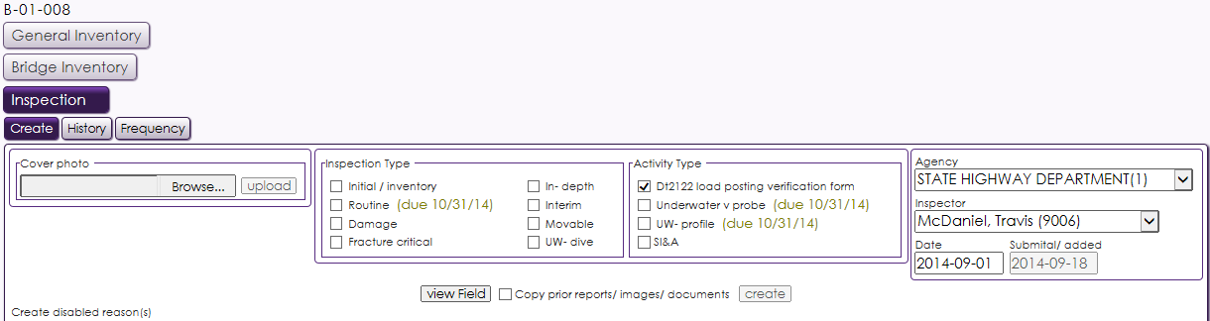

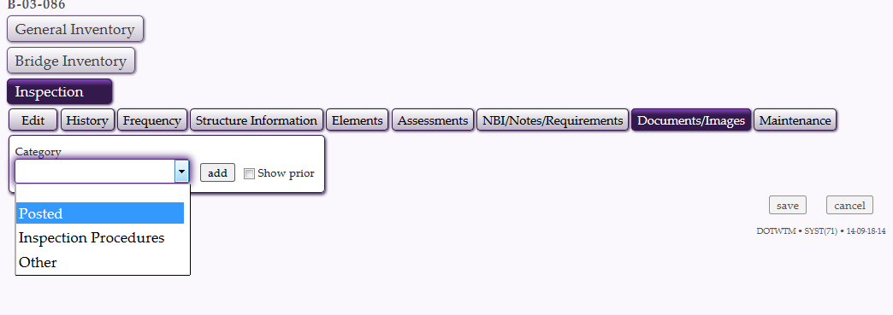4. Report Updates
Several inspection-related reports have been updated to accurately handle the new element system. Included in this list are the scheduling and performance reports. More reports will be upgraded in the following weeks.
- And many other fixes that can be found in G0 – HELP – TOPIC – RELEASE NOTES

