April 22nd, 2015

- File Sandbox. This feature allows the user to gather requested files (most often Field Inspections) into a folder system that can be accessed directly in HIS by the user, rather than having the files emailed in a separate process. This is particularly useful when file sizes exceed limits in the email system.
For example, say you want to print the field inspection forms for the Bong Bridge in Superior. To do this, you would add those 19 structure ID’s into a collection, and click Collection – Print – Field Inspection as shown below (same as before).
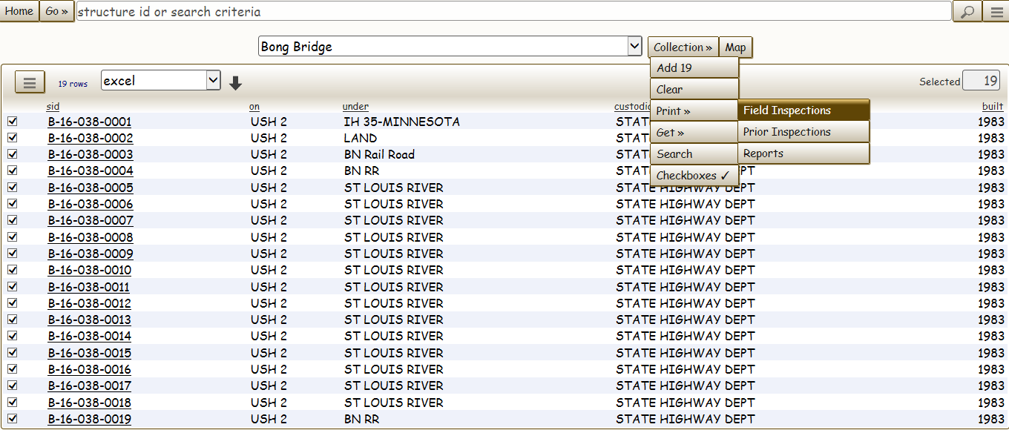
The system takes you to the Structure Collection tab in Tools (same as before). The difference is the checkbox just to the right of your email address (see circled item below)
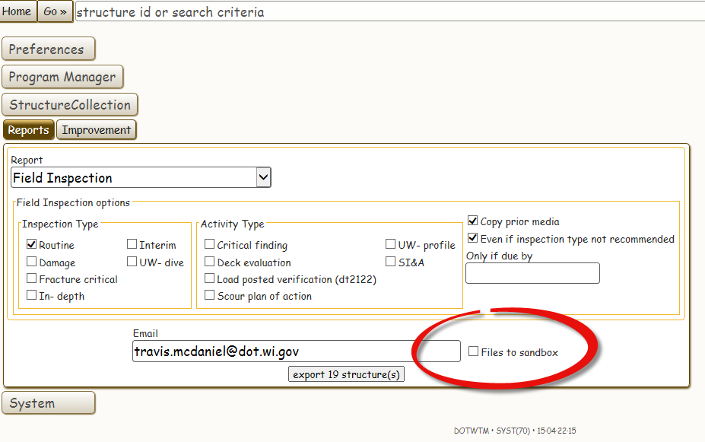
By checking “Files to Sandbox” and clicking export, you will start a process where the reports are gathered in a batch process internally by the system. You can continue to work while the system is building your request. Also note that the default is to “copy prior media” in your request. What that means is if you want previous attached documents, photos, etc. to be included then you have that box checked. If you simply want your inspection form (elements, notes, etc.), then un-check that box. Un-checking the box will lower your file size.
When the system completes the request, it will send you a confirmation email. When you see that email, you have a few different ways to get to your “sandbox”. The first way is to Navigate by clicking Go – Tools, and then clicking the System tab and then the Sandbox Tab . The second way is to click the “X” Sandbox Folder in the upper right hand portion of your screen (see below for both.
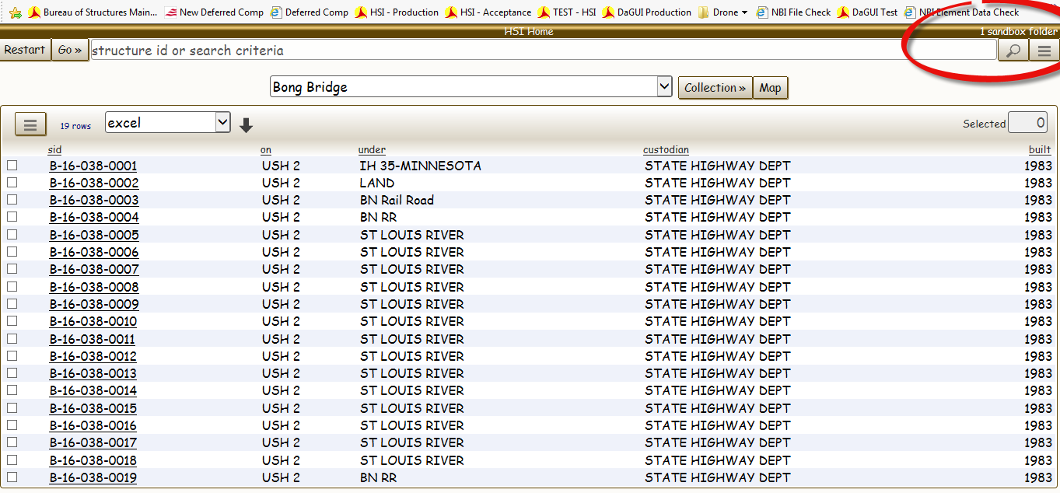
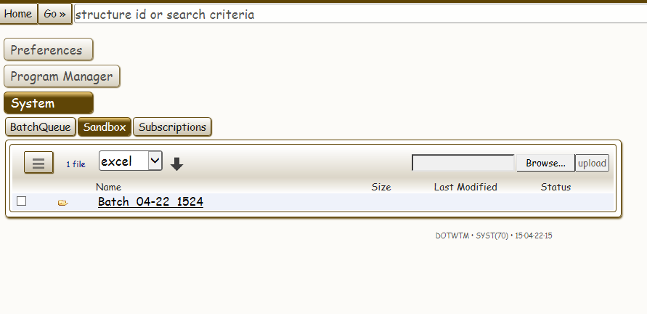
As you can see, there is one folder available called “Batch_04_22_1524”. The 04 is the month (April), 22 is the day, and 1524 is the time (i.e. 3:24pm). If you do multiple requests on the same day at same exact minute, the last number will simply increment by the request #.
When you click on the Folder, it will take you to the file(s) requested. In this example, there is a single pdf that contains the 19 inspection forms. Note that the file size is 16.7MB, which is much greater than the email system firewall limit of 8MB.
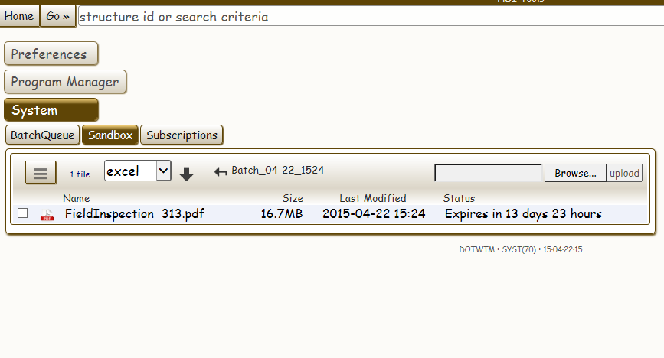
Also note that these files are not permanent; they will be removed after 14 days.
And finally, the system is designed to take the firewall into consideration when you request a collection of bridge inspection documents. Take for instance the 19 structures above. If I forget to check “Files to Sandbox”, I’ll get an email with this message:
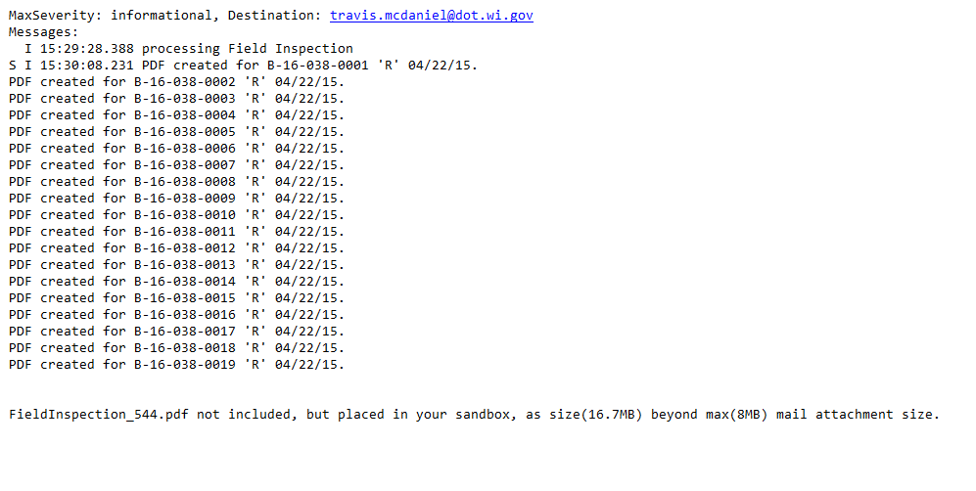
Note two items in this email. First, it lets the user know that the PDF was created. Second, it explicitly tells the user that we could not email the file because the size (16.7MB) was greater than the Firewall limit (8MB), so we placed it in the Sandbox folder for you to grab. When this occurs, your Sandbox will look like this:

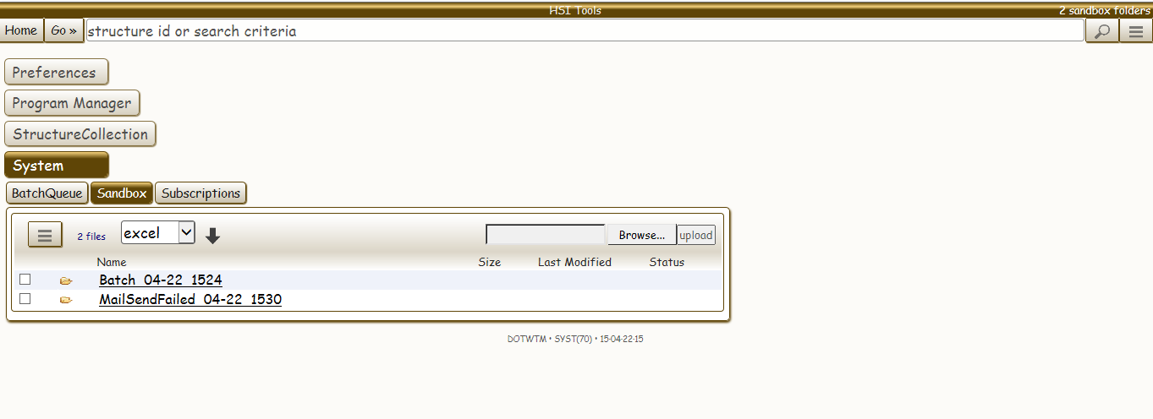
Clicking on the “MailSendFailed 04-22 1530” folder gives me this file:
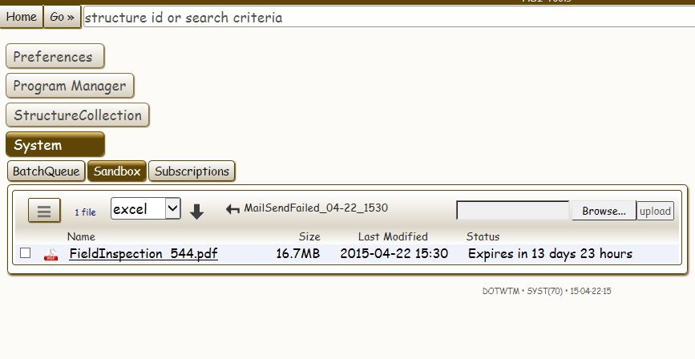

- Copying Photos and other Documents Forward from Previous Inspections There are a few ways to reuse photos from existing inspections. A few common methods will be demonstrated below.
The easiest method is to check “copy prior reports/images/documents” on the Create tab. What that will do is copy all attached documents from the previous inspection of the same type (in the below example, it would be from the last Routine inspection).
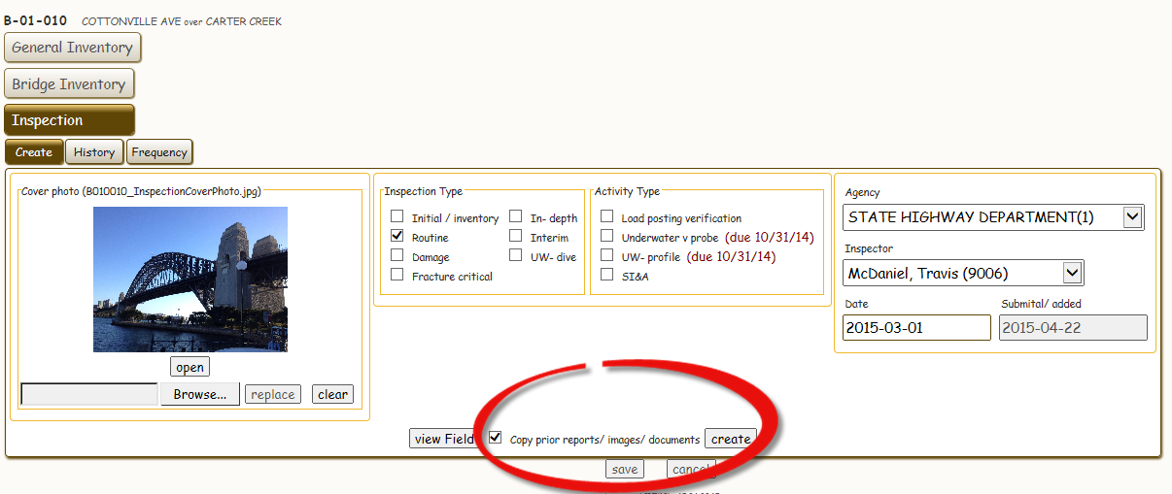
When I clicked create, and then went to the Documents/Images tab, you’ll notice in the next screenshot that we have three photos that have carried over from the old inspection. Say however, you only want to use the 1st photo. To delete the other photos, simply click the delete button below the photo you wish to remove.

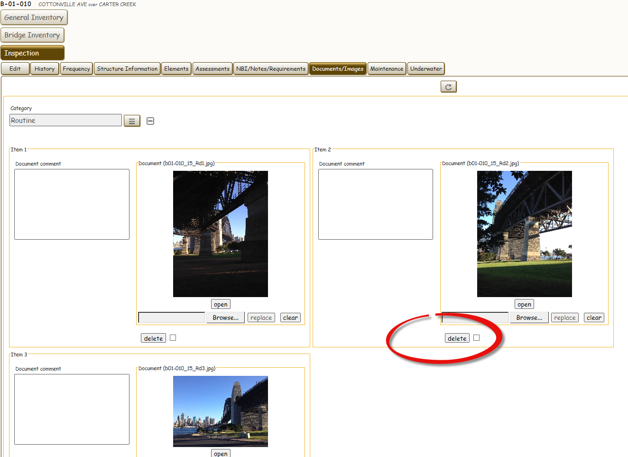

Now suppose you accidentally deleted one too many photos. In this case, you can select documents from previous inspections manually. To do this, click the “Show Prior” checkbox shown below.
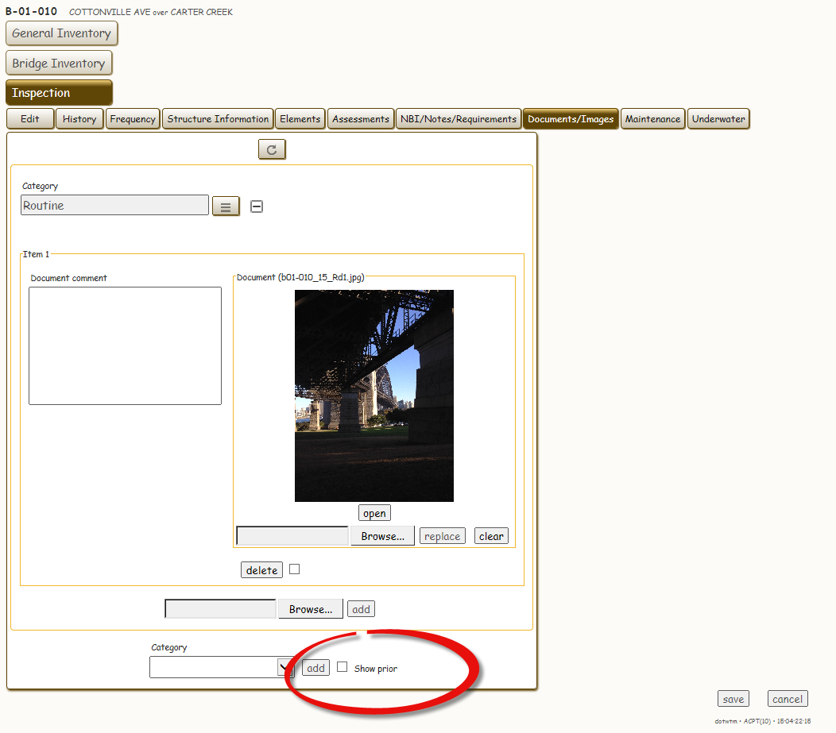
Once you click that, you’ll notice that a “Prior Documents/Images” section appears. Expand that selection by clicking on the “plus” box.
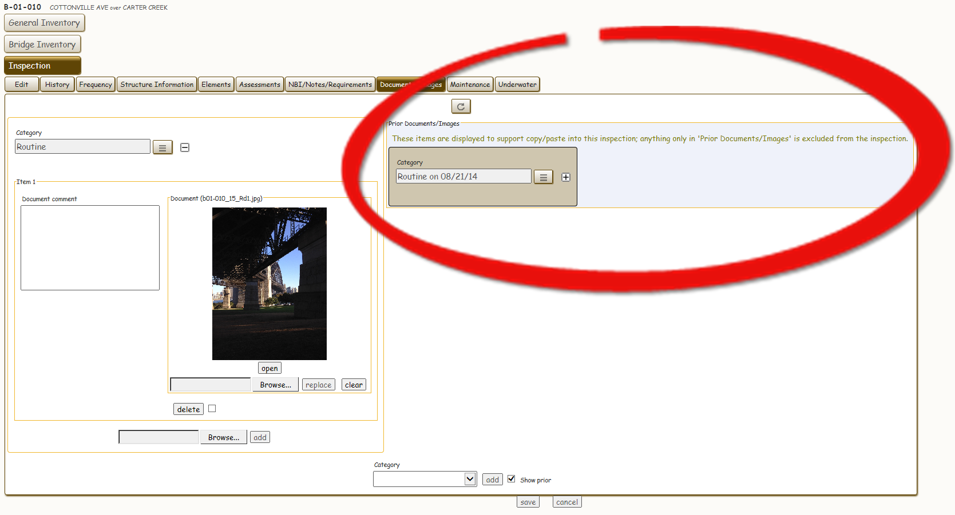
When you expand your selection, you’ll note that the original three photos are there to be copied.

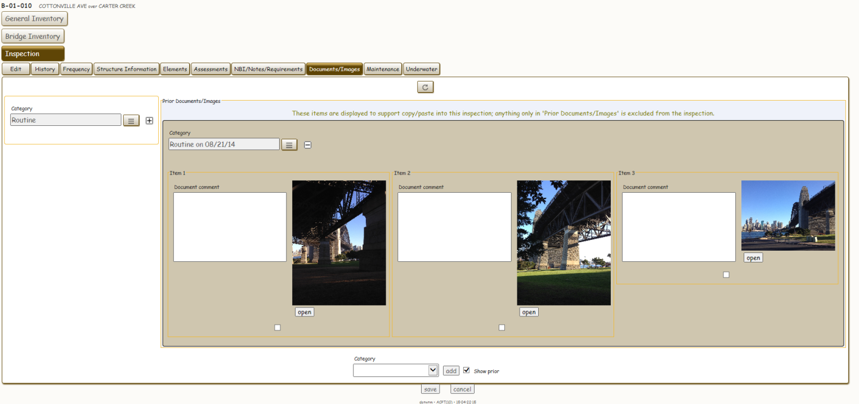

To copy a photo (or multiple documents), click the checkbox below the document(s) and then click Options – Copy.

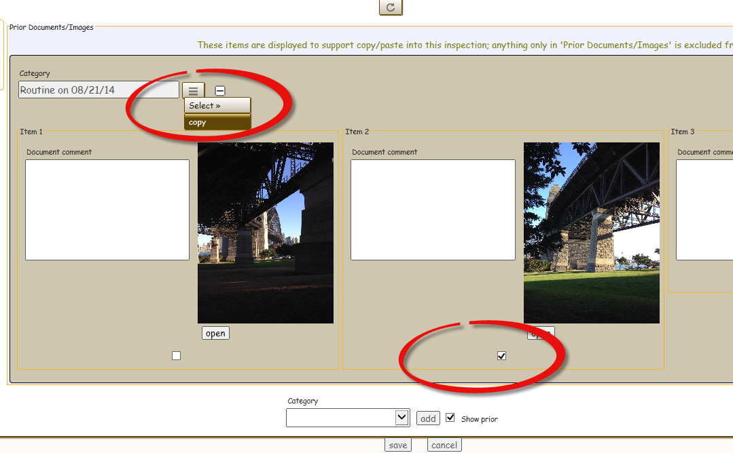

Once you’ve done that, click the options box of the current inspection you want to add the photos and click Paste.

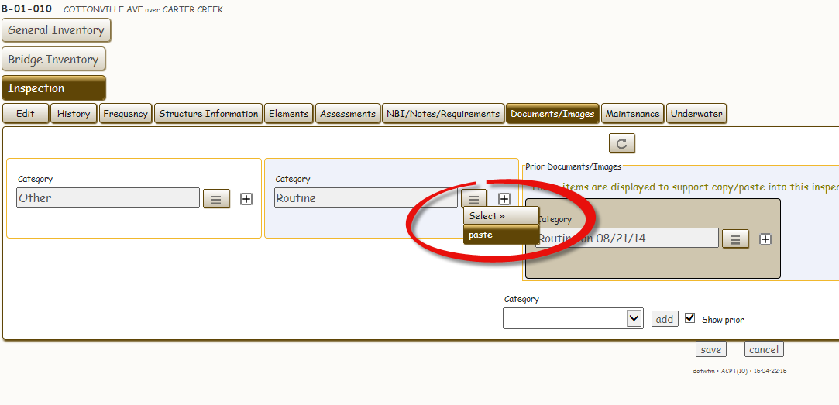

When your screen refreshes, you’ll note that the copied photo is now a part of your new inspection.
To close the old photos, uncheck “copy prior”.
