Timely Decision Making
Project Administration Tools
Revised February 2021
Revisions shown in red.

Timely Decision Making

Project Administration Tools

Table of Contents

background 3

Meetings 4
Agendas
- Preconstruction Meeting Guidance
- Partnering Meeting Guidance
- Weekly Progress Meeting Guidance
- Preconstruction Meeting Agenda - Form
- Partnering Meeting Agenda - Form
- Weekly Progress Meeting Agenda - Form

Minutes/Notes
- Meeting Notes Guidance
- Meeting Notes - Form

line of communication 15
- Line of Communication Guidance
- Line of Communication - Form

Project Materials Coordinators 17
- Designated Materials Person Guidance

3-week look-ahead schedule 18
- 3-Week Look-Ahead Schedule Guidance
- 3-Week Look-Ahead Schedule - Examples

REquest For information (RFI) 22
- RFI Guidance
- RFI Log & Form

EVALUATIONS 25
- Evaluation Form Guidance
- Contractor’s Evaluation of the Project Team - Form
- Project Team’s Evaluation of the Contractor - Form

Timely Decision Making Tools

Background
In 2007 a series of communication “tools” were created as part of a Project Communication Enhancement Effort (PCEE). The PCEE Manual was placed on WisDOT’s website for use by the department and industry. While the tools developed were to assist with project level communications and promote timely decision making, concerns expressed by Wisconsin Transportation Builders Association (WTBA) indicate decision making on projects still remains an issue.
Timely Decision Making Effort
In an effort to improve timely decision making on WisDOT projects, a survey was conducted by UW’s Construction and Materials Support Center (CMSC) to gather information regarding how prevalent the issues are, if there are underlying causes which need to be addressed, how extensively the PCEE tools have been used and how effective they have been, and to identify actions that might be taken. The survey included representatives from WisDOT (Bureau and Regions), consultants, and contractors. A stakeholder group reviewed the results of the survey and identified key initiatives that will be carried forward for implementation in the 2013 construction season.
The key initiatives deemed most useful to the communication enhancement effort were selected to be included in this new Timely Decision Making Manual. Additional guidance and tools were developed to assist the project staff and contractors in their communication efforts. The Timely Decision Making Tools are in a format such that they can be modified to best suit the project and the communications needs of the project team.
WisDOT strongly encourages the use of these tools on projects to improve project communication, enhance the decision making process, and assist in avoiding disputes on projects.
Questions regarding their use should be directed to the respective WisDOT, Bureau of Project Development Construction Oversight Engineer.

Preconstruction Meeting Guidance
The Preconstruction Meeting is an opportunity for department personnel, consultants, and contractor’s staff to become acquainted and begin the process of creating the team that will build the project. It is a vitally important meeting where lines of authority and communication are established; responsibilities and duties of the contractor’s personnel, department personnel, consultants, subcontractors and suppliers are clarified; issues are identified and resolved or a process for resolution determined; potential sources of misunderstanding are resolved; and detailed arrangements necessary for a successful project are worked out. A Preconstruction Meeting will be held on all projects. Both the WisDOT Project Engineer and Contractor’s Superintendent are responsible for making this a productive meeting.
The Draft Preconstruction Meeting Agenda is not intended to be an all-inclusive agenda, but rather an outline of potential topics that should be tailored to the specific project. It is not intended to be a stand-alone document. It is intended to be used in conjunction with Section 226 of the WisDOT Construction and Materials Manual (CMM). The CMM has much more information on the individual agenda topics and this should be reviewed prior to conducting the project preconstruction meeting. Department form WS1030 is a template that can be used to develop an agenda for a particular project.
Each WisDOT Region has prepared and assembled an agenda to be used in their respective regions. The agendas are specifically tailored for use in each region. All regions have included the basic essentials to be discussed at all preconstruction meetings.
It is important to document items such as the meeting date and time, attendees, summary of issues discussed, actions to be taken, and action assignments made. The Project Engineer or his/her designee will prepare minutes of the meeting and promptly distributed to all contractors in attendance, as well as those indicating receipt on the attendance roster. (See Minutes/Notes section)

PARTNERING MEETING GUIDANCE
The project partnering meeting is an opportunity for the project’s leadership to discuss roles, expectations, and decision making in greater detail than at the preconstruction meeting. The purpose of the meeting is to reinforce the communication and collaboration aspects of the meeting so that issues and potential conflict areas can be identified and dealt with at the beginning of the project. Resolving lines of communications, roles and responsibilities, issues, and conflict areas before starting the construction project will have a payoff throughout the duration of the project.
This meeting should be held on all projects prior to beginning major work. Depending on the size and complexity of the project, it can be a standalone meeting or held as a breakout session adjacent to the preconstruction meeting or the first weekly progress meeting. Some of the main objectives and desired outcomes of the meeting include:
- Review the project line of communication.
- Establish a timeline for project communication (i.e. e-mail/phone response time).
- Discuss project challenges, concerns, and known issues in detail.
- Finalize protocols for RFI/Issues, submittals and contractor proposal processes.
Although many of these topics are also discussed at the Preconstruction Meeting, the Partnering Meeting provides for a smaller group of project leadership to work through them in greater detail and ensure that the communication tools necessary for a successful project are established.
The team members that should be invited include:
- Contractor:
  - Project Superintendent and/or Project Manager
  - Main office (a level up from project staff)
- WisDOT:
  - Construction Leader
  - Construction Project Manager
  - Construction Supervisor (optional)
  - Design Leader (optional)
  - Design Project Manager (optional)
- Local Program
- Construction Project Engineer
- WisDOT Project Manager
- Local Program Project Manager (optional)
- Design Representative (optional)

Weekly Progress Meeting Guidance
It is anticipated that project progress meetings will be conducted weekly on typical WisDOT projects. However, there may be select noncomplex, low-cost projects where weekly meetings may not be necessary. The intent is that these meetings be kept as brief as possible to minimize demands on attendees and enable prompt distribution of notes. The weekly progress meetings are conducted to: review construction progress and future work activities, identify potential delays as early as possible for mitigation planning, raise issues and bring them to resolution, and make subsequent action assignments when appropriate. Action assignments should be re-visited as part of “Outstanding Issues” at each meeting to verify closure of each assignment in a timely fashion.
The Draft Agenda is meant to provide a starting point for typical projects and some items may not need to be covered. However, it was developed to encourage discussion on items that routinely can become larger issues if left unaddressed. Eliminating any agenda topic should be done deliberately and carefully. Normally, the WisDOT Project Engineer is responsible for establishing the agenda, and it should be distributed to attendees ahead of time as it forms the basic meeting outline. The prime contractor is responsible for attendance of appropriate subcontractors needed to discuss current issues and upcoming work. In lieu of subcontractor attendance, the prime contractor is responsible to contact subcontractors and be knowledgeable of their work.
The Project Engineer or his/her designee will prepare minutes of each meeting and distribute minutes in a timely manner to the prime contractor and other attendees, as requested. The prime contractor is responsible to review and comment, if necessary, on the minutes. (See Minutes/Notes section)

PRECONSTRUCTION MEETING AGENDA

Wisconsin Department of Transportation
WS1030 1/2018

Project ID
Project Name
Location
Project Engineer

1. Introduction
A. Purpose of meeting
B. Review Agenda
C. Distribute Attendance Roster

2. General Project Information
A. Description of proposed work
B. Contract number/WisDOT Project ID/Federal Project No
C. Contract Cost and Time
D. Anticipated Starting Date
E. Project construction issues

3. Project Personnel
A. WisDOT Personnel
a. Area construction supervisor
b. Engineer
c. Inspectors
B. Prime Contractor’s Personnel
a. Superintendent
b. Work supervisors
C. Roles and Responsibilities
D. Line of Communication (Line of Communication Form)
E. Dispute Escalation

4. Subcontractors
A. Names of proposed subcontractors
a. List of work operations to be sublet
b. Names of authorized representatives plus work address and phone
B. Sublet Request Forms
a. WisDOT for approval:
b. Need for WisDOT approval before start of work by subcontractors
C. Line of communication: WisDOT, prime contractor, subcontractors

5. Suppliers
A. Names of proposed suppliers
a. List of items to be supplied
b. Names of authorized representatives, plus work addresses and phones

6. Progress Meetings
A. Frequency of Meetings
B. Meeting location and time
C. Expected attendance

7. Public Relations
A. Contact with news media
B. Contact with local government officials
C. Contact with abutting property owners

8. Contract Administration
A. Forms to be submitted by contractor
a. Provide a separate list that shows the “when, to whom and how many”
b. Furnish an initial supply of forms
B. RFI Process
C. Notice of Change and claims process
D. Contract Features
a. Special Provisions & clarifications
b. Items of work
c. Measurement, acceptance, and payment process
d. Special measurement and acceptance procedures
E. Special permits
F. Progress payment process and frequency
G. Field Office and Field Laboratory
a. Delivery date
b. Location and access
c. Requirements
d. Safety
e. Sanitary and Health
f. Equipment; computer

9. Construction Work Schedule
A. Overview by WisDOT
a. Notice to Proceed Procedures
b. Coordination with other projects, contractors, utilities, railroad
B. Contractor’s work schedule
a. Plan of work operations
b. Time frame, hours of work, number of shifts
i. WisDOT Form EC707 requirements
ii. Advance notice required for extra shifts
c. Anticipated Conflicts

10. Major Work Operations

11. Utility Coordination and Adjustments
A. Utility agreements
B. Utility work schedule
C. Current status of work
D. Anticipated Problems

12. Right of Way
A. Current status of agreements and commitments
a. Agreements and commitments
i. Buildings
ii. Easements
iii. Encroachment
iv. Fences
v. Firewood and timber
b. Blue commercial signs: (see Removal of Specific Information Signs and Associated Posts special provision)
B. Unsecured Parcels
a. Anticipated secural date
C. Notifying owners about conflicts

13. Traffic Control
A. Traffic Control Plan
a. Detours and bypasses
b. Road closings
c. Access
i. Through traffic
ii. Local traffic, school buses, mail delivery
iii. Non-vehicular traffic
iv. Emergency vehicles
1. Notify fire and police of road closings
B. Holiday work restrictions
C. Signing requirements
a. Signing plan
i. Conformance with MUTCD (State and Federal)
b. Barricades
c. Lights
d. Arrow Boards
e. Changeable/programmable message boards
f. Maintenance Plan
i. Name and phone of person responsible for 24-hour emergency service
g. Advance warning signs
D. Dust and Noise Control
a. Haul roads
b. Crushers
c. Mixing plants

14. Environmental Considerations
A. Erosion Control Implementation Plan
B. Erosion Control for the project
C. Protection of environmental features
D. Environmental Permits

15. Ancillary Structures Inspections
A. Overhead sign supports
B. Sign bridges
C. Traffic signal monotube poles (type 9,10,12, and 13 poles)
D. High mast lighting poles

16. Materials
A. Sources and locations
a. Contractor to submit list of suppliers ASAP
b. Use of standard State form for reporting
B. Testing and Certifications
a. Establish list of all materials needing testing test reports and certifications;
i. Catalog numbers, manufacturing details
b. Establish needed lead time
C. Acceptance procedures
D. Rejected or Deficient Materials
E. Pits, quarries, and waste area requirements
a. Location of pits and quarries to be used for project
b. State Historical Society requirements and procedures:
i. Archaeological finds reported to SHSW
c. Negotiations and royalties
d. Establishing commercial status:
i. Necessary permits
e. Contractor’s obligations upon closing pit:
i. Site restoration
f. Marsh excavation disposal sites
i. DNR restrictions
F. QMP Process & Reporting procedures
G. Identify the CPMC and WPMC
H. Provide E-Guide to contractor

17. Detours and Haul Roads
A. Identification of routes
B. Logging
a. Local officials notified and allowed to attend
C. Traffic Control
D. Restrictions, noise & dust control

18. Surveying
A. Initial layout and data transfer
B. Special staking information
a. Offsets; how to mark and read stakes

19. Safety
A. Contractor’s Safety Plan
B. Job-related injuries and how will they be handled
C. Incident Management
D. Emergency protocols and contacts

20. Project Acceptance and Finals Process
A. Final acceptance procedure and punch list
B. Retainage
C. Production rates (enter using online tool)

21. Evaluations and Critiques
A. Plan, specifications and special provisions
B. Contractor and subcontractor
C. Consultant

22. DBE Involvement
A. Project Goals
B. Contractor’s approach for achieving goal
C. Apprenticeship Program

23. Labor and Wage Compliance Meeting
A. Introduction of representatives:
a. Contractor
b. Subcontractor
c. WisDOT; consultant (if applicable)
B. Equal Employment Opportunity:
a. Designation of EEO officers
i. Prime contractor
ii. Subcontractor
b. Contract provisions
C. Wage compliance:
a. White sheet rates
b. Fringe benefits
c. Payroll reviews
D. Postings:
a. List of required documents
i. State
ii. Federal
E. Required WisDOT forms; supply a quantity plus a sheet of explanation.
F. Reviews by WisDOT:
a. Field interviews with contractor personnel
G. Responsibility of prime contractor for subcontractor actions.

Project Partnering Meeting Agenda
Project ID
Project Name
Location
Project Engineer

- Introductions

- Project Personnel and Communication
  - Review Lines of Communication developed at the Precon (see: page 15)
  - Dispute Escalation
  - Communication courtesy protocol
    - Timely email response
    - Timely telephone response

- Design/Construction discussion of sensitive issues such as:
  - Schedule
  - Stakeholders/Property Owners/Community
  - Environmental
  - Utilities
  - Other issues that came up at the Precon as needing further discussion

- RFI/Issues Process
  - Forms and logs
  - Decision timing and expectations from both sides
  - General agreed upon procedures

- Submittal Process (shop drawings, permits, haul routes, materials certs, borrow/waste sites, etc.)
  - Notice requirements and review time (initial submittal and revisions)

- Contractor Proposals (i.e. CRI process, stage change proposals, etc.)
  - Notice requirements and review time (initial submittal and revisions)
  - Contract procedures - information needed in a thorough submittal

Weekly Progress Meeting Agenda

Project I.D.: Date:
Highway Description:
Project Location:
Project Engineer:
Note Taker:

Attendees:

- Review Previous Meeting Notes
  - Outstanding issues

- Contractor’s Schedule
  - Schedule update
  - Work in progress
    - Prime Contractor
    - Subcontractors
  - Controlling items of work
  - Delays
    - Controlling item
    - Non-controlling items
  - Contract time

- Utilities / Railroads

- Maintenance of Traffic
  - Lane Closure System (LCS) issues
  - Modification to traffic control
  - Maintenance of traffic control
    - Device condition
    - Device location

- Materials
  - Certification / test report submittals
  - QMP testing; Non-QMP testing
  - Non-conforming materials
  - Up-coming testing and materials submittals

- Environmental
  - Erosion Control
  - Weekly erosion control inspections / work orders
  - ECIP revisions

- Request for Information (RFIs)
  - Status of outstanding RFIs
  - Upcoming RFIs

- Contract Change Orders (Contract Modifications)
  - Status of contractor information for pending contract modifications (pricing info)
  - Status of pending contract modifications (contractor signature & department signature)
  - New issues / concerns

- Progress Estimates
  - Completed items
  - Quantities for payment
  - Finals process

- Safety
  - Work site safety
  - Work zone safety
  - Accidents / Emergency incidents
- Public Relations
  - Property Owners / Businesses
  - Local officials

- EEO / Prevailing Wage Issues
  - Prompt payment (ASP - 4)
  - Payroll issues
    - Missing
    - Underpayment of wages
    - ASP 7
  - Wage claims

- DBE Commitment Status

- New Issues / Concerns; Other Items

- Next Meeting (if not regularly scheduled)

- Action Items / Assignments
  - Contractor
  - Department

Meeting minutes will be distributed to the prime contractor and other attendees, as requested.
Hard copies will be available at the next meeting.

Meeting Notes Guidance
It is important that concise notes be developed from the Preconstruction Meeting and the Weekly Progress Meetings in order to record and document the discussions held. The notes should be concise, summarizing the discussion topics and adding detail only when required or appropriate to the subsequent actions required. It is equally important to document the attendees at each meeting and include their attendance on the Minutes/Notes form. Reasons for this documentation include:
- Documentation of attendance by the Project Manager to verify that he/she is in responsible charge.
- Document that the proper contractors, including subcontractors, are in attendance at these meetings.
- Document attendance at meetings where issues/concerns are discussed in case claims about those issues/concerns arise later.
- Document attendance by specific utilities if utility work or conflicts are present on the project.
- Document attendance by the local government officials to show their participation and their issues are addressed.
The Project Engineer or his/her designee will prepare minutes/notes for each meeting and distribute them in a timely manner to the prime contractor and other attendees, as requested.
Recording of the meeting minutes/notes can take many formats. Some Project Engineers prefer to simply add discussion summaries to the published agenda. Others have other styles they prefer. Regardless, it is important to document items such as the meeting date and time, attendees, summary of issues discussed, actions to be taken, and action assignments made. Action items and/or assignments are often made for follow-up at subsequent meetings. These must be documented in the published notes. Final resolution of each item / issue should be documented.
A Meeting Notes Form is provided and may be used to document each meeting.
Meeting Notes

Project I.D.: Date:
Highway Description:
Project Location:
Project Engineer:
Note Preparer:

Attendees:

Notes, Comments, Issues

Action Items (with timelines)
Contractor

Department

Meeting notes are distributed to the prime contractor and other attendees, as requested.

Line of Communication Guidance
As soon as the WisDOT Bureau of Project Development has confirmed that the project has been awarded to the low bid contractor, the communications process should be initiated by the WisDOT Project Engineer. The Project Engineer should contact the contractor’s main office, identify the project Superintendent, and begin discussions about the project and who will be on the project team from each organization. The information on the Line of Communication Form should be completed by each party and be available for distribution at the preconstruction meeting.
This form should be used to identify the level of decision making on a project. All communications must start at the lowest level (Project Engineer and Foreman) and proceed accordingly to the next highest level in the hierarchy shown on the form. If decisions are not made at the identified level in a timely manner, the issue can be elevated to the next level for a decision. Elevation to the next higher level should not occur without notifying the level at which the decision currently sits.
This form also provides the basis for dispute escalation should a disagreement arise on the project. It starts with the Project Engineer/Foreman level and escalates through the respective organizational hierarchy until ultimately reaching the WisDOT Project Development Chief and the Contractor’s Main Office.
The Project Engineer and foreman may choose to create a list of contacts within their own organizations to be used as a resource for technical expertise. Typically, this list would include contacts for materials, traffic, DNR liaison, utilities, railroads, real estate, etc.
The Bureau of Project Development and/or any other Bureau should not be contacted directly by the contractor. The proper progression of communication and decision making needs to be followed.

LINE OF COMMUNICATION
(Associated levels of decision making)

WisDOT Contacts Contractor Contacts

Project Engineer Foreman

Name Name
Phone Phone
Cell Cell
E-mail E-mail
Fax Fax

Project Manager Superintendent

Name Name
Phone Phone
Cell Cell
E-mail E-mail
Fax Fax

Project Development Supervisor Superintendent

Name Name
Phone Phone
Cell Cell
E-mail E-mail
Fax Fax

Project Development Chief Contractor’s Main Office

Name Name
Phone Phone
Cell Cell
E-mail E-mail
Fax Fax

Project Materials coordinator Guidance
The contractor is responsible to ensure that all materials used on a project meet the contract requirements. All materials used on a project are subject to approval by the engineer prior to incorporating them into the work. As such, the contractor shall designate a Contractor Project Materials Coordinator (CPMC). This person is a member of the contractor’s organization or a person acting as an agent for the contractor.
The department should also designate a WisDOT Project Materials Coordinator (WPMC) who will directly coordinate with the CPMC to ensure the use of quality materials on the project.
The WPMC will provide a project-specific sampling and testing guide (E-Guide) to the contractor at the preconstruction conference. Both the CPMC and WPMC should review the E-guide to verify that the testing methods and frequencies and material documentation requirements shown in the guide are correct per contract requirements.
The responsibilities of the CPMC are outlined in standard spec 106.1. These include but are not limited to the following:
- Communicate materials requirements to subcontractors
- Submit all required materials information from prime contractor and subcontractors to the WPMC in a timely manner
- Report non-conforming materials to the WPMC
- Ensure documentation of all QMP requirements is met
- Coordinate with the WPMC to ensure all materials-related concerns are satisfied
- Communicate or meet with the WPMC on a regular basis
The WPMC is responsible for administration of the contract with regards to contract materials requirements. This person’s responsibilities include but are not limited to the following:
- Communicate or meet weekly with the CPMC to discuss outstanding materials issues on the contract
- Monitor the submittals from the CPMC to ensure timeliness and completeness
- Review contractor submittals to verify materials requirements are met
- Inform the Project Engineer of non-conforming materials issues and discuss actions to be taken
- Prepare materials documentation for inclusion into the project files
The communication between the CPMC and WPMC is important to ensure submittal of materials information is done in accordance with the contract, and that all materials incorporated into the project meet contract requirements.
Additional guidance can be found in CMM 8-10.1.2.

3-Week Look-Ahead Schedule Guidance
It is anticipated that project progress meetings will be conducted weekly on typical WisDOT projects. One of the discussion items on the weekly meeting agenda includes review of the contractor’s schedule. One of the tools that is highly recommended for use during the schedule discussion is the 3-Week Look-Ahead Schedule.
The 3-Week Look-Ahead Schedule is prepared by the contractor. The intent of this schedule is to show the work done within the past week and to show the work planned for the next 2 weeks. The schedule should include the major work to be performed and the contractor responsible for that work.
The 3-Week Look-Ahead Schedule is not a contract document. The requirements shown in standard spec section 108 do not apply. Therefore, the format for this schedule can vary. Some contractors may wish to show their work in a bar chart format showing the major work items for each day of the schedule and who is responsible for each item. Other contractors may wish to show their work in a verbal format with bullet points indicating the work to be done and which contractor is responsible for that work. Traffic control/lane closures are always a good item to include.
Reasons for utilizing a 3-Week Look-Ahead Schedule may include the following:
- Scheduling of contractor’s equipment and crews
- Scheduling of subcontractor’s work
- Scheduling of engineering staff
- Scheduling of third party work (railroads, utilities, municipal work, etc)
- Anticipating/identifying utility conflicts
- Identifying traffic control issues
- Advanced notification to local police, fire, etc, for upcoming work and traffic closures
The use of this tool is highly recommended to assist in early identification of problems/issues that could cause delay to the contractor and affect the schedule of this project.
Three examples of 3-Week Look-Ahead Schedules are included in this document.
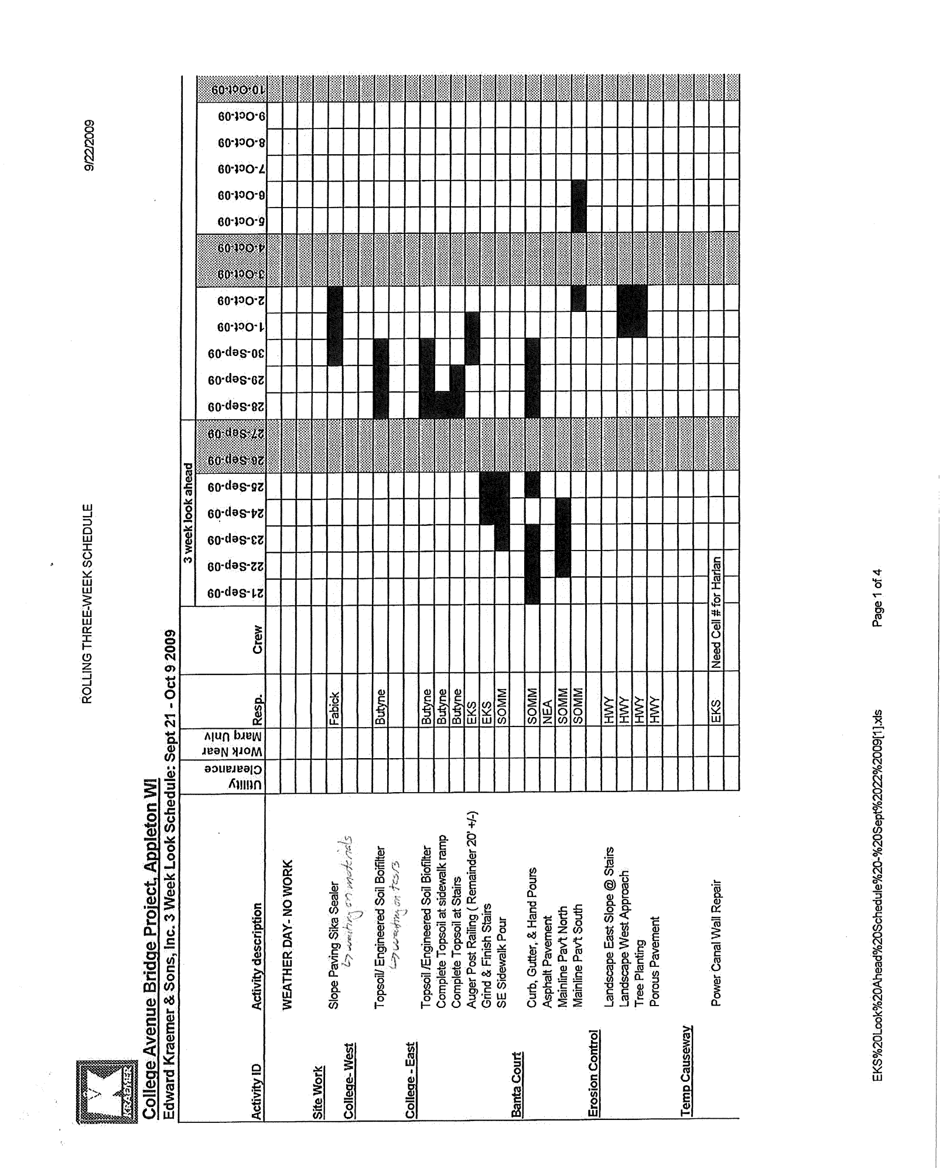

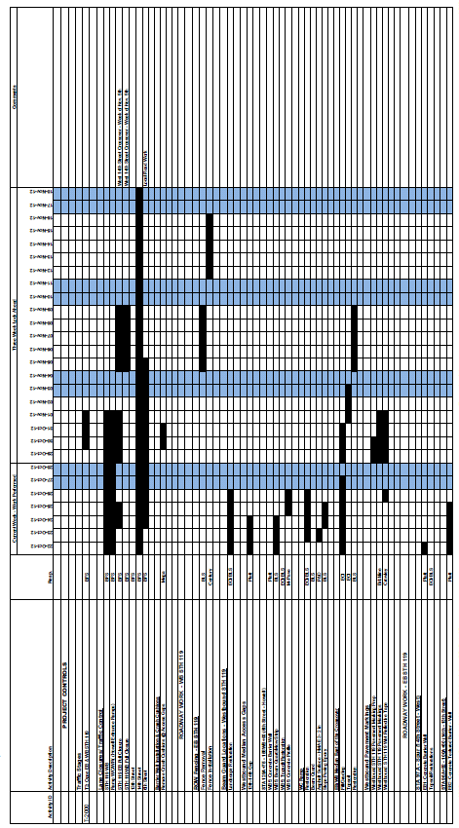
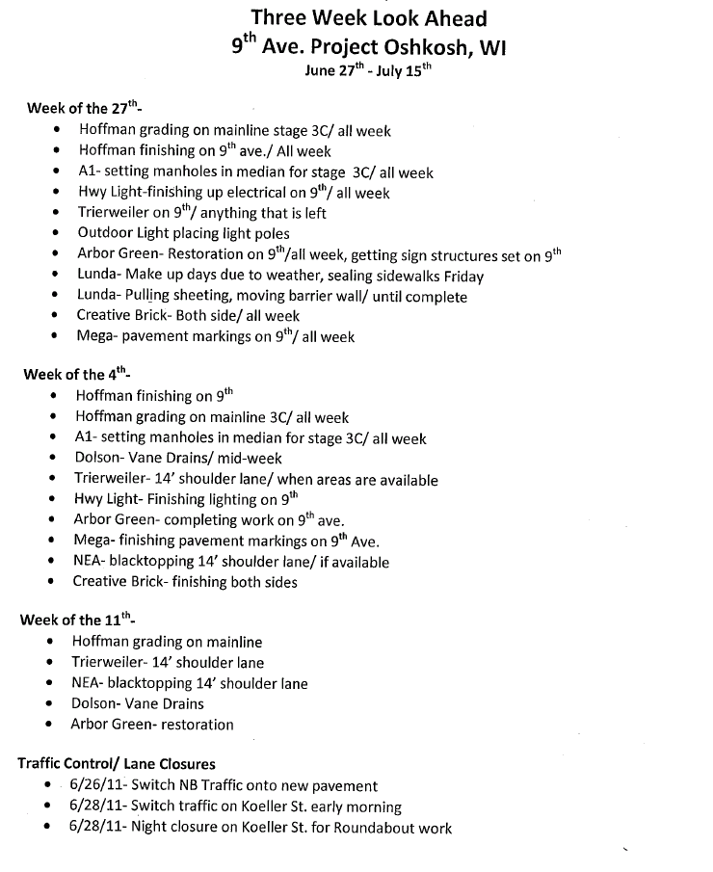

Request for information (RFI) Guidance
Under standard spec 104.4 Request for Information ( RFI) is used during the construction of a project to obtain clarification of the plans, specifications, special provisions, or other contract documents. The use of RFIs is strongly encouraged with the intent of improving the communication between the contractor and engineer and to assist in avoiding contract disputes and claims.
The contractor typically initiates an RFI, however, either the contractor or department can submit an RFI to the other party for clarification of an issue. If a subcontractor needs clarification of an issue, they should not submit RFIs directly to the department. Subcontractors should submit the RFI to the prime contractor, who will then forward the issue to the department.
The contractor or engineer submits an RFI to the other party using RFI form DT2502. The party submitting the RFI must clearly and concisely identify the issue for which clarification or interpretation is needed, why a response is needed, and to provide a date for when the response is needed. The responding party should make significant effort to produce a response as soon as possible so as to not impact the construction schedule. If the responding party requires a longer time than requested by the requesting party, the responding party must communicate that fact in writing, and let the requesting party know how long it will take to produce a response. Responses should make reference to appropriate specifications, plans, and/or drawings. If the requesting party is not satisfied with the response provided or the response is still not clear, they can re-submit the request as a new RFI with the short description "resubmittal." If there are disagreements regarding the response to an RFI, the Project Manager should immediately get involved to facilitate resolving the issue.
The responding party forwards the response to the requesting party. The engineer is responsible to monitor, track, and expedite the response to an RFI. Once a response is provided, the engineer forwards one copy to the RFI requester, and files one copy in the project file for reference.
The engineer maintains a log for tracking the status of RFIs. The engineer will log the RFI in the RFI Log form DT2501. The Project Engineer will post the RFI Log in the field office.
The engineer and contractor should work together to ensure that RFIs are appropriate, in order to control the number of RFIs. RFIs should not be used to request a contract modification or to change the contract documents.
Discussion of outstanding RFIs should be an agenda item at the weekly progress meetings.
A copy of form DT2501 "Contract Requests for Information Log" and DT2502 "Request for Information (RFI)" are shown in this manual. These forms can be found at the department’s forms website at:
https://wisconsindot.gov/Pages/global-footer/formdocs/default.aspx
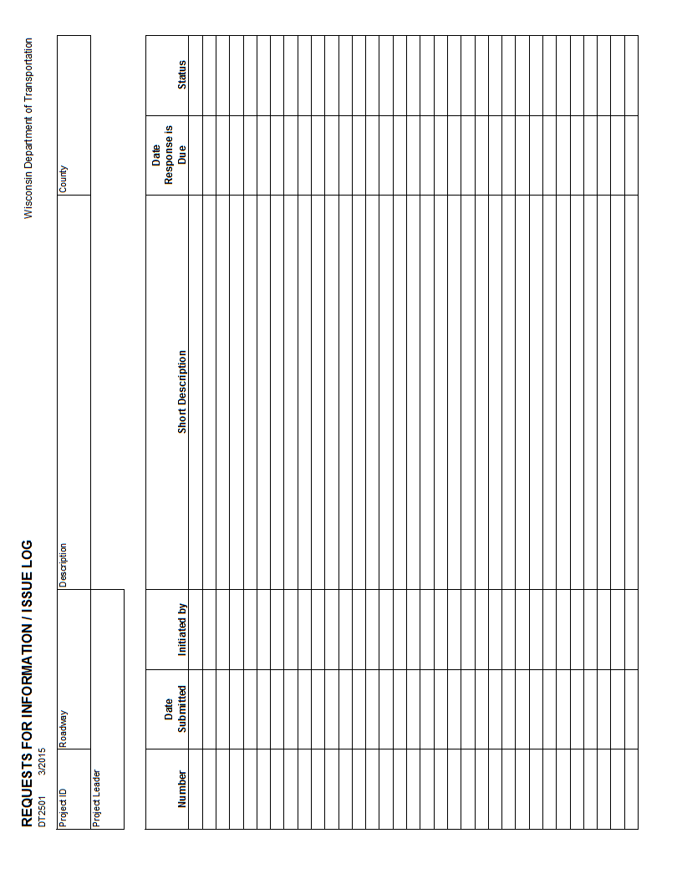
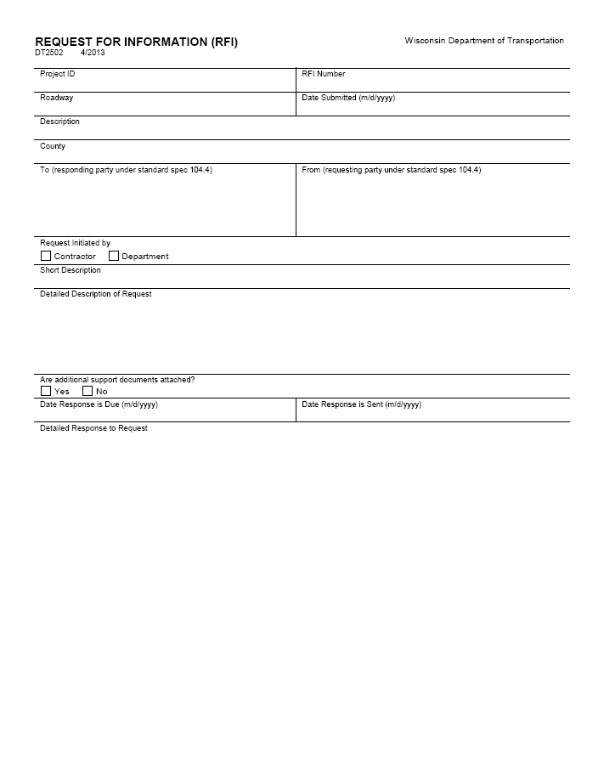

Evaluation Form Guidance
The Evaluation Forms provide information to WisDOT management on how the construction project went. Both the Contractor and the Project Team are rated in seven performance categories:
- Communication
- Knowledge
- Timely Decision Making / Completion of Work
- Timely Estimates / Payments
- Changes in the Field
- Fairness / Conflict Resolution
- Adequacy of staff
The purpose of these evaluations is to provide candid feedback about each party’s performance, so that individuals can continuously improve their efficiency and effectiveness. It is very important that comments remain constructive and promote more positive working relationships between the contractor and construction administration staff.
These seven performance categories should be reviewed periodically throughout the project life rather than just at the very end. Please rate the performance of individuals on the overall project rather than one specific event.
A copy of form DT2509 "Contractor's Evaluation of the Project Team" and DT2510 "Project team's Evaluation of the Contractor" are shown in this manual. These forms can be found at the department’s forms website at:
https://wisconsindot.gov/Pages/global-footer/formdocs/default.aspx
Note: The DT2510 "Project Team's Evaluation of the Contractor" is to be completed in addition to the "Contractor Performance Evaluations" described in CMM 170.1. The Contractor Performance Evaluations are confidential reports used for rating the prime contractor and subcontractors. They provide input to personnel establishing the bidding limit for a contractor, and to monitor extremes in work performance. They are also used to monitor a subcontractor’s ability to sublet work and serve as a basis for certifying DBE and WBE firms.

